The Demand for Money

- Define what economists mean by the term interest rate.

The interest rate is the annual interest payment on a loan expressed as a percentage of the loan. Equal to the amount of interest received per year divided by the amount of the loan.

Difficulty: E Type: D

- In broad terms what is monetary policy?

Monetary policy is the behavior of the Federal Reserve regarding the money supply.

Difficulty: E Type: D

- What are the two major forces that determine the demand for money?

The two major forces that determine the demand for money are the interest rate and the dollar volume of transactions. The latter is a function of aggregate output and the price level.

Difficulty: E Type: F

- One rationale for holding money is the transaction motive. Explain what this means.

The transaction motive is the main reason that people hold money – to buy things.

Difficulty: E Type: C

- What is meant by the nonsynchronization of income and spending?

Nonsynchronization is the mismatch between the timing of money inflow to the household and the timing of money outflow for household expenses.

Difficulty: E Type: C

- Assume that Joe earns $2400 a month, deposits it in a checking account and draws down his income evenly throughout the course of the month with an average money holding of $1200. What are the costs of this money strategy?

What is wrong with this strategy is that Joe is giving up interest on his funds, interest he could be earning if he held some of his funds in interest-bearing bonds instead of in his checking account.

Difficulty: E Type: D

- Assume that the interest rate paid on bonds rises from 4% to 6%. Explain what would happen to the level of optimal (money) balances.

Optimal balances would decrease because it opportunity cost of holding money goes up.

Difficulty: E Type: D

- Explain briefly what the optimal balance of money strategy is.

It is the level of average money balances that earn the most profit taking into account both the interest earned on bonds and the costs paid for switching from bonds to money.

Difficulty: E Type: D

- Explain why money management is costly.

Money management is costly because there are brokerage fees and other costs to buy and sell bonds. In addition, there are costs associated with spending time waiting in line and conducting the transactions.

Difficulty: E Type: C

- Draw the demand curve for money balances and explain how the interest rate affects the number of switches that an individual would make between money balances and bonds.
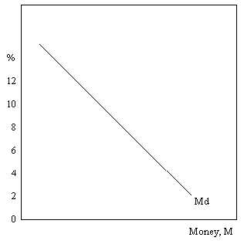

As interest rates fall, the opportunity cost of holding money drops as well. Therefore, we would expect to see households switching some of their assets from bonds to money.

Difficulty: E Type: D

- Explain why the theory of money demanded presented in the book may be more complicated in real life.

The theory explained in the book assumes that a person knows the exact timing of his or her income and spending. In reality, both of these activities may have some uncertainty attached to them. First, some people are paid in irregular intervals. Secondly, there can be some expenses that can occur unexpectedly like car repairs or medical expenses.

Difficulty: E Type: D

- How do changes in interest rates affect the composition of bonds and money that people will want to hold?

When interest rates are high, people want to take advantage of the high return on bonds, so they choose to hold very little money and hold more bonds.

Difficulty: E Type: D

- Explain the speculative motive for holding money.

Investors may wish to hold bonds when interest rates are high with the hope of selling them when interest rates fall. This can be profitable since the market value of bonds varies inversely with the interest rate. When interest rates rise bond prices tend to fall. You may speculate that interest rates are higher than normal and expect interest rates to drop. When interest rates fall bond prices tend to rise and can be sold to realize a capital gain.

Difficulty: M Type: C

- Suppose that you own a $1000 bond which earns 5% interest. Furthermore, assume that interest rates on newly issued bonds rise to 10%. Explain why no one would be willing to buy your bond for a $1000. In addition, calculate the price that you could reasonably expect to receive for your bond.

No one would be willing to buy the bond at $1000 because they can easily buy the newly issued ones and earn a higher interest rate. The only way that someone would be willing to buy my bond is if the price fell far enough to yield a rate of return equal to the newly issued bonds. Since my bond is earning a $50 per year and new bonds are earning 10% my bond would have to fall far enough to provide this same yield.

Difficulty: M Type: D

- Suppose that you own a $1000 bond which earns 20% interest. Now assume that interest rates on newly issued bonds fall to 10%. How much could you reasonably expect to receive for your bond if you were to sell it?

Since I would be earning $200 a year in interest (20% x $1000) then I should be able to receive a price for my bond that will achieve this same yield. That is $200/price of the bond should equal the new interest rate of 10%. The bond price that would provide this same yield would be $2000.

Difficulty: E Type: A

- Assume that the current interest rate is 8%. Let’s say that investors know that normally interest rates are 10%. How would this affect investors’ decisions with regard to how much money and bold holdings to keep?

Investors will want to hold more cash instead of bonds because interest rates are likely to increase in the future and this will bring about a decrease in the value of bonds.

Difficulty: E Type: D
- Explain the demand for money in relation to interest rates.

The demand for money is a negative relationship between the interest rate and the quantity of money demanded.

Difficulty: E Type: D

- What do economists mean when they say that bond prices and interest rates are really “two sides of the same coin?”

What it means is that when the bond market rallies, bond prices have gone up and interest rates, or bond “yields” have gone down. Similarly, when the bond market “drops,” interest rates, or yields, have gone up. The main point is that changes in interest rates do not “cause” changes in bond prices or vice versa. A change in one simply implies an inverse change in the other.

Difficulty: E Type: D

- Why don’t people simply keep all of their asset in forms that are easiest to use for making transactions?

If people kept all of their assets in forms that are easiest to use for making transactions they would be give up interest that they could earn from holding non-money assets. The opportunity cost of holding money is the interest rate. In addition, when people receive income they don’t always need it right away to conduct transactions. Better for the funds to be earning interest until the last moment that they are needed for transactions purposes.

Difficulty: E Type: D

- Explain how the demand for money might change even if interest rates remain unchanged.

The demand for money might change if the economy is producing more output. More output means an increase in the number of transactions and more demand for money. Similarly, if output were to fall there would be a decrease in the demand for money.

Difficulty: E Type: D

- Explain how and why the demand for money might change even if the number of transactions in the economy does not.

One way that could happen is if the price level is rising. If prices of goods and services are rising then you will need more money simply to conduct these transactions. Even though the number of transactions may not have changed, the quantity of money needed to engage in them has. On the other hand if the price level is falling, less money will be needed to conduct these transactions.

Difficulty: E Type: D

- Explain why money demand is not a flow measure.

Money is a stock variable, measured at a given point in time. Its demand tells us how much firms and households desire to hold, given the current interest rate, volume of economic activity, and the price level.

Difficulty: E Type: D

- Why are money demand and saving not really the same thing for the household?

The amount of money that people choose to hold is dependent upon the interest rate, the amount of transactions that the household makes and the prices for the goods and services that it buys. The stock of assets that a household decides to hold in the form of money is different from how much of its flow of income it saves during the year.

Difficulty: E Type: D

- What is the nonsynchronization of income and spending?

The nonsynchronization of income and spending relates to the mismatch between the timing of money inflows to the household and the outflow of money to meet household expenses. That is, a typical household may receive their income once or twice a month whereas they incur daily expenses and financial obligations.

Difficulty: E Type: D

- What is the relationship between interest rates or yields on bonds and their price or market value?

There is an inverse relationship between changes in bond prices and their yield or interest rate. When prices rise, the interest rate decreases, and when prices fall, the interest rate increases.

Difficulty: E Type: C

- Summarize the determinants of the demand for money.

The demand for money depends on:
(1) the rate of interest
(2) the dollar volume of transactions
(a) aggregate output
(b) the prices of goods and services

Difficulty: E Type: F

- What is the federal funds rate? What is the commercial paper rate? What is the prime rate of interest?

The federal funds rate is the rate of interest banks charge each other when borrowing reserves. The commercial paper rate is the interest that large businesses pay lenders when borrowing short-term funds. The prime rate of interest is the rate that banks charge their larger low-risk corporate borrowers.

Difficulty:E Type: D

- Explain the transaction and speculation motives for holding money.

The transaction motive for holding money is the main reason why people hold money-to buy things. The speculation motive for holding money is as follows: when interest rates are lower than normal, people may expect them to increase in the future thus bringing about a decline in the value of bonds. People hold money speculating that the price of bonds will fall in the future and they can buy them cheaply. If interest rates are higher than normal, people will hold bonds expecting interest rates to return to normal, ie fall, and the price of bonds to rise.

Difficulty: E Type: D

- Explain what demands make up the total demand for money.

The total demand for money is made up of the demand for money by both households and firms.

Difficulty: E Type: F

- Explain the trade-off between holding bonds and holding money. Why don't people keep all their assets in the forms that are the easiest to use for making transactions?

The opportunity cost of holding money is forgone interest. The opportunity cost of holding bonds is that bonds cannot be used for exchange. A bond must be converted to cash before it can be used to make transactions. This conversion involves both monetary and time costs. People don't keep all of their assets in cash because cash earns no interest and there is a nonsynchronization of income and spending. People don't need to spend all their income when it is received, so they are able to purchase interest-bearing bonds with some of their cash.

Difficulty: E Type: A

- Draw a demand curve for money. Explain the two factors that could cause an increase in the demand for money.

Money demand will increase if there is an increase in the price level or an increase in aggregate output.

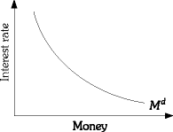

Difficulty: E Type: C

- Mary earns a monthly income of $3,000. She spends the entire amount each month at the rate of $100 a day. (Assume there are 30 days in the month.) The interest rate paid on bonds is 5% per month. It costs $10 every time Mary sells a bond.

(a) Describe briefly how Mary should go about deciding how much money to hold.
(b) Mary can switch from bonds to cash up to a maximum of three times. How many times should Mary switch from bonds to cash?
(c) What is Mary's optimal balance?

(a) Mary should determine how much money to hold by calculating the net profit from different levels of money holdings. If she holds more money in bonds, interest payments increase, but switching costs also increase.
(b) Mary should switch from bonds to cash two times.
(c) Mary's optimal money balance is $500.

Difficulty:D Type: A

- Explain what is meant by the "speculation motive" for holding money.

When interest rates are high (and the opportunity cost of holding money is high), individuals will reduce their money holdings. They may also expect that interest rates will be lower in the future. If interest rates are expected to drop in the future, individuals also expect that the value of bonds will rise in the future. To take advantage of this (i.e., speculate on this), individuals will hold more bonds and hold less money. This represents the speculation motive for holding money.

Difficulty: M Type: C

- Explain all of the determinants of money demand. Also include a brief explanation of how a change in each of these determinants would cause a reduction in money demand.

The four determinants are: income, price level, interest rate, and brokerage fees. Nominal money demand depends on the level of nominal transactions. A reduction in Y or P will cause a reduction in the level of nominal transactions and a reduction in nominal money demand. An increase in the interest rate will cause the return on bonds to be higher and, therefore, the opportunity cost of holding money to be higher. So, money demand will decrease. And finally, a reduction in brokerage fees would cause a reduction in money demand (see answer to the previous question for the explanation).

Difficulty: M Type: C

The Equilibrium Interest Rate

- Label each of the following events as either leading to an increase or a decrease in the equilibrium interest rate?
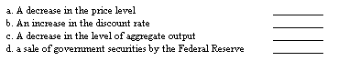

- Decrease – because it will cause a decrease in the demand for money.
- Increase – because it will increase the cost of borrowing money to commercial banks.
- Decrease – because it will cause a decrease in the demand for money.
- Increase – because it will reduce the supply of money.

Difficulty: E Type: D

- In simple terms how is the interest rate determined in the economy and explain why?

The interest rate is determined at the point at which the quantity of money demanded equals the quantity of money supplied. If interest rates were above this point then there would be an excess supply of money. That is, people would want to hold less money than the amount of money in supply. This would eventually result in a decline in the interest rate. If the interest rate is below the point where the point where the quantity demanded and supplied are equal then this would result in and excess demand for money. In this case the interest rate would rise to choke of this excess demand.

Difficulty: E Type: D

- Why is the money supply curve discussed in the book a vertical line?

Because it assumes that the Fed’s money supply behavior does not depend on the interest rate.

Difficulty: E Type: D

- What is meant by the term “excess supply of money?” How does the money market resolve this disequilibrium?

An excess supply of money means that at the prevailing interest rate the money supply exceeds the amount of money that the public wishes to hold. The money market resolves this by placing downward pressure on the interest rate.

Difficulty: E Type: D

- What is meant by the term “excess demand for money?” How does the money market resolve this disequilibrium?

An excess demand for money means that at the prevailing interest rate the amount of money the public wishes to hold exceeds the supply of money. The market resolves this by placing upward pressure on the interest rate.

Difficulty: E Type: D

- Draw the demand and the supply for money and identify the equilibrium interest rate. Make sure to draw a money supply curve that is independent of the interest rate. Draw the curves so that the equilibrium interest rate is 8%. Explain why interest rates above or below 8% are not stable.
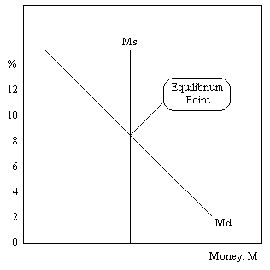
Interest rates above 8% create an excess supply of money and interest rates below create an excess demand for money. The former will place pressure on the interest rate to fall. The latter will place pressure on the interest rate to rise.

Difficulty: E Type: D

- Explain how people will switch between bonds and money if the interest rate is initially above the market-clearing level. Explain your answer in terms of opportunity costs.

If the interest rate is above the market-clearing level the interest rate will eventually fall, discouraging people from moving out of money into bonds. The opportunity cost of holding money is now lower.

Difficulty: E Type: D

- Explain how people will switch between bonds and money if the interest rate is initially below the market-clearing level. Explain your answer in terms of opportunity costs.

If the interest rate is below the market-clearing level the interest rate will eventually rise, discouraging people from moving out of bonds into money. The opportunity cost of holding money is now higher.

Difficulty: E Type: D

- Graphically demonstrate the effect on the equilibrium interest rate of an increase in the money supply by the Fed.
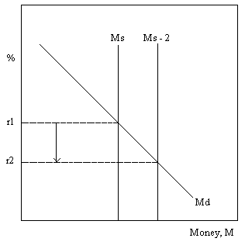

An increase in the money supply lowers the interest rate to squeeze out the excess supply of money.

Difficulty: E Type: D

- Assume for some reason that the demand for money has risen. In addition, the Fed has responded to this development by increasing the money supply. Explain why the movement of the interest rate is largely indeterminate. In other words, what information are we lacking in order to make a definitive statement about the direction of the interest rate?

The reason we cannot be sure as to the direction of the interest rate is that we must know the relative changes in the demand for money versus the change in the money supply. All other things equal the increase in the demand for money should increase the interest rate. However, an expansion of the supply of money should lower the interest rate. Unless we know the size of these changes we cannot determine whether the net impact on interest rates will portend a rise, a fall or no change.

Difficulty: E Type: D

- Graphically demonstrate the effect on the interest rate of a decrease of the money supply by the Fed.
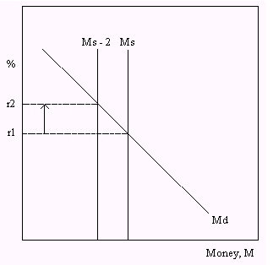

The decrease in the money supply raises the interest rate to “choke off” the excess demand for money.

Difficulty: E Type: D

- Explain with the use of a graph why the shape of the money demand curve makes a difference in terms of the effectiveness of monetary policy. (Hint: draw one money demand curve very steep and another very flat)
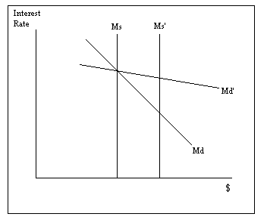

Given an expansion in the supply of money, the interest rate changes by a greater amount the steeper the demand for money is. Therefore, monetary policy will have a more pronounced effect along Md than along Md’.

Difficulty: E Type: D

- Graphically demonstrate how an increase in the level of aggregate output can have an impact on the money market and ultimately on the equilibrium interest rate.
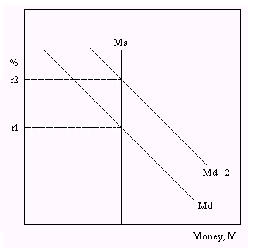

An increase in aggregate output will trigger an increase in the total demand for money because of the increased amount of transaction demand. This creates an excess demand at r₁, which will place upward pressure on the interest rate.

Difficulty: E Type: D

- Explain the effect of a reduction in the price level on the demand for money and the interest rate.

If the price level falls, the demand for money shifts to the left, because people need less money for their transactions. However, with an unchanged money supply this necessitates a fall in the interest rate.

Difficulty: E Type: D

- Use a graph to illustrate the effect an expansionary fiscal policy will have on the money market. What happens to the interest rate? What impact will this have on the effectiveness of fiscal policy?

An expansionary fiscal policy will increase the demand for money and increase the interest rate. If investment is sensitive to the interest rate, an increase in the interest rate may cause investment to fall. If consumption is sensitive to the interest rate, an increase in the interest rate may cause consumption to fall. Fiscal policy will not be as effective if investment and consumption are sensitive to the interest rate.

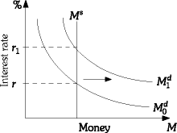

Difficulty: M Type: C

- Draw a graph of a money demand curve and a money supply curve. On the graph, indicate the equilibrium interest rate. Also indicate the new equilibrium interest rate if the Fed increases the money supply.

If the Fed increases the money supply, the interest rate will fall.
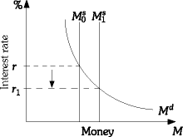

Difficulty: M Type: C

- Illustrate each of the following situations using supply and demand curves for money. In each case explain what happens to the equilibrium interest rate.

(a) Aggregate output increases.
(b) The Fed sells government securities in the open market during a recession.
(c) During a period of rapid growth, the Fed reduces the reserve requirement.

(a) The interest rate increases.

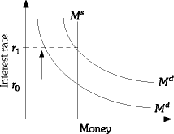

(b) The change in the equilibrium interest rate is indeterminate.

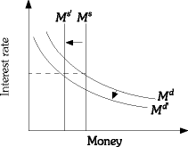

(c) The student should draw a graph as in part (b) where money supply increase and money demand increases. The change in the equilibrium interest rate is indeterminate. The increase in money demand will tend to increase interest rates and the increase in money supply would tend to reduce interest rates.

Difficulty: M Type: A

- What do economists mean when they say that there is an "excess supply of money" in the economy? Illustrate this situation graphically. If there is an excess supply of money, what happens to the interest rate? How does the change in the interest rate influence the trade-off between holding money and holding bonds?

An excess supply of money means that the quantity of money supplied exceeds the quantity of money demanded. An excess supply of money occurs when the interest rate is above the equilibrium interest rate. The interest rate should fall until quantity of money demanded equals quantity of money supplied. As the interest rate falls, the opportunity cost of holding money is reduced and money becomes more attractive. The lower interest rate will increase the price of bonds and bonds will become less attractive.

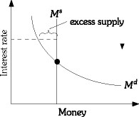

Difficulty: M Type: A

- Answer the following three questions dealing with monetary policy.

(a) Explain how the Federal Reserve might carry out a "tight" monetary policy.
(b) Explain how the Federal Reserve might carry out an "easy" monetary policy.
(c) How would each of the policies affect the equilibrium interest rate?

(a) A tight monetary policy means that the Fed is seeking to reduce the growth rate of the money supply. The Fed can implement a tight monetary policy by increasing the required reserve ratio, increasing the discount rate, or selling government bonds in the open market.
(b) An easy monetary policy means that the Fed is trying to increase the growth rate of the money supply. The Fed can implement an easy monetary policy by decreasing the required reserve ratio, decreasing the discount rate, or buying government bonds in the open market.
(c) A tight monetary policy will cause the interest rate to increase and an easy monetary policy will cause the interest rate to decrease.

Difficulty: M Type: A

- Joe has two investment opportunities. He can buy a two-year security today, hold onto it for two years, and then cash it in. The interest rate on the two-year security is 8%. Or Joe can buy a one-year security today. At the end of the year he can cash in the one-year security and buy another one-year security. The interest rate on the first one-year security is 7%. Explain under what circumstances it would be preferable for Joe to:

(a) buy the two-year security;
(b) buy the two one-year securities.
(c) Under what circumstance would Joe be indifferent between the two-year security and the two one-year securities?

(a) It would be preferable for Joe to buy the two-year security if the expected rate of return on the two one-year securities is less than the rate of return on the two-year security. If the expected interest rate on the second one-year security is less than 9%, then the expected rate of return on the two one-year securities is less than 8%, and Joe would prefer the two-year security.
(b) It would be preferable for Joe to buy the two one-year securities if the expected rate of return on the two one-year securities is greater than the rate of return on the two-year security. If the expected interest rate on the second one-year security is greater than 9%, then the expected rate of return on the two one-year securities is greater than 8% and Joe would prefer the two one-year securities.
(c) Joe will be indifferent between the two-year security and the two one-year securities if the expected rate of return on the two one-year securities is the same as the return on the two-year security. The two rates of return will be equal if the expected interest rate on the second one-year security is 9%.

Diff: 3
Type: A

- Explain what is meant by the "transactions motive" for holding money.

As income, for example, increases, individuals will purchase more goods and services. To facilitate the purchase of these goods and services, they will increase their demand for the asset that is used to obtain these goods and services (i.e., money). The effect of income on transactions and the higher transactions on money demand is referred to as the transactions motive.

Difficulty: M Type: C

- Explain what effect an increase in the brokerage fees associated with the purchase and sale of bonds will have on money demand and on the equilibrium interest rate.

An increase in brokerage fees will cause individuals to increase their holdings of money and reduce their holdings of bonds. The higher cost of converting money into bonds will increase their optimal balance of money. This is represented as a rightward shift in the money demand curve. This increase in money demand will cause an excess demand for money, and the interest rate will have to increase in order to clear the money market.

Difficulty: M Type: A

- Assume the money market is initially in equilibrium. Now suppose there is an increase in income. Explain what effect this increase in income will have on the equilibrium interest rate. Also explain what the Fed would have to do if it wants to prevent this change in Y from affecting the interest rate.

The increase in Y will cause an increase in money demand and an excess demand for money. The excess demand for money will cause individuals to reduce their bond holdings. This will cause an increase in the interest rate. If the Fed wishes to prevent any change in the interest rate, it would have to increase the money supply as money demand increased. Specifically, all of the increase in money demand would have to be offset by an equal increase in money supply.

Difficulty: M Type: A

- Suppose there is an excess demand for money. Explain what will happen in the money market as a result of this.

In this situation, individuals will want to reduce their holdings of bonds and increase their holdings of money. In this situation, the interest rate will increase to restore equilibrium.

Difficulty: E Type: C

- What is meant by the term structure of interest rates?

The term structure of interest rates illustrates the relationship between the yields to maturity on bonds and the maturity of the bonds.

Difficulty: E Type: D

- Assume the money market is initially in equilibrium. Now, suppose the Fed sells bonds. Graphically illustrate and explain what effect this Fed open-market sale of bonds will have on the money market.

The Fed sale of bonds will cause a reduction in the money supply. This is represented by the leftward shift in the money supply curve. At the initial interest rate, there is an excess demand for money. This will cause an increase in the interest rate from r0 to r1. The interest rate will continue to rise until the excess demand for money is eliminated.

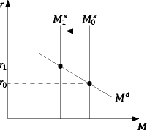

Difficulty: M Type: A

- Assume the money market is initially in equilibrium. Now, suppose that the aggregate price level falls. Graphically illustrate and explain what effect this reduction in the aggregate price level will have on the money market.

The reduction in the price level will cause a reduction in the nominal level of transactions. As the level of transactions falls, money demand will fall. This is represented by the leftward shift in the money demand curve. At the initial interest rate, there is an excess supply of money. This excess supply of money will cause a reduction in the interest rate from r0 to r1. The interest rate will continue to fall until the excess supply of money is eliminated.
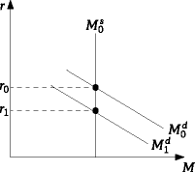

Difficulty: M Type: A

Looking Ahead: The Federal Reserve and Monetary Policy

- Explain what is meant by a “tight monetary policy?”

It is any set of policies that contract the money supply in an effort to restrain the economy.

Difficulty: E Type: D

- Explain what is meant by an “easy monetary policy?”

It represents any set of policies that expand the money supply in an effort to stimulate the economy.

Difficulty: E Type: D

- Briefly explain the concept of the “term structure of interest rates.”

The “term structure of interest rates” is the relationship between the interest rates offered on securities of different maturities.

Difficulty: E Type: D

- What is the rational thing for an investor to do if the interest rate on one-year securities is currently 8% and the interest rate on the two-year securities is 9%? Explain why you would need more information to answer this question properly.

Investors must form expectations of the interest rate on a one-year security one year from now. If you expect the one-year rate to remain the same then you should buy two-year securities. You will earn a higher return. If you expect the one-year rate to rise 12% then you should buy the one year security now, hold it for a year sell it and buy the one-year security next year. The expected rate of return is better now at 10%.

Difficulty: D Type: C

- Explain the expectation theory of the term structure of interest rates. Explain in terms of one-year and two-year securities.

The interest rate on two-year securities will either rise or fall until people are once again indifferent between one two-year security and two one-year securities. That is, the interest rate on the two-year security will rise or fall until it is equal to the average of the current one-year rate and the expected one-year rate for next year.

Difficulty: D Type: C

- It is clear that the Fed can affect short-term interest rates by changing the money supply. Can it also affect long-term interest rates? That is, if it can affect the interest rate on a one-year security can it also affect the interest rate on a two-year security? If so, explain your reasoning.

The answer is that it can do so indirectly. Because the two-year rate is an average of the current one-year rate and the expected one-year rate a year from now, the Fed influences the two-year rate to the extent that it influences the current one-year rate (and the expected future rate on one-year securities).

Difficulty: D Type: C

- How can the Fed affect future short-term interest rates through expectations?

If the Fed testifies before Congress or if the Fed chairman grants an interview before the media indicating that it is thinking about raising short-term interest rates, people’s expectations of higher future short-term interest rates are likely to increase. These expectations will then be reflected in current long-term interest rates.

Difficulty: D Type: C

- What is a Treasury bill?

A Treasury bill is a government security that matures in less than a year.

Difficulty: E Type: D

- What are government bonds? Identify the different types of bonds.

Government bonds are securities with terms of one year or more. There are 1-year bonds, 2-year bonds, and so on up to 30-year bonds.

Difficulty: E Type: D

- What is the federal funds rate?

If one bank has excess reserves, it can lend some of those reserves to other banks through the federal funds market. The interest rate in this market is called the federal funds rate.

Difficulty: E Type: D

- What is commercial paper and upon what does the interest rate depend?

Commercial paper is simply short-term corporate IOUs. The interest rate offered on them depends on the financial condition of the firm and maturity date of the IOU.

Difficulty: E Type: D

- What is the prime rate?

The prime rate is a benchmark that banks often use in quoting interest rates to their customers. It typically is the interest rate that it offers to its low-risk customers. Many other interest rates are often tied to this benchmark.

Difficulty: E Type: D

- What is the AAA corporate bond rate?

Corporate bonds are classified by various bond dealers according to their risk. The AAA corporate bond rate is the interest rate that the least risky firms pay on the bonds that they issue.

Difficulty: E Type: D

