The Links Between the Goods Market and the Money Market

- Describe in broad terms what the goods market is.

The market in which goods and services are exchanged and in which the equilibrium level of aggregate output is determined.

Difficulty: E Type: D

- Describe in broad terms what the money market is.

The market in which financial instruments are exchanged and in which the equilibrium level of the interest rate is determined.

Difficulty: E Type: D

- Discuss the two links between the goods market and the money market.

The first link exists because the demand for money depends on income. As aggregate output increases so does income. With the interest rate held constant this leads to an increase in money demand. The second link is between planned investment spending and the interest rate. In general, the higher the interest rate, the lower the level of planned investment and vice versa.

Difficulty: E Type: D

- Assume that the investment demand function is represented by the following algebraic function: I = $300 - 2000r where $300 represents autonomous investment and "r" represents the interest rate. Calculate how high the interest rate would have to rise to drive planned investment to zero. Calculate the amount of investment that would take place at an interest rate of zero.

Setting the investment equation to zero yields 0 = 300 - 2000r. Rearranging the equation yields 2000r = 300. Solving for r gives us 300/2000 or 15%. At an interest rate of zero the amount of investment would be $300. This represents autonomous investment.

Difficulty: M Type: A

- As interest rates increase what happens to planned investment and aggregate expenditures?

Planned investment decreases and aggregate expenditure decreases.

Difficulty: E Type: C

- Suppose the investment demand function is given as the following algebraic function: I = 300 - 1000r where r is the interest rate. Calculate the amount of investment that would take place at an interest rate of ten percent. How much investment would there be if interest rates rose to fifteen percent?

The level of investment at a ten percent interest rate would be 300 - 1000(.10) = 200. If the interest rate rises to fifteen percent the level of investment will fall to 300 - 1000(.15) = 150.

Difficulty: E Type: D

- Draw a flowchart showing the impact of an increase in interest rates on planned investment, planned aggregate expenditures and equilibrium output.
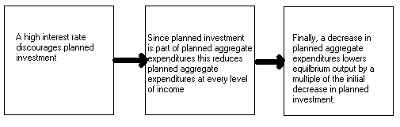

Difficulty: E Type: D

- Draw an aggregate expenditure function illustrating the effect of an increase in the interest rate.
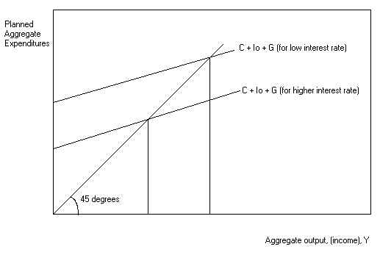
Difficulty: E Type: D

- Assume the following graph for money supply and money demand. Explain the adjustment process that would take place in this money market if the interest rate is 12 percent. Make sure that your answer includes a discussion of what happens to money balances and bond prices.
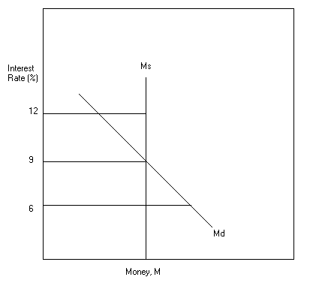
If the interest rate is 12 percent then the quantity of money in circulation will exceed the amount that households will want to hold. This excess supply of money will cause the interest rate to drop as people try to shift their funds into interest bearing bonds. The increased demand for bonds will bid their price up; i.e., the interest rate will drop.

Difficulty: E Type: D

- Assume the money supply is set by the Fed at $1000 billion and the money demand function is represented by the following algebraic equation Md = 3000 - 20000r, where r = the interest rate. Calculate the interest rate which will clear this money market.

The market clears when the quantity of money demanded is equal to the quantity of money supplied. Set 1000 = 3000 - 20000r. Rearranging terms yields 20000r = 2000. Solving for r gives us 2000/20000 or 10%.

Difficulty: E Type: D

- If the amount of money demanded by household and firms is less than the amount in circulation as determined by the Fed what will happen to the rate of interest and why?

The equilibrium interest rate will fall to rid the money market of the excess supply of money.

Difficulty: E Type: D

- Graphically illustrate the relationship between interest rate changes and the level of planned investment.

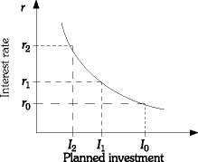

Difficulty: E Type: C

- Graphically illustrate the impact of a decrease and increase in the interest rate on aggregate expenditure. On your graph, illustrate the impact of an increase and decrease in the interest rate upon aggregate expenditure. Summarize the relationship among changes in the rate of interest (r), the change in planned investment spending (I), its impact on the aggregate expenditure function (AE), and the multiple effect on income (Y).

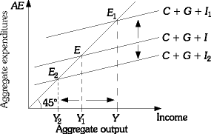

As r↓ ⇒ I↑ ⇒ AE↑ ⇒ Y↑ and as r↑ ⇒ I↓ ⇒ AE↓ ⇒ Y↓.

Difficulty: M Type: C

- Using the money market model, graphically illustrate the relationship among income changes, the demand for money, and the changes in the rate of interest. Summarize the relationship among the level of income (Y), the demand for money (Md), and the rate of interest (r).

As illustrated in the following figure, an increase income will increase the downward sloping demand for money and result in a rightward parallel shift in the money demand, for example from money demand M0 to M1, which will increase the rate of interest. A decrease in income will lessen the demand for money, for example from money demand M0 to M2, and result in a leftward parallel shift in the money demand, which will lower the rate of interest.

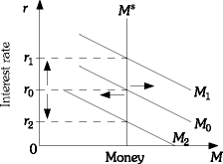

Y↑ ⇒ Md↑ ⇒ r↑

Difficulty: M Type: C

Combining the Goods Market and the Money Market

- Assume that money demand is perfectly elastic. What implications would this have for an expansionary monetary policy?

It would mean that monetary policy would be ineffectual in stimulating the economy. The reason is that changes in the money supply would have no impact on interest rates and therefore no impact on investment and GDP.

Difficulty: E Type: D

- Describe the chain of events that are likely to unfold when the government reduces net taxes. Explain your answer in terms of its impact on aggregate output, the demand for money, the interest rate and planned investment

Aggregate output will increase, the demand for money increases which places pressure on the interest rate to rise. This in turn causes planned investment to decline and causes aggregate output to decrease, offsetting some of the initial increase in output.

Difficulty: E Type: C

- Describe expansionary fiscal policy.

It is an increase in government spending or a reduction in net taxes aimed at increasing aggregate output.

Difficulty: E Type: D

- Describe expansionary monetary policy.

It is an increase in the money supply aimed at increasing aggregate output.

Difficulty: E Type: D

- How does monetary policy affect the goods market?

It affects the goods market by changing the interest rate which changes planned investment and interest-sensitive consumption like automobile purchases and major appliances.

Difficulty: E Type: C

- Did the anti-recession policies of 1974-1975 and 1980-1982 produce a crowding-out effect? Why or why not?

No they did not because the Federal Reserve simultaneously increased the money supply.

Difficulty: E Type: D

- Explain the chain of events that results from an expansionary monetary policy. Explain your answer in terms of its impact on money supply, aggregate output, the demand for money, the interest rate and planned investment. Be sure to include any feedback effects in your answer.

The money supply increases which places downward pressure on the interest rate. The lower interest rate stimulates planned investment and aggregate output. This in turn increases the amount of money demand. This in turn may cause interest rates to fall by less than they otherwise would had there been no feedback effect from the increased demand for money.

Difficulty: E Type: D

- Explain the "crowding-out effect."

It is the tendency for increases in government spending to cause reductions in private investment spending.

Difficulty: E Type: D

- What action could the Fed take to reduce the crowding-out effect of an expansionary fiscal policy?

The Fed could increase the money supply at the same time the federal government increases government spending. This will have the effect of keeping interest rates from rising as fast as they otherwise would, thus reducing the crowding-out effect.

Difficulty: E Type: D

- What are the two primary things on which the size of the “crowding-out” effect depend?

One is the sensitivity of planned investment to changes in the interest rate and the other is the sensitivity of money demand to changes in the interest rate.

Difficulty: E Type: D

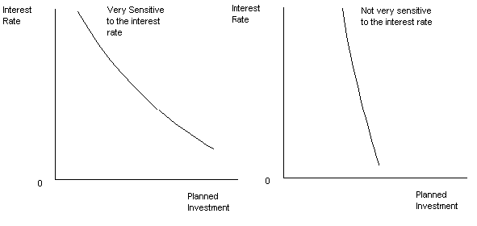
- Draw two investment demand curves: one that is very sensitive to the interest rate and one that isn't.

Difficulty: E Type: D

- Explain how the crowding out effect can be softened by the Federal Reserve accommodating an expansionary fiscal policy.

Expansionary fiscal policy generally increases the demand for money and hence the interest rate. If the Federal Reserve accommodates this policy by increasing the money supply the interest rate need not rise. Therefore, there need not be a crowding out effect.

Difficulty: E Type: C

- Explain how the sensitivity of investment to the interest rate can have a bearing on the amount of crowding out that results from an expansionary fiscal policy.

The more sensitive investment is to a given change in the interest rate the stronger the crowding out effect. As investment becomes less sensitive to a given change in the interest rate this mitigates the amount of crowding out.

Difficulty: E Type: C

- How much crowding out would be expected from an expansionary fiscal policy if investment was completely insensitive to the interest rate: that is independent of the interest rate? Explain your answer.

There would be no crowding out at all if investment were unaffected by changes in the interest rate. This is because investment would remain the same regardless of the concomitant change in the interest rate.

Difficulty: E Type: D

- Using the short-hand symbols G, Y, Md, r and I to demonstrate the effects of an expansionary fiscal policy.

G↑ → Y↑ → Md↑ → r↑ → I ↓ → Y↑ but less than if r did not increase.

Difficulty: E Type: C

- Using the short-hand symbols Ms, r, I, Y, and Md to demonstrate the effects of an expansionary monetary policy.

Ms↑ → r↓ → I ↑ → Y↑ → Md↑ which causes r to decrease less than if Md did not increase.

Difficulty: E Type: C

- Explain the only circumstance in which expansionary monetary policy is likely to be effective. Hint: Use the linkage between the interest rate and investment spending to explain your answer.

Monetary policy can be effective only if investment reacts to changes in the interest rate. If firms increase the number of investment projects considerably when the interest rate falls, expansionary monetary policy works well at stimulating the economy.

Difficulty: E Type: D
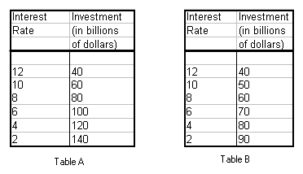

- According to the two investment demand schedules above which will allow an expansionary monetary policy to have its greater impact? Why?

Table A's investment demand schedule will allow the expansionary monetary policy to have a greater impact because any given change in the interest rate has a much larger impact on investment and hence aggregate expenditures than does Table B's investment demand schedule.

Difficulty: M Type: A

- Assume investment demand is independent of the interest rate. Explain why an expansionary monetary policy designed to drive the interest rate to zero may not be enough to stimulate the economy.

If investment demand is independent of the interest rate no amount of drop in the interest rate will increase investment. Therefore, even if interest rates were to drop to zero this would not be enough to stimulate the economy.

Difficulty: E Type: D

- Draw an investment demand curve that would render monetary policy completely ineffectual. Make sure to explain why it looks the way it does.
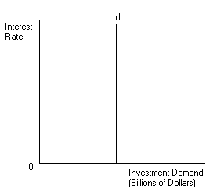

This investment demand curve would render monetary policy completely ineffectual because no amount of change in the interest rate would bring about changes in the level of investment spending. Aggregate expenditures would be left unchanged.

Difficulty: E Type: A

- What will be the impact on money demand, the interest rate and the level of planned investment if the government increases spending?

Money demand will rise which will place pressure on interest rates to rise which will lower the amount of planned investment.

Difficulty: E Type: C

- Explain what is meant by a contractionary fiscal policy.

It is a decrease in government spending or an increase in net taxes aimed at decreasing aggregate expenditure.

Difficulty: E Type: D

- Explain what is meant by a contractionary monetary policy.

It is a decrease in the money supply aimed at decreasing aggregate output.

Difficulty: E Type: D

- Using short-hand symbols, explain the effects of a contractionary fiscal policy.

G↓ or T↑ → Y↓ → Md↓ → r↓ → I ↑ → Y decreases less than if r did not decrease.

Difficulty: E Type: D

- Using short-hand symbols, explain the effects of a contractionary monetary policy.

Ms↓ → r↑ → I↓ → Y↓ → Md↓ → r increases less than if Md did not decrease.

Difficulty: E Type: D

- Describe the sequence of events that occurs in response to a contractionary fiscal policy. Explain in terms of the impact on aggregate output, money demand, interest rates and planned investment.

Aggregate output decreases which in turn causes money demand to decrease. This places pressure on the interest rate to fall which in turn causes planned investment to increase.

Difficulty: E Type: D

- Describe the sequence of events that occurs in response to an expansionary monetary policy. Explain in terms of the impact on aggregate output, money demand, interest rates and planned investment.

Aggregate output increases which in turn causes money demnad to increase. This places pressure on the interest rate which inturn causes planned investment to decrease.

Difficulty: E Type: D

- Explain the impact upon the crowding-out effect if the Federal Reserve changes the money supply when government spending increases.

The increase in government spending increases the demand for money. However, the rate of interest would not increase and result in a decrease in investment spending if the Federal Reserve increased the supply of money. An increase in the money supply would stabilize the rate of interest, not adversely change investment spending, and the multiplied impact of increased government spending on income would be at its greatest.

Difficulty: M Type: A

- Discuss the impact of an increase in the money supply upon the goods and money markets. What most importantly determines the effectiveness of monetary policy?

The increase in the money supply will decrease the rate of interest, which will increase investment spending. As a result, production output and income will rise, which will increase the demand for money and contribute to upward pressure on the rate of interest. The effectiveness of monetary policy is most importantly dependent upon the sensitivity of investment spending to changes in the rate of interest.

Difficulty: M Type: A

- Summarize the effects of a contractionary fiscal policy where government spending (G) and/or taxes (T) are changes upon output and income (Y), the demand for money (Md), the rate of interest (r), and investment spending (I).

A contractionary fiscal policy can be summarized as:

G↓ or T↑ ⇒ Y↓ ⇒ Md↓ ⇒ r↓ ⇒ I↑

Difficulty: M Type: A

- Summarize the effects of a contractionary monetary policy where the change in the money supply (Ms) impacts upon the rate of interest (r), investment spending (I), output and income (Y), and the demand for money (Md).

A contractionary monetary policy can be summarized as:

Ms↓ ⇒ r↑ ⇒ I↓ ⇒ Y↓ ⇒ Md↓

Difficulty: M Type: A

- In addition to the rate of interest, what other conditions affect the level of planned investment? Explain how these factors affect planned investment spending.

Other determinants of planned investment include:
(a) Expectations regarding business and overall economic conditions
(b) Capital utilization rates
(c) Relative labor and capital costs

Planned investment will likely increase if the economy is expected to expand, when the firm's capital utilization rates are high, and if the cost of labor is high compared to the cost of capital. In contrast, planned investment will likely lessen if the economic future is bleak, if the firm's capital utilization rates are low, and if the cost of labor is low compared to the cost of capital.

Difficulty: M Type: C

- What is determined in the goods market? What is determined in the money market? Explain the two links between the goods market and the money market.

The equilibrium level of output is determined in the goods market. The equilibrium interest rate is determined in the money market. The link from the goods market to the money market is changes in the level of output, which will affect the demand for money and the equilibrium interest rate. The link from the money market to the goods market is changes in the interest rate, which will affect the level of planned investment and the equilibrium level of output.

Difficulty: E Type: D

- Summarize the effects of an expansionary fiscal policy in the aggregate expenditure model. That is graphically illustrate the effects of an expansionary fiscal policy on the equilibrium level of output.

An expansionary fiscal policy increases the level of government spending, increases aggregate output, increases the demand for money, increases the interest rate, decreases planned investment and decreases aggregate output. The final increase in aggregate output is reduced because of the crowding-out effect.

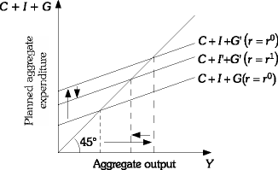

Difficulty: E Type: C

- Define the crowding-out effect. What factors can influence the extent to which crowding-out occurs when the government implements an expansionary fiscal policy?

The crowding-out effect is the tendency for increases in government spending to cause reductions in private investment spending. The two factors that influence the size of the crowding-out effect are the interest sensitivity of investment demand and whether or not the Fed accommodates the expansionary fiscal policy by increasing the money supply. The more sensitive planned investment is to the interest rate, the larger the crowding-out effect. If the Fed increases the money supply at the same time the government is increasing government spending, the amount by which the interest rate increases will be reduced and the crowding-out effect will be reduced.

Difficulty: E Type: D

- Explain why the effectiveness of an expansionary monetary policy in increasing aggregate output is partially dependent on the interest sensitivity of the demand for money.

As the money supply is increased, the interest rate decreases, planned investment increases, and the equilibrium level of output increases. The effectiveness of expansionary monetary policy in reducing the interest rate will depend on how much the interest rate is reduced as a result of the increase in the money supply. If the demand for money is perfectly elastic with respect to the interest rate, a change in the money supply will have no effect on the interest rate. The more inelastic the demand for money, the larger the reduction in the interest rate from a given change in the money supply. The larger the change in the interest rate, the larger the potential increase in investment and aggregate output.

Difficulty: M Type: C

- Explain when fiscal policy is more effective in changing equilibrium output.

The smaller is the crowding-out effect, the less is the impact of government spending on investment. Thus, the less sensitive the planned investment schedule is to changes in the interest rate, the greater the effectiveness if fiscal policy.

Difficulty: M Type: C

- Indicate the effect of each of the following policies on the variables: Y, C, S, r, I, Ms, and Md.

(a) The government reduces the personal income tax rates.
(b) Firms become more pessimistic about future sales.

(a)The decrease in personal income tax rates will increase disposable income, so consumption and saving will increase. The increase in consumption will increase aggregate output, which will increase the demand for money. The increase in the demand for money will increase the interest rate. The increase in the interest rate will cause planned investment to decrease and aggregate output to decrease, and the final increase in aggregate output is less than it would have been if the interest rate did not increase. Money supply will not change.
(b) If firms become pessimistic about future sales, planned investment will decrease, aggregate output will decrease, consumption and saving will decrease, the demand for money will decrease, the interest rate will decrease, planned investment will increase, and aggregate output will increase. Money supply will not change.

Diff: 2
Type: A

- How can monetary policy be used to reduce the impact of the crowding-out effect?

When the government increases spending, the interest rate increases and planned investment decreases. In this case, the Fed can implement an expansionary monetary policy to decrease the interest rate to offset the upward pressure on interest rates caused by the increase in government spending.

Difficulty: M Type: A

- Between the spring of 1990 and the spring of 1991, interest rates in the United States dropped nearly two full percentage points, but this did not have much of an effect on investment spending plans. Explain how this could happen. Draw a graph of the investment demand schedule that would represent this situation. During this time period would an expansionary monetary policy have been an effective way to stimulate the economy? Explain.

A drop in the interest rate wouldn't have an effect on the level of planned investment if investment was not sensitive to the interest rate. Investment at that time may have depended more on a firm's expectation of future sales, capital utilization rates, and the cost of capital relative to labor. An expansionary monetary policy would not have been an effective way to stimulate the economy because a reduction in the interest rate did not increase planned investment and therefore, there could have been no change in aggregate output.

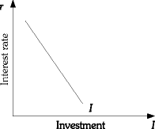

Difficulty: M Type: F

- Discuss what is meant by the crowding-out effects of fiscal policy.

A fiscal expansion causes an increase in output and an increase in money demand. As money demand increases, we will observe an increase in r. As r rises, firms will reduce investment. The reduction in investment caused by, for example, the increase in G is referred to as the "crowded-out" investment.

Difficulty: M Type: A

- Suppose investment becomes more responsive to (i.e., sensitive to) changes in the interest rate. What effect will this have on the effectiveness of monetary policy? Specifically, what will happen to the output effects of a given change in the money supply?

The effectiveness of monetary policy will increase. A given increase in the money supply will cause r to fall. If investment is relatively interest rate sensitive, we will observe a larger increase in AE and a larger increase in output.

Difficulty: E Type: A

- Suppose investment becomes less responsive to (i.e., sensitive to) changes in the interest rate. What effect will this have on the effectiveness of fiscal policy? Specifically, what will happen to the output effects of a given change in government spending?

The effectiveness of fiscal policy will increase. The answer to this question is related to the crowding-out effects of fiscal policy. A fiscal expansion will cause an increase in Y and an increase in r. The higher r will cause a reduction in I partially offsetting the increase in G. If I does not fall as much, there will be less crowding-out and the increase in Y will be larger.

Difficulty: M Type: A

- Graphically illustrate and explain the effects of a reduction in the money supply on the equilibrium interest rate, investment, and equilibrium output. Clearly label all curves and the initial and final equilibria.

The reduction in the money supply will cause an excess demand for money at the initial interest rate. This excess demand for money will cause the interest rate to rise. As r rises, firms will reduce investment. The reduction in investment will cause a reduction in planned aggregate expenditures. The drop in AE causes the AE curve to shift down. As inventories rise, firms will reduce production. The drop in income will reduce the level of transactions and cause a leftward shift in the money demand curve. This reduction in money demand will partially offset the effects of the lower money supply on the interest rate. The initial equilibrium is represented by point E0 and the final equilibrium is represented by point E1.

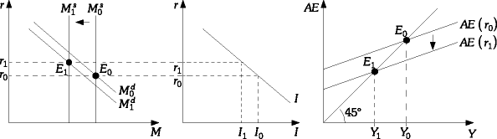

Difficulty: D Type: A

- Graphically illustrate and explain the effects of a reduction in government spending on the equilibrium interest rate, investment, and equilibrium output. Clearly label all curves and the initial and final equilibria. Does any crowding-out take place when government spending falls? Explain.

The reduction in government spending will cause the AE curve to shift down. As AE falls, firms reduce output. This drop in income causes a reduction in the level of transactions and, therefore, a reduction in money demand. As money demand falls, there is an excess supply of money. This excess supply of money will cause a reduction in the interest rate. As r falls, investment will increase partially offsetting the drop in G. The final equilibrium is represented by point E1. Is there crowding out here? In a sense, yes. There is negative crowding out or, alternatively, crowding in of investment. The drop in G causes a lower r. This lower r results in an increase in investment. This is the opposite of the crowding-out effects discussed before.

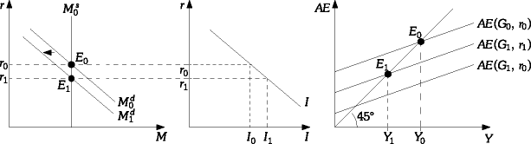

Difficulty: D Type: A

- Suppose the Federal Reserve pursues expansionary monetary policy at the same time a reduction in taxes occurs (i.e., a fiscal expansion). Explain what effects this combination of monetary and fiscal policy will have on the macroeconomy.

The increase in M would cause lower r, higher I, and an increase in output. The lower taxes would raise consumption, raise AE, increase output, raise r, and reduce I. The effects on output are unambiguous. Both policies will result in higher income. The effects on the interest rate and, therefore, investment will depend on the relative magnitude of the two policies. If the monetary policy dominates, r will fall and I will increase. If the tax cut dominates, the opposite will occur.

Difficulty: D Type: A

- Explain the two key links between the goods market and the money market.

The first key link is between income and the demand for money. As Y increases, the number of transactions requiring the use of money increases. The second key link is between planned investment spending and the interest rate. The higher the interest rate, the lower the level of planned investment spending.

Difficulty: D Type: A

- Briefly explain what type of policy mix existed in the United States in 1980-82. What effect did this policy mix have on the interest rate and investment?

During this period, the Fed was pursuing contractionary monetary policy. At the same time, fiscal policy was expansionary as a result of the increase in G and reduction in taxes. This policy mix caused the interest rate to rise and, therefore, investment to fall.

Difficulty: M Type: F

- Explain what is meant by the "mix of macroeconomic policy" and explain how it can affect the level and composition of output (i.e., GDP).

The mix of macro policy refers to the combination of monetary and fiscal policy. Monetary (and fiscal) policy can be either expansionary or contractionary. The stance of either policy will determine the interest rate, the level of investment, and the level of economic activity. In terms of output, monetary and fiscal policy can work together (both expansionary or both contractionary); in this case Y will either increase or decrease. If monetary policy is contractionary and fiscal policy is expansionary, the effects on Y will be uncertain; however, the interest rate will clearly rise and I will clearly fall. So, the mix of policy can affect the level of output. It can also affect the composition of output. Y might stay the same, but more of Y might be allocated to consumption and less to investment because of a particular policy.

Difficulty: D Type: A

Other Determinants of Planned Investment

- What is a policy mix?

It is the combination of monetary and fiscal policies in use at a given time.

Difficulty: E Type: D

- Discuss the effects of a policy mix of an expansionary fiscal policy and an expansionary monetary policy on output and interest rates. Is there any ambiguity with regard to the effect on interest rates and why?

The policy mix will cause aggregate output to increase. Interest rates may either increase, decrease or remain unchanged. The reason for the ambiguity is that the effect on interest rates depends on the relative magnitude of the change in the supply of money and the magnitude of change in fiscal policy.

Difficulty: E Type: C

- What would be the policy mix that would cause the interest rate to increase, and investment to decrease but have an indeterminate effect on aggregate output?

An expansionary fiscal policy and a contractionary monetary policy would cause the interest rate to rise, investment demand to decrease but would have an indeterminate effect on aggregate demand.

Difficulty: E Type: C

- Explain why changes in the goods market may have side effects in the money market.

If the goods market were to expand, this could cause an increase in the demand for money which will cause interest rates to rise. This could partially offset some of the expansionary effect of the goods market.

Difficulty: E Type: C

Other Determiants of Planned Investment

- Explain the role of expectations and "animal spirits" on investment decisions.

If a firm expects that its sales will increase in the future, it may begin to build up its capital stock now so that it will be able to produce more in the future. Pessimistic expectations would of course work in the opposite direction. Keynes used the phrase animal spirits to describe the optimistic or pessimistic feelings of entrepreneurs, and he argued that these feelings affect investment decisions.

Difficulty: E Type: C

- Would each of the following cause planned investment to increase or decrease?

(a) Owners of firms become more optimistic about their future sales.
(b) The degree of utilization of a firm's capital stock is very low.
(c) The cost of capital relative to the cost of labor increases.

(a) If the owners of firms become more optimistic about sales, planned investment will increase.
(b) If the degree of capital utilization is very low, planned investment will be low.
(c) If the cost of capital increases relative to the cost of labor, planned investment will fall.

Difficulty: M Type: A

- List four determinants of planned investment.

The interest rate, expectations of future sales, capital utilization rates and relative capital and labor costs.

Difficulty: E Type: F

- Explain how capital utilization rates can have an impact on the investment of new capital.

It can be costly to get rid of capital quickly once it is in place. Therefore, firms sometimes respond to a fall in output by keeping the capital in place and utilizing it less. Firms tend to invest less in new capital when their capital utilization rates are low than when they are high.

Difficulty: M Type: C

- Explain how the relative labor and capital costs have an impact on the acquisition of new capital.

If labor is expensive relative to capital (high wage rates), firms tend to substitute away from labor toward capital and vice versa.

Difficulty: M Type: C

- Draw the IS curve and explain its shape.
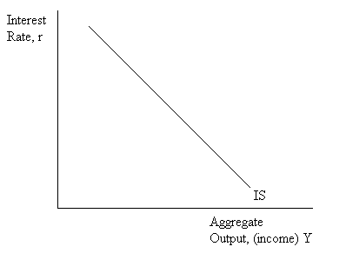

Each point on the IS curve represents the equilibrium income in the goods market for the given interest rate.

Difficulty: E Type: A

- Draw the LM curve and explain its shape.

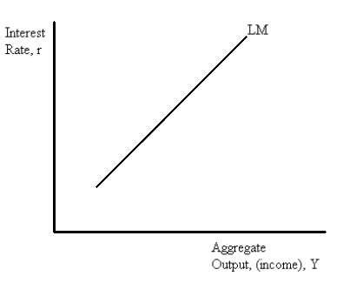
Each point on the LM curve corresponds to the equilibrium interest rate in the money market for the given value of aggregate output (income).

Difficulty: E Type: A

- Draw the IS and LM curve on one graph. Explain the significance of the point of intersection of these two functions.
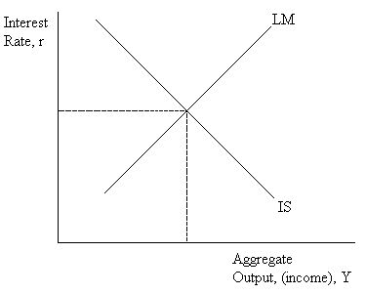

The point at which the IS and LM curve intersect corresponds to the point at which both the goods market and the money market are in equilibrium.

Difficulty: E Type: D

- What does each point on the IS curve represent? What does each point on the LM curve represent? Using the IS-LM diagram, explain how equilibrium output is determined. On the graph, illustrate the effect of an increase in the money supply. Explain how this change affects the equilibrium level of output and the interest rate.

Each point on the IS curve represents the equilibrium point in the goods market for the given interest rate. Each point on the LM curve represents the equilibrium point in the money market for the given value of aggregate output. The intersection of the IS and LM curves determines the equilibrium level of aggregate output and the equilibrium interest rate. An increase in the money supply will shift the LM curve to the right. The equilibrium level of output will increase and the equilibrium interest rate will decrease.

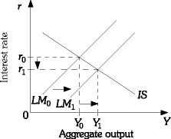

Difficulty: M Type: D

