The Aggregate Demand Curve

- Define aggregate demand.

Aggregate demand is the total demand for goods and services in the economy.

Difficulty: E Type: D

- Explain how aggregate quantity-demanded falls when the price level increases and the impact this has on interest rates and aggregate output.

Aggregate quantity-demanded falls when the price level increases because the higher price level causes the demand for money to rise. With the money supply constant, the interest rate will rise to reestablish equilibrium in the money market. It is the higher interest rate that causes aggregate output to fall.

Difficulty: E Type: D

- Discuss how the consumption link provides another explanation for the downward-sloping aggregate demand curve.

Other things equal, consumption expenditures tend to rise when the interest rate falls and to fall when the interest rate rises. For example, an increase in the price level increases the demand for money, which leads to an increase in the interest rate, which leads to a decrease in consumption, which leads to a decrease in aggregate output.

Difficulty: E Type: D

- Discuss why the logic that explains why a simple demand curve slopes downward fails to explain why the AD curve also has a negative slope.

In deriving a simple demand curve we assume that the price of all other goods and income are held constant. Neither of these assumptions hold true for an aggregate demand curve. When the overall price level rises for instance, many prices, wages and income rise together.

Difficulty: E Type: D

- Explain the real wealth effect as it pertains to the downward-sloping nature of the aggregate demand curve.

The real wealth effect is the change in consumption brought about by a change in real wealth that results from a change in the price level. When the price level falls, this increases the real value of wealth, which induces further consumption, and vice versa.

Difficulty: E Type: D

- How does planned aggregate expenditure relate to aggregate demand?

At every point along the aggregate demand curve, the aggregate quantity demanded is exactly equal to planned aggregate expenditure, C + I + G.

Difficulty: E Type: D

- On a graph show the effect on the aggregate demand curve of an increase in the money supply.
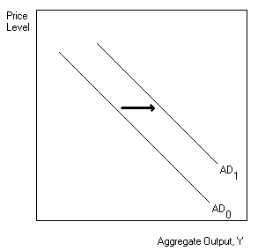

Difficulty: E Type: D

- Show the effect on the aggregate demand curve of an increase in government purchases or a decrease in net taxes.

Difficulty: E Type: A

- Define the aggregate demand curve. Explain the impact of an increase in the price level on the level of aggregate output.

The aggregate demand curve represents the total demand for goods and services in the economy at a given time period. An increase in the price level increases the demand for money, which results in an increase in the rate of interest and a decrease in investment spending. The decrease in overall investment spending contributes to a decrease in equilibrium output (income) with increased unemployment.

Difficulty: E Type: D

- Using the models for the money market, investment demand and aggregate output, graphically illustrate the impact of the increase in the price level upon equilibrium output.

The impact of an increase in the price level on aggregate output and income is illustrated in the following figure. The increased price level has a multiplied contractionary impact on the economy.
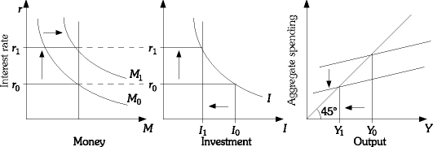

Difficulty: E Type: C

- Explain the consumption link. Summarize the consumption link with regard to a decrease in the price level.

A change in the price level impacts on the demand for money, which then changes the rate of interest. The change in the rate of interest inversely affects both planned investment and consumption spending. This change in consumption results in a change in output and income and illustrates another link between the money and goods markets. The consumption link with regard to a decrease in the price level would be: P↓ ⇒

Md↓ ⇒ r↓ ⇒ C↑ ⇒ Y↑

Difficulty: Type: C

- Explain the real wealth effect on aggregate demand. Summarize the real wealth effect with regard to an increase in the price level.

The real wealth effect measures the impact of a price change on the real value of wealth and its subsequent effect upon consumption and output. An increase in the price level will lower the real value of wealth which will result in less consumption spending. This will contribute to less production and an overall decrease in output and income.

Difficulty: M Type: D

- Summarize the impact of fiscal and monetary policies on the aggregate demand function.

Expansionary Monetary Policy: An increase in Ms will shift AD to the right. Expansionary Fiscal Policy: An increase in G and/or a decrease in T will shift AD to the right. Contractionary Monetary Policy: A decrease in Ms will shift AD to the left. Contractionary Fiscal Policy: A decrease in G and/or an increase in T will shift AD to the left.

Difficulty: E Type: C

- An economy's aggregate demand curve is derived by horizontally summing the market demand curves for all the products consumed in the economy. Do you agree with this statement? Explain your answer.

An economy's aggregate demand curve is not derived by horizontally summing the market demand curves for all the products consumed in the economy. The logic that explains why a simple demand curve slopes downward fails to explain why the aggregate demand curve also has a negative slope. Aggregate demand falls when the price level rises because the higher price level causes the demand for money to rise. As the demand for money increases, the interest rate increases and planned investment and consumption fall.

Difficulty: M Type: C

- Explain what the aggregate demand curve represents.

This curve illustrates the negative relationship between aggregate output and the aggregate price level. It is derived based on equilibrium in the goods and services and money markets.

Difficulty: M Type: C

- Explain why the aggregate demand curve has its particular shape.

An increase in the price level will cause an increase in the nominal demand for money. As money demand increases, r increases, AE falls, and equilibrium output falls. Therefore, an increase in the price level is associated with a lower level of output. The AD curve is downward sloping.

Difficulty: M Type: C

- Summarize the impact of fiscal and monetary policies on the aggregate demand function.

Expansionary Monetary Policy: An increase in Ms will shift AD to the right. Expansionary Fiscal Policy: An increase in G and/or a decrease in T will shift AD to the right. Contractionary Monetary Policy: A decrease in Ms will shift AD to the left. Contractionary Fiscal Policy: A decrease in G and/or an increase in T will shift AD to the left.

Difficulty: E Type: C

- An economy's aggregate demand curve is derived by horizontally summing the market demand curves for all the products consumed in the economy. Do you agree with this statement? Explain your answer.

An economy's aggregate demand curve is not derived by horizontally summing the market demand curves for all the products consumed in the economy. The logic that explains why a simple demand curve slopes downward fails to explain why the aggregate demand curve also has a negative slope. Aggregate demand falls when the price level rises because the higher price level causes the demand for money to rise. As the demand for money increases, the interest rate increases and planned investment and consumption fall.

Difficulty: M Type: C

Aggregate Supply

- Define aggregate supply.

Aggregate supply is the total supply of all goods and services in an economy.

Difficulty: E Type: D

- Explain what the aggregate supply curve represents.

It is a graph that shows the relationship between the aggregate quantity of output supplied by all firms in an economy and the overall price level.

Difficulty: E Type: D

- Explain why the aggregate supply curve is not a market supply curve.

When a firm's supply curve is drawn we assume that input prices, including wage rates, are constant. This assumption is not tenable for the aggregate supply curve for two reasons. First, the outputs of some firms are the inputs of other firms. Therefore, if output prices rise, there will be an increase in at least some input prices. Second, it is unrealistic to assume that wage rates do not rise when the overall price level rises.

Difficulty: M Type: C

- What do the authors of the text mean when they say that an "aggregate supply curve" in the traditional sense of the word supply does not exist?

They are arguing that because input prices change when the overall price level changes and because many firms in the economy set prices as well as output it is perhaps not valid to speak of the aggregate supply curve as a market supply curve.

Difficulty: M Type: C

- The reaction of firms to an expansion in aggregate demand is likely to depend on what two factors?

It is likely to depend on how close the economy is to capacity at the time of the expansion and how rapidly input prices (such as wage rates) respond to increases in the overall price level.

Difficulty: E Type: C

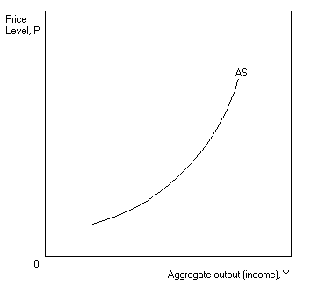
- Draw a graph of the short-run aggregate supply curve.
Difficulty: E Type: D

- Explain why the aggregate supply curve is likely to be fairly flat at low levels of aggregate output.

Firms will respond to an increase in demand by increasing output much more than they increase prices at low levels of aggregate output. The reason is that when firms are below capacity the extra cost of producing more output is likely to be small. In addition, firms can get more labor without much, if any increase in wage rates.

Difficulty: E Type: C

- Why will the price level tend to rise as firms get closer to their productive capacity?

As firms continue to increase their output, they will begin to bump into their short-run capacity constraints. As aggregate output rises, the prices of labor and capital will begin to rise more rapidly, leading firms to increase their output prices.

Difficulty: E Type: D

- At what point might the aggregate supply curve become completely vertical? Why might this be true?

There may come a point when firms are utilizing all of their existing factories and equipment. Plants may be running double shifts, and many workers are on overtime. At this point firms respond to increases in aggregate demand simply by raising prices instead of expanding production (which they may find difficult or impossible to do).

Difficulty: E Type: C

- Explain what a cost shock or supply shock is.

A cost shock is a change in costs that shifts the aggregate supply curve.

Difficulty: E Type: D

- Explain why it is not realistic to assume that all input prices (including wages) are fixed when deriving the short-run aggregate supply curve. What is a better assumption?

It is not realistic because the outputs of some firms are the inputs of other firms. It is also unrealistic to assume that wage rates do not respond at all to change in the overall price level. It is more realistic to assume that wage rates do not fully respond in the short run than it is to assume no response at all.

Difficulty: E Type: D

- Illustrate what happens to the aggregate supply curve when there is an increase in costs (for example, and increase in wage rates or energy prices).
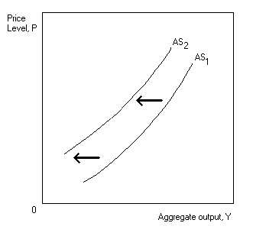

Difficulty: E Type: A

- Illustrate the effects of an increase in economic growth on the aggregate supply curve.
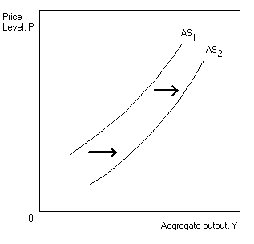

Difficulty: E Type: A

- List some of the elements that have increased the aggregate supply curve during the 1960s and 1970s that relate to labor.

First there was a greater participation in the labor force by women. Secondly, there had been an increase in the amount of legal and illegal immigration from Mexico and Central and South American countries.

Difficulty: E Type: F

- Explain how economic decline can happen as it relates to the capital stock.

Over time, capital deteriorates and eventually wears out completely if it is not properly maintained. If an economy fails to invest in both public capital and private capital at a sufficient rate, the stock of capital will decline. This can cause economic decline and a shift of the aggregate supply to the left.

Difficulty: E Type: C

- Discuss how public policy during the 1980s was aimed at shifting aggregate supply.

The policies that were enacted involved tax reductions and deregulation to increase the incentives to work, engage in entrepreneurial activity, and invest. The intent was to shift the aggregate supply curve to the right.

Difficulty: E Type: D

- Discuss why the aggregate supply function is relatively flat within the low ranges of aggregate output. Discuss why the aggregate supply function is relatively vertical within the ranges of high aggregate output.

The relatively flat portion of the aggregate supply function is associated with excess or unused productive capacity. As a result, increases in aggregate demand will contribute to production increases but very limited changes in price. It is the range of excess capacity. The vertical portion of the aggregate supply function is associated with full utilization of capacity and high levels of output. As a result, increases in aggregate demand will contribute to limited output gains and sharp increases in the price level. It is the range of full capacity utilization.

Difficulty: M Type: A

- Graphically illustrate and explain the aggregate supply (AS) curve.

An aggregate supply curve is illustrated in the following figure. It relates the relationship between aggregate output and prices.

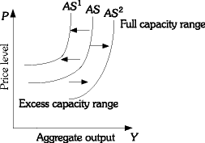

Difficulty: E Type: D

- Indicate the effects of cost shocks upon the aggregate supply (AS) function.

An increase in costs will result in a leftward parallel shift in the AS curve, and a decrease in costs will be exhibited as a rightward parallel shift in the AS curve. A leftward shift means that prices are higher at all levels of output and a rightward shift means that prices are lower at all levels of output.

Difficulty: M Type: A

- Explain why the AS curve cannot be the sum of the supply curves of all the individual firms in the economy.

An individual firm's supply curve shows what would happen to a firm's output if the price of its output changes with no corresponding changes in costs. But if the overall price level is increasing, it is unrealistic to assume that costs are constant for individual firms. Therefore, the AS curve cannot be the sum of the supply curves of the individual firms in the economy. The outputs of some firms are the inputs of other firms, so if output prices are increasing there will be an increase in at least some input prices. It is also unrealistic to assume that wage rates will remain constant as the overall price level is increasing. Another reason why the AS curve cannot be the sum of the supply curves of the individual firms in the economy: imperfectly competitive firms don't have supply curves.

Difficulty: M Type: C

- Explain why the aggregate supply curve is flat in the short run and steep in the long run.

In the short run, the price of inputs and the various raw material is relatively fixed and they are abundant. An increase in aggregate demand enables firms to produce more without a significant change in the price level. In the long run, the price of inputs and raw material is flexible, and they are scarce. Thus, an increase in aggregate demand causes a significant increase in the price level.

Difficulty: M Type: C

Equilibrium Price Level

- What is the macroeconomic equilibrium price level?

The equilibrium price level is the point at which the aggregate demand and aggregate supply intersect.

Difficulty: E Type: D

- Explain in broad terms what the equilibrium price level and equilibrium output level correspond to with respect to the money market and the goods market.

They correspond to equilibrium in the goods market and the money market, and to a set of price/output decisions on the part of all firms in the economy.

Difficulty: E Type: D

- Draw an aggregate supply curve in which all prices (both input and output prices) change at the same rate.
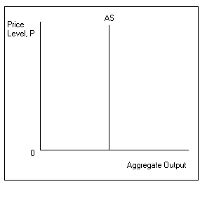

Difficulty: E Type: A

- What might keep the aggregate supply curve from becoming completely vertical?

If in the short run at least some costs changes lag behind price level changes then the aggregate supply curve will still be upward-sloping but will not be completely vertical.

Difficulty: E Type: C

- Using aggregate supply and aggregate demand curves, indicate what impact each of the following would have on the price level and on the equilibrium level of aggregate output in the short run.

(a) The Fed buys bonds in the open market.
(b) The economy is far below capacity and the government increases government spending.
(c) The floods in the Midwest in 1993 destroyed a large portion of the United States' agricultural crops.

(a) Aggregate demand will increase and the price level and the equilibrium level of output will increase.

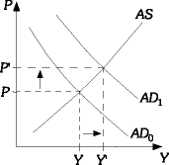

(b) Aggregate demand will increase, the price level will increase by a small amount, and the equilibrium level of output will increase by a large amount.

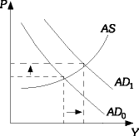

(c) Aggregate supply decreased, the price level increased, and the equilibrium level of output fell.

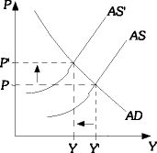

Difficulty: M Type: A

The Long-Run Aggregate Supply Curve

- Explain what is meant by potential output.

Potential output is the level of aggregate output that can be sustained in the long run without inflation.

Difficulty: E Type: C

- Draw the short-run aggregate supply and long-run aggregate supply curve on the same graph along with the aggregate demand curve. Illustrate the effects of an increase in aggregate demand on both the price level and the output level both in the short-run and the long-run.
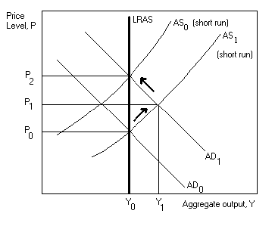

Difficulty: D Type: A

- According to economists who believe the aggregate supply is vertical in the long run, what is the adjustment process in the economy if output is below full employment?

The argument is that when the economy is operating below full employment with excess capacity and high unemployment, input prices are likely to fall. A decline in input prices shifts the short-run aggregate supply curve to the right, causing the price level to fall and the level of real GDP to rise to potential output.

Difficulty: D Type: C

- Demonstrate on a graph the effect on output and the price level if there is an increase in aggregate demand along the nearly flat part of the aggregate supply curve.
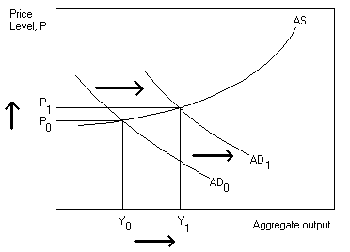

Difficulty: M Type: A

- Explain why expansionary policy is not likely to work very well when the economy is operating along the steeper portion of the aggregate supply curve.

The reason is that it results in a much higher price level with little increase in output. The multiplier is therefore close to zero: output is initially close to capacity, and attempts to increase it further lead mostly to a higher price level.

Difficulty: M Type: C

- Show the effect on the price level and output of a shift of the aggregate demand curve when the economy is operating at or near maximum capacity.
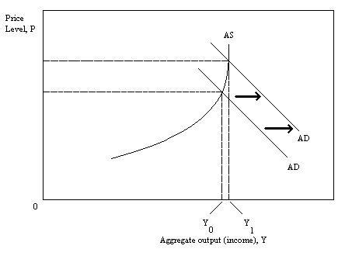

Difficulty: E Type: A

- Show using graphs and explain what is the likely impact of expansionary policies when the economy is operating at excess capacity on the flat, horizontal portion of the AS curve? Graphically illustrate this policy effect.

Expansionary policies, such as an increase in the money supply, decrease in taxes, or increase in government spending, within this range of the AS curve will result in substantial output and income gains with little or no impact on the price level. In the following figure, the increase in aggregate demand from AD0 to AD1 results in significant increases in the aggregate output and income and only slight price increases. This is because of the excess or underutilized productive capacity that exists within this output range.

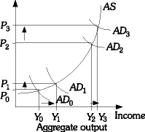

Difficulty: M Type: A

- What is the likely impact of expansionary policies when the economy is operating at full capacity on the vertical portion of the AS curve?

Expansionary policies within this range of the AS curve will result in negligible or no aggregate output increases and accelerated increases in prices. In the figure below, the increase in aggregate demand from AD2 to AD3 results in very limited increases in aggregate output and income and significant increases in prices. This is the full capacity range of productive capacity.

Difficulty: M Type: A

- Explain why increases in long-run aggregate supply are the only means to achieve sustained increases in aggregate output.

Output can exceed potential GDP in the short run, but only if output prices are increasing faster than input prices. Eventually there will be upward pressure on input prices and this will constrain growth. Increases in output in the long run can be sustained only if potential GDP is increasing.

Difficulty: M Type: A

- What is the general economic view regarding whether the AS curve is vertical in the long run?

The "new classical" economics assumes that prices and wages are flexible and adjust quickly to changing conditions. This is consistent with the existence of a vertical AS curve in both the short and long run. The simple Keynesian view would dispute this contention and question a completely vertical AS curve in the long run. Thus, it advances the need for appropriate government policies.

Difficulty: M Type: C

- Suppose the economy is initially operating at the potential level of output. Graphically illustrate and explain what effect a one-time permanent reduction in the money supply will have on output and the price level in the short run and in the long run.

The reduction in the money supply will cause a reduction in aggregate demand. This causes the AD curve to shift left. As AD falls, firms cut production and the price level falls. Over time, wages will be reduced and the short-run aggregate supply curve shifts right. As it does this, the price level continues to fall and output will now increase. In the long run, output returns to the potential level of output and the price is lower. The economy moves from point E0 to E1.

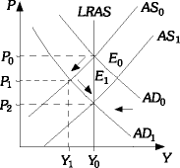

Difficulty: D Type: C

Causes of Inflation

- What is sustained inflation and what do most economists believe is its root cause?

Sustained inflation occurs when the overall price level continues to rise over some fairly long period of time. Most economists believe it must be "accommodated" by an expanded money supply, in others words it is a purely monetary phenomenon.

Difficulty: E Type: C

- Explain demand-pull inflation

Demand-pull inflation is initiated by an increase in aggregate demand.

Difficulty: E Type: C

- Explain cost-push inflation and give an example of a possible cause.

Cost-push inflation is caused by an increase in costs. It could be the result of rising oil prices or higher wage rates or any other factors that affect the cost of doing business throughout the economy.

Difficulty: E Type: C

- Using aggregate supply and aggregate demand analysis illustrate with the use of a graph the effect of cost-push inflation on the economy.
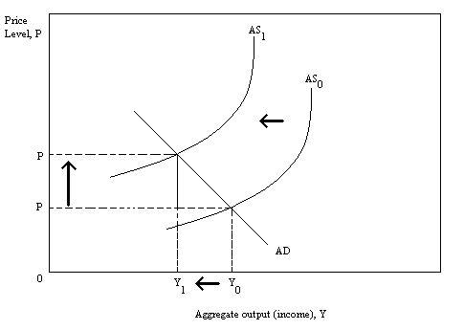

Difficulty: E Type: A

- Define stagflation.

Stagflation occurs when output is falling at the same time that prices are rising.

Difficulty: E Type: D

- Explain why costs shocks are bad news for policy makers.

Costs shocks drive prices up and output down. Monetary or fiscal policy can change enough to offset the effect on output, but not without the price level increasing even more than it would without the policy action.

Difficulty: E Type: C

- Explain how expectations can affect the price level.

If prices have been rising and people's expectations are adaptive - that is, they form their expectations on the basis of past pricing behavior - then firms may continue raising prices even if demand is slowing or contracting.

Difficulty: E Type: C

- Assume the economy is operating in the vertical range of the AS curve and the government increases spending. Explain how Fed accommodation can trigger further increases in the price level.

If the Fed tries to keep the interest rate unchanged by increasing the money supply the AD curve will shift farther and farther to the right. The result is a sustained inflation.

Difficulty: E Type: C

- Explain under which circumstances the government will not be able to increase non-taxed-financed spending without the Fed's cooperation.

At some point, the public may be unwilling to buy any more bonds that are being issued to finance government spending even when the interest rate is very high. At this point the inflation cannot be perpetuated without the help of the Fed.

Difficulty: E Type: C

- Assuming that the Fed takes no action to change the money supply, as the price level increases, what chain of events will occur?

As the price level rises, there will be an increase in the demand for money, which leads to excess demand in the money market, which will cause interest rates to rise and investment and aggregate output to fall.

Difficulty: E Type: C

- Assuming a decline in money demand explains what will happen to planned investment and aggregate output.

Planned investment will increase because the lower money demand will drive the interest rate down making investment more attractive. This in turn will cause aggregate output to increase.

Difficulty: E Type: C

- Define hyperinflation.

Hyperinflation is a period of very rapid increases in the price level.

Difficulty: E Type: D
- Explain how action by the Fed might bring about a hyperinflation when the economy is operating on the steep part of the AS curve.

If the Fed tried to keep the interest rate constant when the economy is operating on the steep part of the AS curve this could trigger hyperinflation. The reason is that in this region of the AS curve no more output can be produced in the economy and if planned investment is not allowed to fall, and then it is not possible to increase G. The more and more money the Fed pumps into the economy to keep interest rates unchanged the greater the pressure on the price level to keep rising. (Note: This answer ignores the Fisher effect of higher inflationary expectations on interest rates.)

Difficulty: D Type: C

- Explain the difference between demand-pull inflation and cost-push inflation.

Demand-pull inflation is caused by a rightward shift in the aggregate demand curve. It is associated with higher prices and higher output. Cost-push inflation is caused by a leftward shift in the aggregate supply curve due to an increase in the cost of production. It is associated with higher prices and lower output.

Difficulty: E Type: D

- How do expectations impact upon inflation?

Expectations can have a significant impact on pricing decisions and inflation. A business may decide to increase its prices because it expects its competitors to increase price. Consumers may spend more now in anticipation of a future event or condition. This may increase current prices and contribute to inflation.

Difficulty: M Type: C

- Assume that in the long run input prices fully adjust to changes in output prices. Use a diagram to indicate the effect of an expansionary fiscal policy on the price level and equilibrium level of output in the long run.

The long-run aggregate supply curve will be vertical. An expansionary fiscal policy will increase the price level, but will not change the equilibrium level of output in the long run.

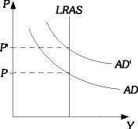

Difficulty: M Type: A

- Define cost-push inflation. Using an AS/AD diagram, illustrate how cost-push inflation affects the level of aggregate output and the price level in the economy. Suppose that the government uses expansionary fiscal policy to counter the effects of the cost-push inflation. Indicate on the diagram the impact of this policy on the price level and level of aggregate output.

Cost-push inflation is inflation caused by an increase in costs. Cost-push inflation leads to an increase in the price level and a reduction in the level of aggregate output. This is shown by a shift from AS' to AS in the graph below. If the government uses expansionary fiscal policy to counter the effects of cost-push inflation, aggregate output will increase and the price level will increase even more. This is shown by the shift in from AD to AD' in the graph below.

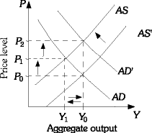

Difficulty: M Type: A

- In 1993 there was a severe drought in Maldavia. As a result of the drought, approximately two-thirds of the country's agricultural crops were destroyed. Using an AS/AD diagram, indicate what effect this drought would have on the overall price level and the equilibrium level of output. The Maldavian government is considering a number of policies to counter the effects of the drought on the economy. For each of the following policies, draw a graph that indicates the effects of the drought and then indicate how the policy would affect the overall price level and level of equilibrium aggregate output in Maldavia.

(a) The government is considering reducing net taxes.
(b) The monetary authority in Maldavia is considering a one-time increase in the money supply.
(c) The government is considering reducing public investment in agriculture and not spending that money on any other projects.

The drought would cause the aggregate supply curve to shift to the left. This would increase the overall price level and reduce the equilibrium level of output.

(a) A reduction in net taxes would increase both the overall price level and the equilibrium level of aggregate output.
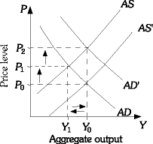

(b) An increase in the money supply will increase aggregate demand. This will increase the overall price level and the level of aggregate output.

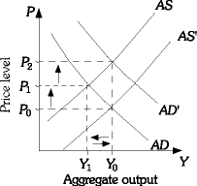

(c) A reduction of public investment in agriculture will cause both aggregate demand and aggregate supply to decrease. Output will fall farther than if there were no policy action, but the price level increase will be smaller.

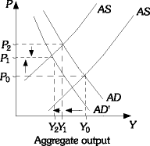

Difficulty: D Type: A

6) Will a decrease in inflationary expectations affect aggregate supply or aggregate demand? Explain why it affects the one you chose. Using an AS/AD diagram, illustrate how a decrease in inflationary expectations affects the output level and the price level in the economy. Explain why these changes occur.
Answer: A decrease in inflationary expectations will shift the aggregate supply curve to the right. If prices have been falling or if the rate of inflation has been slowing, people will come to expect this trend to continue. Firms may decrease their prices because input prices are falling. The price level will fall and the equilibrium level of aggregate output will increase.

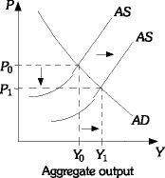

Diff: 3
Type: A

7) Explain why a sustained inflation must be a purely monetary phenomenon and cannot exist without the cooperation of the Federal Reserve.
Answer: An expansionary monetary or fiscal policy will increase aggregate demand, the equilibrium level of output, and the demand for money. As the demand for money increases with no change in the money supply, the interest rate will increase and there will be some crowding out of investment. If the Fed decides to keep interest rates constant by increasing the money supply, aggregate demand will increase again, with a higher price level resulting. The price level will continue to rise only if the Fed continues to increase the money supply so as to keep the interest rate constant.
Diff: 2
Type: A

