The Labor Market: Basic Concepts

- Define cyclical unemployment.

It is the increase in unemployment that occurs during recessions and depressions.

Difficulty: E Type: D

- What is the labor supply curve?

It is a graph that illustrates the amount of labor that households want to supply at each particular wage rate.

Difficulty: E Type: D

- Differentiate between frictional unemployment, structural unemployment, and cyclical unemployment.

Frictional unemployment represents short-term unemployment that results from job changes or the search of recent graduates for long-term, career-oriented employment. Structural unemployment represents long-term labor displacement that results from a lack of necessary skills or educational requirements. Individuals must be retrained to meet new employment requirements. Cyclical unemployment is a measure of job losses that result from cyclical downturns in the economy. During a recessionary period, businesses typically lay off employees until sales and production needs increase during expansionary periods.

Difficulty: E Type: D

The Classical View of the Labor Market

- Briefly discuss the classical view of the labor market. Specifically, to what extent can unemployment occur based on the classical view? Explain.

The classical view of the labor market assumes that wages are sufficiently flexible so that the labor market is always in equilibrium. Alternatively, if there is an excess supply or excess demand for labor, the wage will quickly adjust to eliminate this surplus or shortage of labor. Because wages adjust so quickly, we would not observe unemployment based on the classical view.

Difficulty: M Type: A

- Based on the classical view of the labor market, explain the characteristics of the aggregate supply curve.

Because the labor market adjusts so quickly to changes in demand and supply, the labor market also adjusts quickly to changes in the price level. If there is an increase in the price level, the wage (nominal) will quickly adjust to this change in P. In this case, wages would adjust completely to any changes in the price level. Because wages adjust to changes in the price level, the aggregate supply curve, based on the classical view, would be vertical. Specifically, changes in the price level will have no effect on the level of output.

Difficulty: M Type: A

- According to the Classical view, what are the factors that are used by the household in determining how much labor to supply? Why might some members of the household decide not to be part of the labor force?

Households look at the market wage rate, the prices of outputs, and the value of leisure time. A household member not in the labor force has decided his or her time is more valuable in non-market activities. Perhaps the reason has to do with raising children or caring for an elderly parent who is sick or disabled.

Difficulty: E Type: C

- What is the labor demand curve?

A graph that illustrates the amount of labor firms wishes to employ at each particular wage.

Difficulty: E Type: F

- Explain how a decline in the demand for labor does not necessarily mean that unemployment will rise.

A decline in the demand for labor will initially create an excess supply of labor. Like many other markets this will push wage rates down until the quantity of labor supplied again equals the quantity of labor demanded, restoring the labor market to equilibrium.

Difficulty: E Type: C

- Explain why Classical economists argue that the unemployment rate is not a very accurate indicator of whether the labor market is working properly.

The Classical economists argue that the unemployment rate is not a very accurate indicator of whether the labor market is working properly because people who are classified as unemployed have chosen not to accept jobs at the wages offered.

Difficulty: M Type: C

- Using the Classical view, draw a graph which illustrates the impact of a decline in the demand for labor on the wage rate and the equilibrium level of employment.

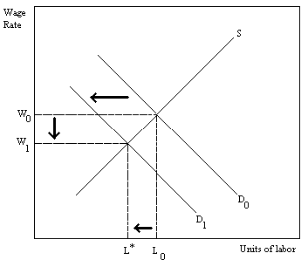

Difficulty: E Type: A

- Assume that the percentage of the labor force covered by labor contracts that set wages for a predetermined period of time decreases. How will this impact the effectiveness of fiscal and monetary policy and why?

It will decrease the effectiveness of both monetary and fiscal policy. The reason is that increases in the price level that may be forthcoming from either an expansionary monetary or fiscal policy are likely to allow for greater upward flexibility in wage rates, which will place added pressure on inflation.

Difficulty: D Type: C

- According to Classical economists, how will the economy respond to an increase in the demand for output?

Output will tend to rise. This will trigger an increase in the demand for labor, which will cause wages to rise. This will then draw more workers into the labor market.

Difficulty: E Type: C

- What would be the definition that classical economists would use for unemployment?

Classical economists would argue that the unemployed include anyone who is willing to work at the current market wage, but has not yet been able to find employment.

Difficulty: E Type: D

- Graphically illustrate an increase in the labor supply curve and explain its impact on the equilibrium wage rate and quantities. On a separate graph, illustrate an increase in the labor demand curve and explain its impact on the equilibrium wage rate and quantities.

In the following figure, the supply of labor has increased as illustrated by the rightward shift in the supply curve from S0 to S1. The increase in labor supply lowers the equilibrium wage rate from W* to W1 which results in greater quantities supplied and demanded to L1.

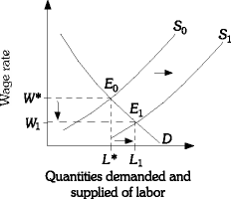

In the following figure, the demand for labor has increased as illustrated by the rightward shift in the demand curve from D0 to D1. This results in an increase in the equilibrium wage rate to W1 and additional quantities demanded and supplied to L1.

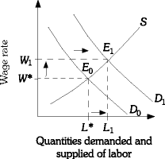

Difficulty: E Type: C

- Why do Classical economists believe that the labor market always clears?

In the Classical model, wages are flexible. Thus, when there is a surplus in the labor market, the wage rate declines to eliminate the surplus. Similarly, when there is a shortage in the labor market, the wage rate increases to eliminate the shortage.

Difficulty: M Type: C

- Explain how the value that people place on the time they spend on nonmarket activities affects their decisions with respect to participation in the labor force.

If a person places a higher value on his or her time in non-market activities than the wage he or she is offered in the labor market, the person would choose not to supply any hours to the labor market. As the value that people place on their time in non-market activities changes, the labor supply also changes.

Difficulty: M Type: A

- Classical economists argue that when the labor market is in equilibrium, those people who are not working are those who have CHOSEN not to work at that market wage. Why might an individual choose not to work at the market wage? Do you agree with the classical view of the labor market? Why or why not?

An individual may choose not to work because the value he or she places on his or her time in non-market activities is greater than the wage rate he or she could earn. Answers to the second part will vary.

Difficulty: M Type: A

- What explanations do those economists who hold the classical view of the labor market offer for the existence of unemployment?

Classical economists argue that unemployment results from wages being sticky. The explanations for sticky wages include the relative-wage explanation and explicit contracts. Wages may also be held above the equilibrium wage because of efficiency wages, imperfect information, or minimum wages.

Difficulty: M Type: A

Explaining the Existence of Unemployment

- Explain how social or implicit contracts might result in sticky wages.

Rather than use "explicit" contracts to determine wages, firms and workers might enter social or implicit contracts. These implicit contracts, although not explicitly stating so, would prevent or at least limit the extent to which wages decrease when the demand for labor decreases. So, when the economy goes into a recession, rather than cut wages, the implicit contracts would limit any drop in wages.

Difficulty: M Type: C

- Explain how explicit contracts might help explain sticky wages. Also, briefly explain why workers and firms would enter explicit contracts.

This is a rather easy question to answer. Explicit contracts represent explicit agreements between workers and firms about wages and other employment issues. Often, explicit contracts indicate what wages will be over a one-, two-, or three-year period. Because of these contracts, wages will not drop when demand for labor falls. Hence, they contribute to wage rigidity or wage stickiness. Workers and firms enter explicit contracts because there are negotiation costs. It would be costly indeed to negotiate, for example, each day about wages, etc.

Difficulty: M Type: C

- How does the efficiency wage theory help explain the existence of unemployment?

The efficiency wage theory argues that worker productivity is a function of wages. Specifically, workers are more productive the higher the wage is. Because of this, firms might find it optimal/profitable to pay workers a wage above the market-clearing wage. With wages above the market-clearing wage, we will observe an increase in the quantity supplied of labor and an excess supply of labor. This excess supply of labor represents unemployment.

Difficulty: M Type: C

- What is the social contract explanation for the existence of downwardly sticky wages? Why do you suppose that firms and workers behave this way?

It is the unspoken agreements between workers and firms that firms will not cut wages. Firms may be more reluctant to cut wages for fear of losing their most productive workers. If instead of cutting wages they choose to lay off workers, they can at least decide which workers to lay off (undoubtedly their least productive ones).

Difficulty: M Type: C

- What do economists mean when they refer to "sticky wages?"

They are referring to the downward rigidity of wages as an explanation for the existence of unemployment.

Difficulty: E Type: C

- Using a labor supply and demand curve demonstrate the effect of a decline in the demand for labor assuming wages are "sticky" in a downward direction.
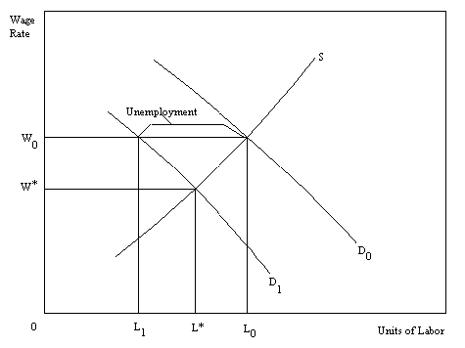

If wages "stick" at W_{o} rather than fall to the new equilibrium then there will be unemployment equal to L₀ - L₁.

Difficulty: M Type: A

- What are social contracts?

Social contracts are unspoken agreements between workers and firms that firms will not cut wages.

Difficulty: E Type: D
- Discuss the relative-wage explanation of unemployment.

If workers are concerned about their wages relative to other workers in other firms and industries, they may be unwilling to accept a wage cut unless they know that all other workers are receiving similar cuts. This is an explanation for sticky wages.

Difficulty: M Type: C

- What are explicit contracts?

They are employment contracts which stipulate workers' wages. It is usually for a period of one to three years.

Difficulty: E Type: D

- What are cost-of-living adjustments?

They are contract provisions that tie wages to changes in the cost of living. The greater the inflation rate, the more wages are raised.

Difficulty: E Type: D

- Explain efficiency wage theory.

It is an explanation for unemployment that holds that the productivity of workers increases with the wage rate. If this is so, firms may have an incentive to pay wages above the market-clearing rate.

Difficulty: M Type: C

- List several potential benefits firms receive from paying efficiency wages which empirical studies have revealed.

It provides lower turnover, improved morale, and reduced "shirking" of work.

Difficulty: E Type: F

- What might be the potential benefit that firms are likely to receive if productivity increases as wages increase and firms pay a wage that is above the market clearing wage? Why is this benefit so important?

A potential benefit that these firms may receive is a reduction in employee turnover. This benefit is important because turnover is costly to the firm. It can involve extensive training of new recruits. Another possible benefit is the higher productivity itself and higher profits.

Difficulty: E Type: C

- If firms set wage rates on the basis of imperfect information and overestimate worker productivity, what is the likely impact on wages and the unemployment rate?

It is likely that wages will be above the market clearing level and this will generate a higher unemployment rate.

Difficulty: M Type: C

- What are minimum wage laws?

Minimum wage laws are laws that set a floor for wage rates - that is, a minimum hourly rate for any kind of labor.

Difficulty: E Type: D

- Show with the use of a graph why minimum wage laws can cause unemployment.
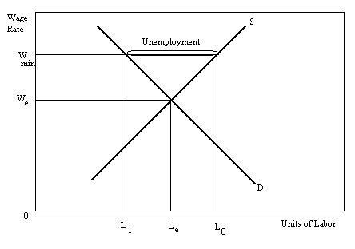

If minimum wages are set above the market-clearing wage then the quantity demanded of labor will fall and the quantity of labor supplied will rise. This will result in an excess supply for labor or unemployment.

Difficulty: M Type: A

- What is the short-run relationship between the unemployment rate and output?

When output rises, the unemployment rate falls, and when output falls, the unemployment rate rises.

Difficulty: E Type: C

- What is the short-run relationship between the unemployment rate and the price level?

There is a negative relationship between the unemployment rate and the price level. As the unemployment rate declines in response to the economy moving closer and closer to capacity output, the overall price level rises more and more.

Difficulty: E Type: D

- Graphically illustrate and describe the principle of sticky wages. What are some causes of inflexible or sticky wages?

The principle of sticky wages is illustrated in the following figure. Assume the initial equilibrium market wage was W0 and quantities demanded and supplied were L0. If the demand for labor declined from D0 to D1 and the wage rate remains stuck at W0, then quantities supplied (L0) would exceed quantities demanded (L2). This excess level of quantities supplied is a measure of unemployment.

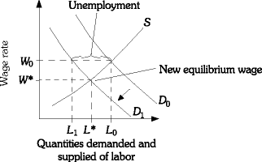

Inflexible wage rates are a result of social or implicit contracts and explicit union-management contract agreements.

Difficulty: M Type: C

- Explain the relative-wage explanation of unemployment.

The relative wage explanation of unemployment suggests that laborers are concerned about their wages relative to the wages of other workers in other firms and industries and may be unwilling to accept wage cuts unless other workers are receiving similar cuts.

Difficulty: E Type: D

- Explain how incomplete or imperfect market information may contribute to unemployment.

Incomplete or imperfectly communicated information between labor and management may result in unemployment in this way. A firm may want to lower its product costs by lowering wages and labor costs when its sales decrease. This would permit it to lower product price and restore sales. However, labor would resist the wage cut which may require the business to lay off workers as a means of lowering its costs because they may not believe that the firm will actually lower the price.

Difficulty: E Type: D

- Explain how the minimum wage laws may cause unemployment. What age group is most adversely affected by the minimum wage law?

If the established minimum wage is higher than the market clearing equilibrium wage, there will be an excess of labor supplied and unemployment will result. Young, new workers into the labor markets tend to be most adversely effected by the minimum wage laws. Their lack of job-related experience and education or training means that businesses can't afford to pay them the mandated minimum wage because their productivity does not match the wage rate.

Difficulty: M Type: A

- Explain the efficiency wage theory. Why would a firm be willing to pay an efficient wage?

The efficiency wage theory states that productivity increases as wages increase, so firms may be willing to pay above the market-clearing wage. The benefits the firm may receive include lower turnover, improved morale, and less shirking.

Difficulty: E Type: D

The Short-Run Relationship Between the Unemployment Rate and Inflation

- Explain how the minimum wage laws account for a percentage of unemployment.

Minimum wage laws target those workers with the least amount of skills. Therefore if the market clearing wage is below the government mandated wage, unemployment will result.

Difficulty: M Type: A

- Explain what the Phillips curve represents.

The Phillips curve illustrates the relationship between the inflation rate and the unemployment rate. Increases in output will cause an increase in employment. As employment increases, unemployment will fall. The higher output will also cause, based on our understanding of the aggregate supply relationship, an increase in the price level. So, an increase in output will be associated with lower unemployment and inflation. This is what the Phillips curve represents.

Difficulty: E Type: C

- During the 1960s, the Phillips curve relationship was relatively stable. During the 1970s, the Phillips curve relationship was unstable. Based on your understanding of the aggregate supply and aggregate demand model, explain why this was so.

During the 1960s, changes in aggregate demand dominated the macroeconomy. Increases in AD will cause higher Y, lower unemployment, and higher inflation. Reductions in AD will cause lower Y, higher unemployment, and lower inflation. So, changes in AD would yield a stable unemployment-inflation trade-off. In the 1970s, supply shocks or cost shocks dominated. With cost shocks, we observe shifts in the aggregate supply curve. Shifts in the aggregate supply curve will cause either: (1) increases in output, reductions in unemployment, and lower inflation; or (2) reductions in output, increases in unemployment, and higher inflation (i.e., stagflation). In such a situation, we do not observe a stable trade-off between inflation and unemployment.

Difficulty: D Type: A

- Explain what role import prices play in determining the Phillips curve.

Import prices and, particularly, the price of imported oil had a significant effect on the Phillips curve. An increase in import prices during the 1970s caused an increase in costs, a leftward shift in the aggregate supply curve, a reduction in output, and an increase in inflation. This would be represented by the Phillips curve shifting up. In short, we would observe higher unemployment and higher inflation. This situation, by the way, was reversed during the 1990s when oil prices and, therefore, import prices, fell.

Difficulty: M Type: C

- Explain what role expectations play in determining the Phillips curve.

Expectations of future prices can play an important role in determining the position of the Phillips curve. As expectations of inflation, for example, increase, negotiated wages will increase. As wages rise, firms' costs increase. And, as firms' costs increase, firms will raise prices. This increase in the price level will cause an increase in inflation. So, the Phillips curve will shift as inflation increases. This also implies that changes in expected inflation will affect the position of the Phillips curve.

Difficulty: M Type: C

- Draw a graph of the Phillips Curve.

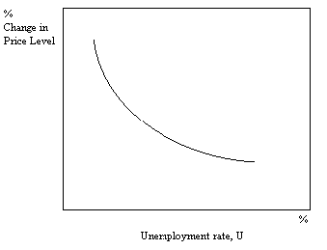

Difficulty: E Type: A

- Explain what the Phillips Curve shows.

It is a graph showing the relationship between the inflation rate and the unemployment rate. It demonstrates a negative relationship.

Difficulty: E Type: C

- Suppose that empirical evidence demonstrated that at a 10% inflation rate the unemployment rate was 4% and that every 2% decline in the inflation rate translated into a 1% increase in the unemployment rate. Draw a graph showing this relationship. Place the inflation rate on the vertical axis.
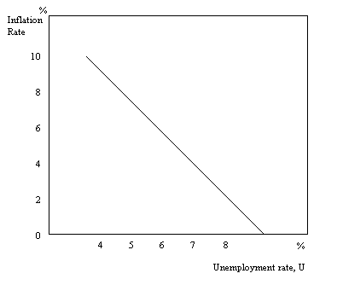
Difficulty: E Type: D

- What would the Phillips curve look like if every year there was a regular shift in the aggregate supply curve to the left but with no corresponding change in the aggregate demand curve, that is, aggregate demand remained constant.

If the AS curve shifts to the left, the economy experiences both a rising price level and an increase in the unemployment rate. Therefore, we would expect to see a positive relationship between the unemployment rate and the price level.

Difficulty: D Type: C

- How do changes in expectations cause the Phillips Curve to be unstable?

If inflationary expectations increase, the result will be an increase in the rate of inflation even though the unemployment rate may not have changed. This will cause the Phillips Curve to shift to the right. Just the opposite will happen if inflationary expectations decrease.

Difficulty: M Type: C

- Why was the Phillips Curve relatively stable during most of the 1950s and 1960s?

The reason was that inflationary expectations were quite stable in the 1950s and 1960s. The inflation rate was moderate during most of this period, and people expected it to remain moderate. This caused the Phillips Curve to remain relatively stable as well.

Difficulty: E Type: F

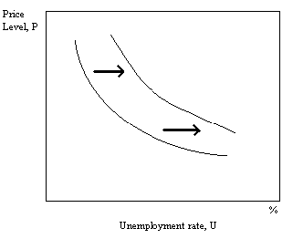
- Illustrate the effect of increased inflationary expectations on the positioning of the Phillips curve.
Difficulty: M Type: A

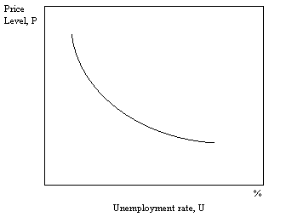
- If the AD curve shifts from year to year, but the AS curve does not, draw the likely Phillips curve that will result.

Difficulty: E Type: D

- What was the nature of the doubts about the Phillips curve during the 1970s?

There were doubts because of simultaneous high rates of inflation and unemployment that occurred during this time period.

Difficulty: E Type: C

- Under what circumstance will the economy experience both inflation and unemployment? Explain in terms of shifts of the aggregate supply and/or aggregate demand curves. Under what circumstances might the impact on inflation be even worse?

If aggregate supply decreases, and aggregate demand remains unchanged, this will likely result in both inflation and unemployment. The effect on inflation will likely be worse if aggregate demand increases as well.

Difficulty: M Type: C

- If input price changes lag behind output price changes in both the long run and the short run what will be the shape of both the short-run and long-run Phillips curve? What consequence does this have for policy making?

Both the short-run and long-run Phillips curves will be downward sloping. The consequence for policy making is that it means there is still a trade off between unemployment and inflation.

Difficulty: M Type: C

- Define the natural rate of unemployment.

It is the unemployment that occurs as a normal part of the functioning of the economy. Sometimes it is taken as the sum of frictional and structural unemployment.

Difficulty: E Type: C

- If aggregate supply decreases and aggregate demand remains unchanged, what can be said about the relationship between the price level and the level of aggregate output?

There will be a negative relationship between the price level and the level of aggregate output.

Difficulty: E Type: C

- What is potential GDP?

Potential GDP is the level of output than can be sustained in the long run without changes in the inflation rate.

Difficulty: E Type: D

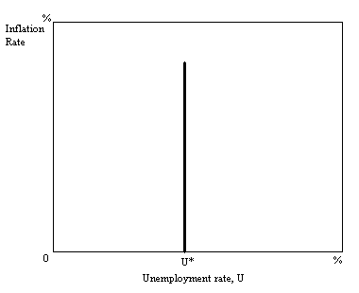
- If the long-run aggregate supply curve is vertical at potential GDP, draw the likely Phillips curve that will result at the natural rate of unemployment.

Difficulty: E Type: A

- Define the Phillips Curve. Graphically illustrate the relationship between the inflation rate and the unemployment rate.

The Phillips Curve illustrates the relationship between the inflation rate and the unemployment rate. The inverse relationship between the unemployment rate and the rate of inflation (percentage change in price) is illustrated here.

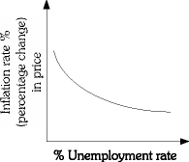

Difficulty: E Type: D

- Explain how expectations can be self-fulfilling in contributing to inflation.

If inflation is expected to be high in the future, negotiated union wages are likely to be higher than if inflation were expected to be low. Wage induced inflation is thus driven by expectations of future price inflation. Thus, price expectations that affect wage negotiations eventually affect prices themselves.

Difficulty: M Type: A

- Explain why in the case of a supply shock, the negative trade-off between inflation and unemployment does not hold.

Supply shocks cause the aggregate supply curve to shift to the left. This causes the inflation rate to increase and the unemployment rate to increase, too. Thus, a positive relationship.

Difficulty: M Type: A

- The relationship between the inflation rate and the unemployment rate was stable during the 1960s. Why was it stable? The relationship between the inflation rate and the unemployment rate was not stable during the 1970s and 1980s. Why wasn't it stable?

The relationship was stable in the 1960s because aggregate demand was changing, but aggregate supply was not. In the 1970s and 1980s, the relationship was not stable because aggregate supply was changing at the same time as aggregate demand, so both inflation and unemployment were increasing simultaneously.

Difficulty: M Type: A

- For each of the following indicate if there would be a positive relationship, a negative relationship, or no systematic relationship between the unemployment and inflation rates.

(a) The government increases government spending.
(b) At the same time the government is increasing the money supply the prices of imports are increasing.
(c) The price of energy is falling.

(a) negative relationship;
(b) no systematic relationship;
(c) positive relationship.

Difficulty: E Type: A

- Explain how inflationary expectations affect the Phillips curve. How do expectations of inflation affect the trade-off between inflation and unemployment?

If inflationary expectations increase, the Phillips curve will shift to the right. This worsens the trade-off between inflation and unemployment.

Difficulty: M Type: A

- Draw a graph of a long-run Phillips curve. What does this graph imply about the long-run trade-off between inflation and unemployment? What does this graph imply about the effectiveness of monetary and fiscal policy in the long run?

There is no trade-off in the long run. In the long run neither monetary nor fiscal policy will be effective in changing the level of output. In the long run these policies can influence only the inflation rate.

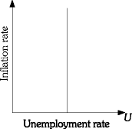

Difficulty: M Type: A

The Long-Run Aggregate Supply Curve, Potential GDP, and the Natural Rate of Unemployment

- Define what economists mean by the term NAIRU.

NAIRU is the non-accelerating inflation rate of unemployment.

Difficulty: E Type: D

- Explain what happens to the change in the inflation rate when the unemployment rate in the economy is to the left of the NAIRU. What happens when it is to the right?

If the actual unemployment rate is to the left of the NAIRU, the change in the inflation rate will be positive. If it is to the right of NAIRU the change in the inflation rate is negative.

Difficulty: M Type: C

- Explain the sequence of events that will unfold when there is a decrease in aggregate demand while the economy is operating in the upward-sloping section of the aggregate supply curve. Make sure to include in your assessment the impact on the price level, inventories, output and employment.

Inventories will increase, the price level will fall, and firms will respond by reducing output and employment.

Difficulty: E Type: C

- Explain the sequence of events that will unfold when there is an increase in aggregate demand while the economy is operating in the upward-sloping section of the aggregate supply curve. Make sure to include in your assessment the impact on the price level, inventories, output and employment.

Inventories will decline, the price level will rise and firms will respond by increasing output and employment.

Difficulty: E Type: C

- Assume an economy where unemployment has been falling, but the price level has increased very little. What is the most likely explanation for this phenomenon? Explain in terms of the aggregate supply curve.

In all likelihood the economy is well below capacity and is operating in the horizontal portion of the aggregate supply curve.

Difficulty: M Type: C
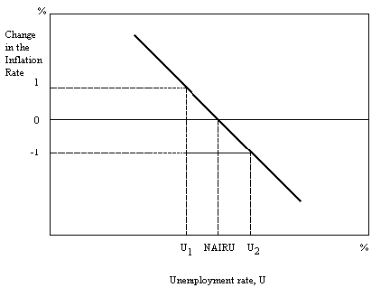
- Using the figure above, explain what would happen if the unemployment rate decreases from the NAIRU to U₁ and stays at U₁ for many periods. Assume that the inflation rate at the NAIRU was 4%.

In the first period the inflation rate will increase from 4% to 5%. The price level will continue to accelerate every period thereafter when the actual unemployment rate is below the NAIRU.

Difficulty: M Type: A

- If the Phillips curve is vertical in the long run, what can be said about the trade-off between inflation and unemployment? What impact does your answer have on the government's expansionary fiscal policy effort to reduce unemployment?

If the Phillips curve is vertical in the long run there will not be any trade-off between inflation and unemployment. This means that the government's effort to use an expansionary fiscal policy to reduce unemployment will only result in a higher inflation rate with no impact on unemployment.

Difficulty: D Type: C

- Draw the shape of the long-run Phillips Curve.
Difficulty: E Type: A

- Assume that the frictional unemployment rate is 2% and the structural unemployment rate is 4%. Draw the long run Phillips curve that is consistent with this information.
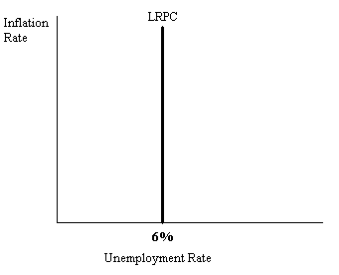
Difficulty: E Type: A

