Scarcity, Choice and Opportunity Cost

- What are resources? Describe two different types of resources.

Resources are anything provided by nature or previous generations that can be used directly or indirectly to satisfy human wants. Capital resources include machinery, equipment, and structures used to produce other goods and services. Human resources include labor, skills, and knowledge. Products of nature can also be used as resources.

Difficulty: E Type: D

- List the three basic economic questions that all societies must answer.

(1.) What will be produced?
(2.) How will it be produced?
(3.) Who will get what is produced?

Difficulty: E Type: F

- Explain the economic concept of opportunity cost.

The opportunity cost of something is the best alternative that we give up when we make a choice or a decision.

Difficulty: E Type: D

- Suppose you have saved $300. You can spend it on a new stereo or on a weekend skiing trip. What is the opportunity cost of going on the skiing trip?

The opportunity cost of the skiing trip is the value of the next best alternative for using the $300 you have saved. If the nest best alternative is purchasing the stereo, then the opportunity cost of going skiing is the enjoyment foregone by not purchasing the stereo.

Difficulty: E Type: C

- What is the opportunity cost of attending class today?

The opportunity cost of attending class today is the next best alternative for your time for including sleeping, studying for another class, or earning income at a job.

Difficulty: E Type: C

- Comment on the following statement: "I decided to buy a car from a dealer in a town 100 miles away because he was offering a price that was $100 lower than the dealer in my hometown. Therefore, I saved $100."

Assuming that the individual had no other reason to travel the 100 miles, the savings from the purchase of the car is less than $100. Travel costs should be taken into account, including the opportunity cost of time.

Difficulty: E Type: C

- Suppose that a local government decides to provide more funds to the local police department in order for the department to hire additional police officers. Is there an opportunity cost of this action? If so, how would you measure it?

Yes, there is an opportunity cost. The opportunity cost should be measured by the next best alternative use of the funds provided to the police department.

Difficulty: E Type: C

- Michael Jordan has more athletic ability than most individuals. Thus, he is more productive at most tasks involving physical skill. Explain why then, it is more efficient for Michael Jordan to pay someone else to mow his lawn.

While Michael Jordan probably has an absolute advantage in mowing his lawn, the opportunity cost of his time is very high. He could spend the time it takes to mow his lawn in a variety of ways including earning a large amount of money making a commercial endorsement. Thus, it is likely that he does not have a comparative advantage in mowing his lawn.

Difficulty: E Type: C

- Because of the quantity and quality of its resources, the U.S. has an absolute advantage in the production of many goods and services. Does this imply that the U.S. cannot benefit from trading with a developing country that has less productive ability? Why or why not?

The U.S. can benefit from trading with less productive countries as long as it produces the goods for which it has a comparative advantage and trades to receive the goods for which it does not.

Difficulty: M Type: C

- Explain Ricardo's theory of comparative advantage.

Specialization and free trade will benefit all trading partners, including those that may be absolutely more efficient producers.

Difficulty: E Type: D

- The following table shows output per hour for Martha and Stewart who make gift baskets
and potholders:

 | Output per Hour
 | Martha | Stewart
Gift Baskets | 10 | 8
Potholders | 20 | 12

What is the opportunity cost of a gift basket for Martha? What is the opportunity cost of a gift basket for Stewart? Who has a comparative advantage in producing gift baskets? How can you tell?

The opportunity cost of a gift basket for Martha is 2 potholders. The opportunity cost of a gift basket for Stewart is 1.5 potholders. Stewart has a comparative advantage in the production of gift baskets. His opportunity cost of producing a gift basket is lower.

Difficulty: E Type: A

- Explain the difference between absolute advantage and comparative advantage.

A person has an absolute advantage in the production of a good if he or she is more productive at producing the good. A person has a comparative advantage in the production of a good if he or she can produce it at the lowest opportunity cost.

Difficulty: E Type: D

- The following table shows output per hour for Martha and Stewart who make gift baskets and potholders:
 | Output per Hour
 | Martha | Stewart
Gift Baskets | 10 | 8
Potholders | 20 | 12

What is the opportunity cost of a potholder for Martha? What is the opportunity cost of a potholder for Stewart? Who has an absolute advantage in producing potholders? Who has a comparative advantage in producing potholders?

The opportunity cost of a potholder for Martha is 1/2 of a gift basket. The opportunity cost of a potholder for Stewart is 2/3 of a gift basket. Martha has an absolute advantage and a comparative advantage in the production of potholders.

Difficulty: M Type: A

- The following table shows output per hour for Fred and Barney who mow lawns and trim hedges:

 | Output per Hour
 | Fred | Barney
Lawns Mowed | 2 | 1
Hedges Trimmed | 8 | 6

What is the opportunity cost of mowing a lawn for Fred? What is the opportunity cost of trimming a hedge for Fred? Who has a comparative advantage in mowing lawns? How can you tell?

The opportunity cost of mowing a lawn for Fred is 4 hedges trimmed. The opportunity cost of a trimming a hedge for Fred is 1/4 of a lawn mowed. Fred has a comparative advantage in mowing lawns. His opportunity cost of mowing a lawn is 4 hedges trimmed and Barney's opportunity cost of mowing a lawn is 6 hedges trimmed.

Difficulty: M Type: A

- The following table shows output per hour for Mexico and Canada, two countries that produce beer and T-shirts:

 | Output per Hour
 | Mexico | Canada
Beer (thousands of bottles) | 5 | 10
T-shirts (thousands) | 10 | 12

What is the opportunity cost of a bottle of beer for Mexico? What is the opportunity cost of a T-shirt for Mexico? Who has a comparative advantage in producing beer? How can you tell?

The opportunity cost of a bottle of beer for Mexico is 2 T-shirts. The opportunity cost of a T-shirt for Mexico is 1/2 bottle of beer. Canada has a comparative advantage in the production of beer. Canada's opportunity cost of producing a bottle of beer is 1.2 T-shirts and Mexico's opportunity cost of producing a bottle of beer is 2 T-shirts.

Difficulty: M Type: A

- Suppose that Rosie and Betty spend their free time making cakes and cookies. Is it possible for Betty to have an absolute advantage in the production of both cakes and cookies? Is it possible for Betty to have a comparative advantage in the production of both cakes and cookies? Explain.

Yes, it is possible for Betty to have an absolute advantage in the production of cakes and cookies. This simply means that she is able to produce more per hour. However, Betty cannot have a comparative advantage in producing both cakes and cookies. Because the opportunity cost of producing a cookie is the reciprocal of the opportunity cost of making a cake, it is impossible to have the lower opportunity cost of each.

Difficulty: E Type: C

- Papa Ray owns a pizzeria. He is more efficient at making pizza than anyone he could hire. Does this mean that he should make all of the pizzas himself?

No. This simply means that Papa Ray has an absolute advantage in making pizza. This does not mean that he has a comparative advantage in making pizza. It is possible that the opportunity cost of his time is high (he could be out selling franchises, for example).

Difficulty: E Type: C

- Suppose that you have saved $100. You can spend it today or you can put it in your savings account for a year and earn 5% interest. What is the opportunity cost of spending the money today?

If you put the money in your savings account, you will have $105 to spend next year on the item (or items) of your choice. Thus, the opportunity cost of spending the money today is the enjoyment you give up by not having the $105 to buy something next year.

Difficulty: E Type: C

- What is the difference between capital goods and consumer goods?

Capital goods are goods that will be used to produce other goods in the future. Consumer goods are goods that are used for current consumption.

Difficulty: E Type: D

- What is the opportunity cost of producing a capital good such a new road?

The opportunity cost of producing a new road can be measured by the next best alternative that could have been produced with the same resources.

Difficulty: E Type: C

- In economic terminology, what is the meaning of investment?

Investment is the process of using resources to produce new capital. The new capital produced can be physical (new machinery) or human (education) in nature.

Difficulty: E Type: D

- How does an individual know whether or not an investment in education is worthwhile?

A worthwhile investment is one for which the expected present value of future benefits exceeds the present value of costs.

Difficulty: E Type: C

- Define opportunity cost. Given the definition of opportunity cost, explain what is meant by the statement “There is not such thing as a free lunch.”

Opportunity cost is what we give up, or forgo, when we make a choice. There
is no such thing as a free lunch because everything involves a cost, even if it
is just a time cost.

Difficulty: M Type: D

- Kathy and Amy paint pictures and do caricatures to sell to tourists. In one day, Kathy can either paint two pictures or do four caricatures. In one day, Amy can either paint three pictures or do three caricatures. For both Kathy and Amy, what is the opportunity cost of painting one picture? Who has the comparative advantage in painting pictures and who has the comparative advantage in doing caricatures? How might they be able to increase their total output?

Kathy’s opportunity cost of painting a picture is two caricatures. Amy’s opportunity cost of painting a picture is one caricature. Amy has a comparative advantage in painting and Kathy has a comparative advantage in doing caricatures. They could increase output by specializing in producing the goods for which they have a comparative advantage.

Difficulty: M Type: C

- Use a graph and comment on the following statement: "If an economy is producing inside its production possibilities frontier, it could possibly produce more of one good without giving up any of the other."

In the graph below, we can see that, at point A, the economy has three options if it begins to produce more efficiently. First, it could continue producing the same level of guns and produce more butter. Second, it could continue producing the same level of butter and produce more guns. Last, the economy could increase production of both guns and butter.
Guns

●
A

Butter

Difficulty: E Type: C

- Use a graph and comment on the following statement: "If an economy is producing at a point on its production possibilities frontier, it could possibly produce more of one good without giving up any of the other."

This statement is false. In the graph above, we can see that if the economy moves from point A to point B (to increase the production of butter), some guns must be sacrificed.

Guns

A

B

Butter

Difficulty: E Type: C

- What does a production possibility frontier represent?

A production possibility frontier is a graph that shows all of the combinations of goods and services that can be produced if all of society's resources are used efficiently.

Difficulty: E Type: D

- What can we say about the employment of resources if the economy is at a point on its production possibility frontier?

If the economy is at a point on its production possibility frontier, this implies that there is full resource employment and productive efficiency.

Difficulty: E Type: C

Cars

●
A

●
B

Corn

Refer to the graph above. In what way could point A be considered more efficient than point B?

Both points represent productive efficiency since they are on the production possibility frontier. However, point A could be considered more efficient than point B if it represents the combination of cars and corn that members of society most want.

Difficulty: E Type: C

- What can we say about the employment of resources if the economy is at a point inside its production possibility frontier?

If the economy is at a point inside its production possibility frontier, this implies that there is either unemployment of resources or productive inefficiency.

Difficulty: E Type: C

- What are the implications for economic growth for countries specializing in consumer goods rather than capital goods?

All else equal, countries that specialize in consumer goods will likely grow less than those that specialize in capital goods, because specializing in capital goods will allow for more goods to be produced in the future.

Difficult: M Type: C

- Why does the production possibility frontier have a negative slope?

Because of scarce resources, increasing the production of one good or service implies that the production of the other good or service must be reduced. Thus, there is a negative relationship between the two goods and the production possibility frontier is downward sloping.

Difficulty: E Type: C

- What is meant by the marginal rate of transformation?

The marginal rate of transformation is the slope of the production possibility frontier. It is the ratio of the change in the good (or service) on the y-axis to the change in the good (or service) on the x-axis.

Difficulty: E Type: D

- Draw a production possibility frontier. Find a point that represents a combination of outputs that is not currently feasible. Label it point A. Find a point that represents efficient production. Label it point B. Find a point that represents inefficient production. Label it point C.

There are many possible answers here, but point A should be drawn outside of the production possibility frontier, point B should be on the production possibility frontier, and point C should be inside the production possibility frontier.
Y

•
B
·A
·C

X

Difficulty: E Type: C

Refer to the information provided in Scenario 1 below to answer the following questions.

SCENARIO 1: Consider the following data for the harvest of crabs versus the harvest of fish off the coast of Virginia in answering the following questions.

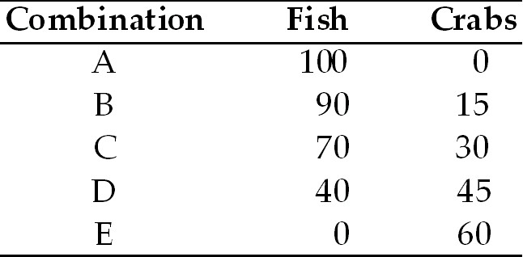

- Refer to Scenario 1. Graph the production possibilities frontier and calculate the
average opportunity cost of any of the first fifteen crabs produced.

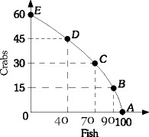

The opportunity cost of the first fifteen crabs is of course the 10 fish given up (15C = 10F). Therefore, the opportunity cost of any one crab is 10/15 F or 2/3 of a fish.

- Refer to Scenario 1. What is the economic significance of 25 fish captured and 25
crabs captured?

The economic significance of capturing 25 fish and 50 crabs is that the harvest would be inside the production possibilities frontier, which suggests some resource unemployment. That resource unemployment could be either land, labor or capital.

Difficulty: M Type: C

- Refer to Scenario 1. Explain how this economy might be able to produce 45 fish and 45 crabs?

The economy could do this with the benefits of an increase in resources or a technological advance in fishing.

Difficulty: M Type: C

Refer to the information provided in Scenario 2 below to answer the questions that follow.

SCENARIO 2: Assume that two countries are the same in every way except that one
allocated more of its resources to the production of capital goods as opposed to consumer
goods.

- Refer to Scenario 2. Graphically illustrate the production choices on a production possibilities frontier. Which country’s PPF will likely move out farther in the future and why?

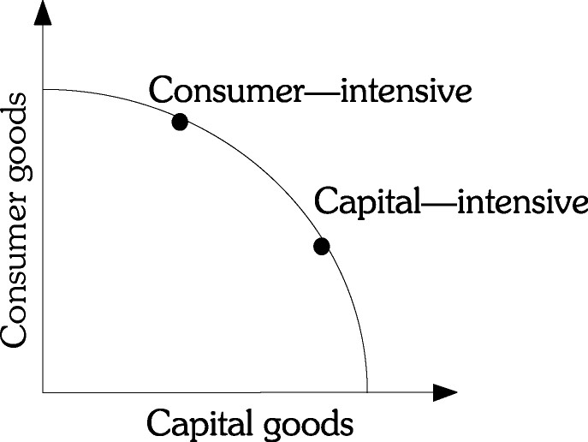

The country with the capital intensive allocation will have its PPF move
out farther since the economy will have greater productive capacity.

Difficulty: E Type: C

- Refer to Scenario 2. Now assume that the countries are not alike, but that one is wealthier than the other in that it has more resources. Graphically illustrate this scenario using the production possibilities frontiers.

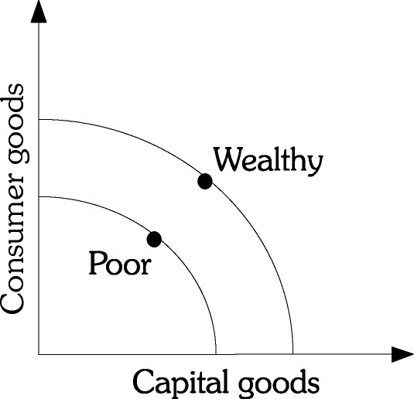

Difficulty: M Type: C

- Refer to Scenario 2. What would be the impact of improvements in technology assuming that each country spends one-half of its resources on capital goods?

There should be a greater improvement in wealth for the wealthier country if each country continues to spend the same percentages.

Difficulty: E Type: C

- Refer to Scenario 2. What happens to the relative income distribution between the two countries under the conditions in the previous question? Explain.

The relative income distributions, with income of the capital-good intensive country greater than the consumer-good intensive country, would be expected to widen as the growth is greater in the capital-good intensive country.

Difficulty: D Type: C

Refer to the information provided in Scenario 3 below to answer the questions that follow.

SCENARIO 3: Assume a desert island economy in which labor is the only scarce resource and labor can be used to gather food (coconuts) or to build huts. There are six equally productive individuals on the island. Each inhabitant can gather 25 coconuts in one day or build one hut in one day.

- Refer to Scenario 3. Draw the production possibilities frontier of the trade-off between coconuts and huts.

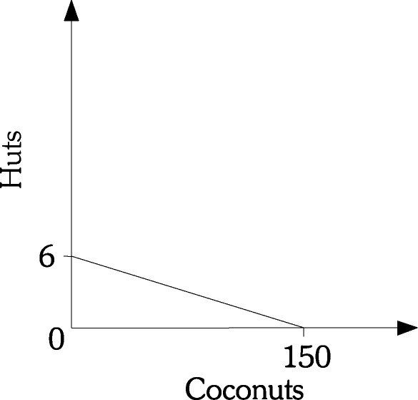

Difficulty: M Type: A

- Refer to Scenario 3. Compute the opportunity cost of building two more huts in one day.

First we start off by calculating what the opportunity cost is of building all 6 huts. We can set this up as an algebraic expression 6H = 150C. Therefore 1H = 25C and 2H = 50C or 50 coconuts.

Difficulty: M Type: A

- Refer to Scenario 3. If half the workers build huts and half of the workers gather
coconuts, what would be the production on the island?

In one day, the inhabitants would produce three huts and 75 coconuts.

Difficulty: M Type: A

- Refer to Scenario 3. Assume that in one day, two huts were built and 75 coconuts were gathered. What does this situation depict?

The situation depicts the inefficient use of resources as the production point represents one that is inside the production possibilities frontier.

Difficulty: M Type: A

- Refer to Scenario 3. What is the maximum potential increase in coconut production and maximum potential increase in hut production described in the previous question?

The maximum potential increase in production is either one more hut or 25 more coconuts.

Difficulty: M Type: A

- Refer to Scenario 3. What would have to occur for three huts to be produced along with 100 coconuts?

Some form of economic growth or technological improvement would have to occur.

Difficulty: M Type: A

- Refer to Scenario 3. Provide possible explanations for the conditions described in the previous questions to be achieved?

In order to exceed the maximum potential, perhaps the individuals could specialize according to their comparative advantage, or tools could be fashioned to improve production potentials.

Difficulty: D Type: C

Refer to the information provided in Scenario 4 below to answer the questions that follow.

SCENARIO 4: Suppose that a state needs to build both prisons and schools with a budget limited to 10 million dollars. Schools cost $1 million each to build and prisons cost $2 million each to build.

- Refer to Scenario 4. What is the maximum number of schools that can be built? The maximum number of prisons?

Ten is the maximum number of schools and five is the maximum number of prisons.

Difficulty: M Type: A

- Refer to Scenario 4. Draw the state’s production possibilities frontier for the
trade-off between schools and prisons.

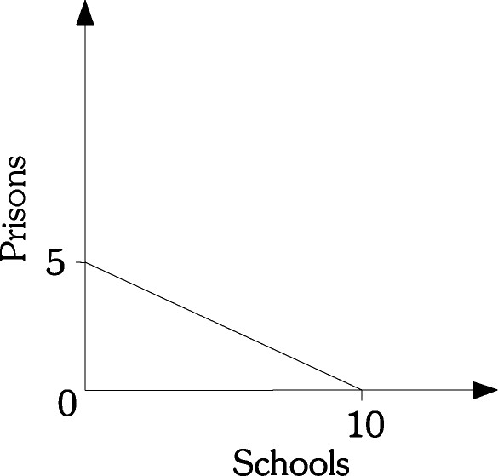

Difficulty: M Type: A

- Refer to Scenario 4. What is the opportunity cost of building one more prison?

The opportunity cost of building one more prison is two schools. This is gleaned from the fact that the opportunity cost of 5 prisons is 10 schools or 5P = 10S. Solving for P leaves you with 2S or two schools

Difficulty: M Type: A

- Refer to Scenario 4. Assume that the price of prison production falls to $1.5 million each. Draw the new production possibilities frontier. In addition, what is the new opportunity cost of producing one more prison?

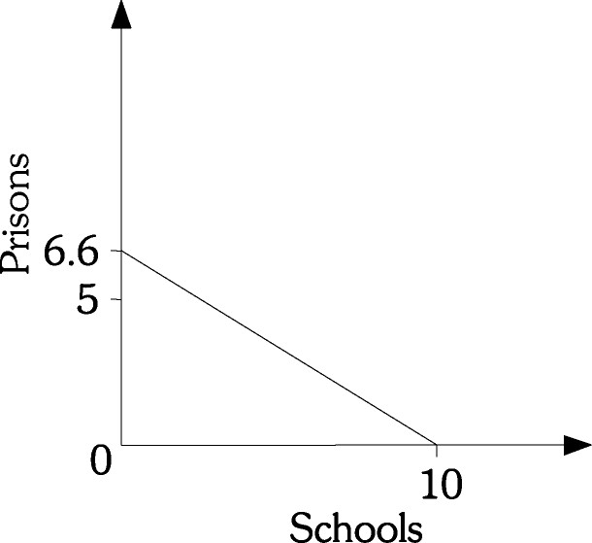

One more prison now costs one and one-half schools (10/6.66).

Difficulty: M Type: A

- Refer to Scenario 4. Assume that the price of a prison falls to $1.5 million and that the price of school production rises to $2 million each. Draw the new production possibilities frontier. What is the new opportunity cost of producing one more prison?

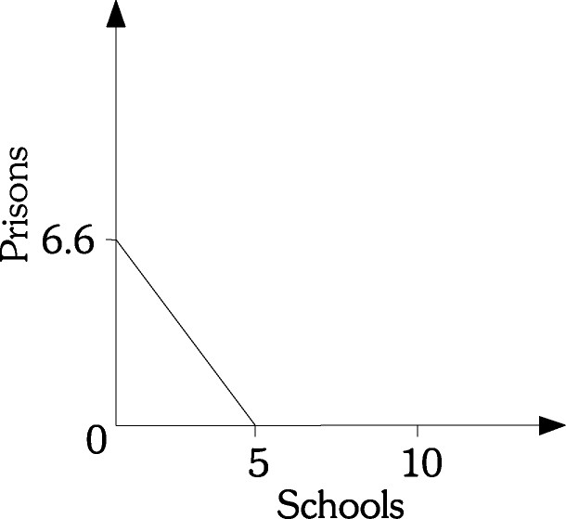

In the new situation, the opportunity cost of producing one more prison is three quarters of a school.

Difficulty: M Type: A

- Refer to Scenario 4. Assume that the state originally spent one-half of its budget on schools and one-half on prisons. What was the production of schools and prisons? Could the same number be achieved after the price of producing prisons falls to $1.5 million and the price of producing schools rises to $2 million? Explain.

Production is five schools and two and one-half prisons. No, the same number of schools and prisons could be built after the price of production changes. If the state continues to divide its budget equally, production would be two and one-half schools and three and one-third prisons. If the budget were juggled, the maximum number of schools that could be built is five, but no prisons could be built. And, if two and one-half prisons were built, there would be enough left in the budget to build just over three schools.

Difficulty: M Type: A

- Why does the opportunity cost of producing a good rise as more resources are devoted to producing that good?

The opportunity cost of a good rises as we devote more resources to producing it because some resources are better suited to the production of one good than another. This is known as the law of increasing opportunity cost.

Difficulty: E Type: C

- The table below represents five points on the production possibility frontier for the
small country of Baca, which produces only rugs (measured in thousands) and wheat (measured in thousands of bushels):

 | A | B | C | D | E
Rugs | 50 | 45 | 35 | 20 | 0
Wheat | 0 | 10 | 20 | 30 | 40

If the economy is currently at point A, what is the opportunity cost of producing an additional 10,000 bushels of wheat? If the economy is currently at point B, what is the opportunity cost of producing an additional 10,000 bushels of wheat? What if the economy is currently at point D?

If the economy is currently at point A, the opportunity cost of producing an additional 10,000 bushels of wheat is 5,000 rugs. If the economy is currently at point B, the opportunity cost of producing an additional 10,000 bushels of wheat is 10,000 rugs. If the economy is currently at point D, the opportunity cost of producing an additional 10,000 bushels of wheat is 20,000 rugs.

Difficulty: E Type: A

- The table below represents five points on the production possibility frontier for the small country of Baca, which produces only rugs (measured in thousands) and wheat (measured in thousands of bushels):
 | A | B | C | D | E
Rugs | 50 | 45 | 35 | 20 | 0
Wheat | 0 | 10 | 20 | 30 | 40

Does the production possibility frontier demonstrate the law of increasing opportunity cost? How can you tell?

Yes. The opportunity cost of increasing the production of wheat rises as more wheat is produced. The opportunity cost of the first 10,000 bushels of wheat is only 5,000 rugs, but the opportunity cost of the fourth 10,000 bushels of wheat is 20,000 rugs.

Difficulty: M Type: A

- If the law of increasing opportunity cost holds, can the production possibility frontier be a straight line?

No. If the production possibility curve is a straight line, this would imply that the marginal rate of transformation is constant. This cannot be the case if the law of increasing opportunity costs holds.

Difficulty: M Type: C

- The table below represents five points on the production possibility frontier for the small country of Ponderosa, which produces only cowboy boots (measured in thousands of pairs) and saddles (measured in thousands):

 | A | B | C | D | E
Cowboy Boots | 180 | 150 | 110 | 60 | 0
Saddles | 0 | 20 | 40 | 60 | 80

What is the opportunity cost of moving from point A to point B? What is the opportunity cost of moving from point D to point C?

The opportunity cost of moving from point A to point B is 30,000 pairs of cowboy boots. The opportunity cost of moving from point D to point C is 20,000 saddles.

Difficulty: E Type: A

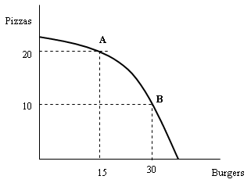

Refer to the graph above. What is the opportunity cost of going from point A to point B? What is the opportunity cost of going from point B to point A?

The opportunity cost of going from point A to point B is 10 pizzas. The opportunity cost of going from point B to point A is 15 burgers.

Difficulty: E Type: A

- What is meant by the term economic growth?

Economic growth occurs when the total output in an economy increases.

Difficulty: E Type: D

- What are the implications for economic growth for countries specializing in consumer goods rather than capital goods?

All else equal, countries that specialize in consumer goods will likely grow less than those that specialize in capital goods, because specializing in capital goods will allow for more goods to be produced in the future.

Difficulty: M Type: C

- The table below represents five points on the production possibility frontier for the small country of Bistro, which produces only crackers (measured in thousands of boxes) and cheese (measured in thousands of pounds):

 | A | B | C | D | E
Crackers | 40 | 30 | 20 | 10 | 0
Cheese | 0 | 5 | 10 | 15 | 20

Does the production possibility frontier demonstrate the law of increasing opportunity cost? How can you tell?

No. The opportunity cost of increasing the production of cheese remains the same as more cheese is produced. The opportunity cost of the first 5,000 pounds of cheese is 10,000 boxes of crackers, and the opportunity cost of the fourth 5,000 pounds of cheese is also 10,000 boxes of crackers.

Difficulty: M Type: A

- Using a graph, show how economic growth affects the production possibility frontier.

When economic growth occurs, the economy can produce more goods and services. Therefore, the production possibility curve shifts outward.

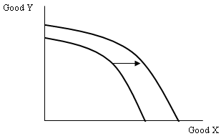
Difficulty: E Type: C

- List two things that can cause economic growth to occur.

(1.) New resources are acquired.
- Society learns to produce more with existing resources.

Difficulty: E Type: C

- In what ways are technological advancements like capital?

Both require an investment in terms of current consumption foregone. Both can lead to increases in the amount an economy can produce.

Difficulty: M Type: C

- Suppose a country produces two goods: corn and cars. New technology is developed that increases the amount of corn that can be produced. Use a graph to show the effect of this graph on the country’s production possibility frontier. Explain what occurs in the graph.

The production possibility frontier shifts outward. The y-intercept is unaffected, however. At the y-intercept, the country would be producing all cars and no corn and the new technology would have no effect.

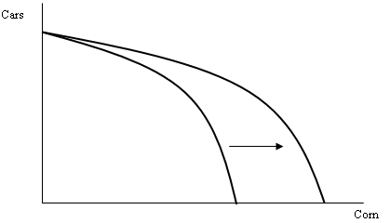

Difficulty: E Type: C

- Why do poor countries often have lower rates of economic growth than richer countries?

If a large part of a country's population is poor, it is very difficult to forgo current consumption to invest in research and development of new technologies or new capital equipment. With less investment, the rate of economic growth in the country will be lower.

Difficulty: M Type: C

- What happens to a country’s production possibility frontier if it experiences a natural disaster such as a hurricane or an earthquake? Explain.

The production possibility frontier will shift in. This occurs because the destruction from the hurricane or earthquake likely destroys resources such as capital and natural resources that are used to produce goods and services. Since the quantity of resources in the country is now lower, the country will not be able to produce as much output.

Difficulty: M Type: C

ECONOMIC SYSTEMS

- What is the economic problem?

The economic problem is finding a way for a society to answer the three basic economic questions (what will be produced?, how will it be produced?, and who will get what is produced?) given that resources are scarce.

Difficulty: E Type: D

- What are the two basic types of economic systems?

(1.) Command economies.
- Laissez-faire economies.

Difficulty: E Type: F

- What is a command economy?

A command economy is one in which a central government either directly or indirectly sets output targets, incomes, and prices. It may even involve direct government ownership of the means of production and central planning of the economy.

Difficulty: E Type: D

- What is a laissez-faire economy?

A laissez-faire economy is one in which individuals and firms pursue their own self-interests without any central direction or regulation.

Difficulty: E Type: D

- Is the United States a command economy, a laissez-faire economy, or neither? Explain.

The United States is a mixed economy. The U.S. basically has a free market economy, but the government is a large purchaser of goods and services and also produces some goods and services as well. In addition, the U.S. economy has significant amounts of government regulation of business.

Difficulty: E Type: C

- What is meant by consumer sovereignty?

Consumer sovereignty is the idea that consumers ultimately dictate what will be produced (or not produced) by choosing what to purchase (or not to purchase).

Difficulty: E Type: D

- According to the idea of consumer sovereignty, what will happen in the market for widgets if consumers decide they no longer desire widgets?

If consumers no longer desire widgets, they will send a message to producers by not purchasing widgets. Since firms will be unable to make a profit selling widgets, widget-producing firms will go out of business (or switch to producing something else) and widgets will no longer be produced. Thus, the consumers’ preferences dictate what is produced.

Difficulty: M Type: A

- What are some of the problems that exist with a laissez-faire economy?

Free markets may not always produce the goods and services that people want at the lowest cost. They are not always efficient. Also, income may be distributed unequally.

Difficulty: E Type: F

- Why is microeconomic theory often referred to as price theory?

The reason is that much of microeconomic theory focuses on the factors which influence and determine prices.

Difficulty: E Type: D

- What is the difference between a command economy and a laissez-faire economy?

The major difference lies in how the two types of economies answer the three basic questions. In a command economy, a central government either directly or indirectly sets output targets, incomes, and prices. In a laissez-faire economy, individual people and firms pursue their own self-interests without any central direction or regulation.

Difficulty: E Type: C

- What is the economic problem? How does a command economy solve the economic problem?

The economic problem is that given scarce resources, how exactly do large, complex societies go about answering the basic economic questions? A command economy answers the questions through some centralized authority making decisions about what to produce, how to produce it, and how to distribute it.

Difficulty: M Type: C

- In a laissez-faire economy, what determines the distribution of output?

It is determined by income and wealth. These in part depend on the skills an individual can offer in the labor market.

Difficulty: E Type: F

- What is the difference between income and wealth?

Income is a flow variable. It is the amount a household earns over a period of time such as a year. Wealth is a stock variable. It is the amount of assets a household has accumulated at a point in time from past income or through saving or inheritance.

Difficulty: E Type: D

- Explain three of the shortcomings of the free-enterprise system.

The shortcomings of the free-enterprise system are: products may not always be produced at lowest cost, income may be unevenly distributed, and periods of inflation and unemployment may recur.

Difficulty: E Type: C

