- Define trade surplus and trade deficit.

A trade surplus is a situation when a country exports more than it imports. A trade deficit is a situation when a country imports more than it exports.

Difficulty: E Type: D

- Discuss the Corn Laws and their purpose.

The Corn Laws were tariffs, subsidies, and restrictions enacted by the British Parliament in the early nineteenth century to discourage imports and encourage exports of grain.

Difficulty: E Type: F

- What is the theory of comparative advantage?

The theory of comparative advantage was Ricardo's theory that specialization and free trade will benefit all trading partners (real wages will rise), even those that may be absolutely less efficient producers. Comparative advantage refers to instances where an individual or a company can produce something at lower opportunity cost than others can.

Difficulty: E Type: C

- Explain absolute advantage.

Absolute advantage is the advantage in the production of a product enjoyed by one country over another when it uses fewer resources to produce that product than the other country does.

Difficulty: E Type: C

- Explain comparative advantage.

Comparative advantage is the advantage in the production of a product enjoyed by one country over another when that product can be produced at lower cost in terms of other goods foregone than it could be in the other country.

Difficulty: E Type: C
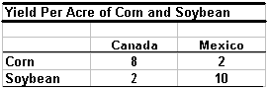

- According to the table above determine which country has the absolute advantage
in corn and which in soybeans. In addition, determine which country has the
comparative advantage in corn and which in soybeans. Make sure to support your
answer by deriving the opportunity costs of each.

Canada has the absolute advantage in the production of corn and Mexico has the absolute advantage in the production of soybeans. In addition, Canada also has a comparative advantage in the production of corn and Mexico has a comparative advantage in the production of soybeans. The reason is that the opportunity cost of corn in Canada is ¼ of a soybean while in Mexico the opportunity cost of corn is 5 soybeans. By taking the reciprocal of each the opportunity costs of soybean are 4 corn for Canada and 1/5 corn for Mexico.

Difficulty: E Type: A

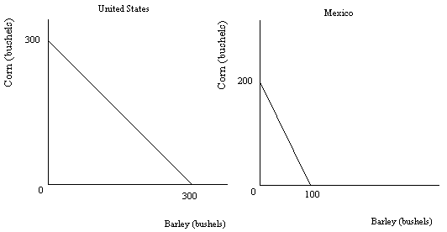
- Using the above figure determine which country has the comparative advantage in the production of corn. In addition, determine which has the comparative advantage in the production of barley.

The United States has the comparative advantage in the production of barley. The reason is that the opportunity cost to the United States for producing one bushel of barley is one bushel of corn. By contrast, Mexico's opportunity cost of one bushel of barley is two bushels of corn. Since the opportunity cost of producing one bushel of corn in Mexico is one-half of a bushel of barley that gives Mexico the comparative advantage in the production of corn.

Difficulty: E Type: A

- Assume the following information for the United States and Mexico. The United States can produce a maximum of 600 bushels of barley or a maximum of 600 bushels of corn. Mexico can produce a maximum of 200 bushels of barley or 400 bushels of corn. Draw the production possibilities for both countries assuming constant costs.

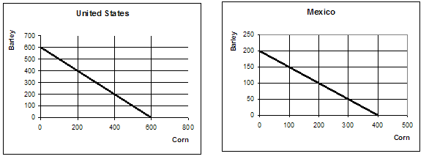

Difficulty: E Type: D

- Explain what happens when nations don't trade. In addition, explain what happens after they decide to trade.

Without trade, nations are constrained by their own resources and productivity. Trade enables nations to move beyond their previous resource and productivity constraints.

Difficulty: E Type: C

- Define the terms of trade.

The terms of trade represent the ratio at which a country can exchange domestic products for imported products.

Difficulty: E Type: D

- Suppose country X can produce a personal computer at an opportunity cost of 1000 t-shirts. Assume that country X has a comparative advantage in the production of t-shirts. Would country X ever agree to terms of trade with country Y such that one personal computer would be exchanged for 1100 t-shirts?

There would be no reason for country X to agree to such terms of trade. If country X can already produce one personal computer at an opportunity cost of 1000 t-shirts why would it agree with country Y to purchase a computer for 10% higher? The answer is it would not.

Difficulty: E Type: A

- When trade is free (unimpeded by government-instituted barriers) how are the patterns of trade and trade flows determined?

The patterns of trade and trade flows result from the independent decisions of thousands of importers and exporters and millions of private households and firms.

Difficulty: E Type: C

- Define the exchange rate.

The exchange rate is the ratio at which two currencies are traded. It is the price of one currency in terms of another.

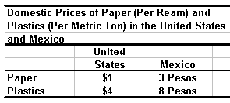
Difficulty: E Type: D

- According to the table above, would there be trade flows in both directions if the exchange rate were $1 = 1 peso?

At this exchange rate the trade flows would only be in one direction. Residents of Mexico would wish to purchase both paper and plastics from the United States. The reason is that in Mexico Paper is three times as expensive and plastics are twice as expensive at prevailing exchange rates.

Difficulty: M Type: A

- According to Table 19.2 what would the flows of trade be between both countries if the exchange rate were $1 = 2.5 pesos?

At this exchange rate residents of the United States would still find paper in Mexico relatively expensive. The reason is that one ream of it in the United States costs $1. However, at prevailing exchange rates that would not be enough to purchase an equivalent amount of paper in Mexico at 3 pesos. Residents of Mexico would find that paper in the United States is comparatively cheaper since it requires 3 pesos to purchase domestically but only 2.5 pesos to purchase it from the United States. With respect to plastics, residents of the United States face a domestic price of $4. If they take their $4 and exchange them for pesos they will obtain 10 pesos in return. This will allow them to purchase more plastics in Mexico with the same amount of dollars domestically. However, residents of Mexico will find that their 8 pesos does not even purchase one metric ton of plastic in the U.S. They will continue to purchase it domestically.

Difficulty: D Type: A

- Explain what the free market will do if exchange rates end up in the "right ranges."

If exchange rates end up in the right ranges, the free market will drive each country to shift resources into those sectors in which it enjoys a comparative advantage. Only those products in which a country has a comparative advantage will be competitive in world markets.

Difficulty: M Type: C

- What are factor endowments?

Factor endowments are the quantity and quality of labor, land, and natural resources of a country.

Difficulty: E Type: D

- Explain the Heckscher-Ohlin theorem.

The Heckscher-Olin theorem is a theory that explains the existence of a country's comparative advantage by its factor endowments. A country has a comparative advantage in the production of a product if that country is relatively well endowed with inputs used intensively in the production of that product.

Difficulty: E Type: C

- What are the assumptions of the Heckscher-Ohlin theorem?

It assumes that products can be produced using differing proportions of inputs and that inputs are mobile between sectors in each economy, but that factors are not mobile between economies.

Difficulty: E Type: F

- What is protection as it refers to international trade?

Protection is the practice of shielding a sector of the economy from foreign competition.

Difficulty: E Type: D

- List the three most common forms of trade barriers.

The three most common forms of trade barriers are tariffs, export subsidies, and quotas.

Difficulty: E Type: F

- What is a tariff?

A tariff is a tax on imports.

Difficulty: E Type: D

- What are export subsidies?

Export subsidies are government payments made to domestic firms to encourage exports.

Difficulty: E Type: D

- Explain dumping.

Dumping is when a firm or industry sells products on the world market at prices below the cost of production.

Difficulty: E Type: D

- What is a quota?

A quota is a limit on the quantity of imports.

Difficulty: E Type: D

- Discuss the Smoot-Hawley tariff and its economic repercussions.

The Smoot-Hawley tariff was a law of the 1930s which set the highest tariffs in U.S. history (60 percent). It set off an international trade war and caused the decline in trade that is often considered a one of the causes of the severity of the worldwide depression of the 1930s. This set the highest rates for the 20th century.

Difficulty: E Type: C

- What was the GATT?

The GATT or General Agreement on Tariffs and Trade was an international agreement signed by the United States and 22 other countries in 1947 to promote the liberalization of foreign trade.

Difficulty: E Type: F

- What is meant by the phrase "economic integration?"

Economic integration occurs when two or more nations join to form a free trade zone.

Difficulty: E Type: F

- Name at least seven members of the European Union.

The European Union is made up of Austria, Belgium, Denmark, Finland, France, Germany, Greece, Ireland, Italy, Luxembourg, the Netherlands, Portugal, Spain, Sweden and the United Kingdom.

Difficulty: E Type: F

- What was the U.S. - Canadian Free-Trade Agreement?

It was a 1988 agreement in which the United States and Canada agreed to eliminate all barriers to trade between the two countries by 1998. Not all trade barriers have been eliminated as of 2003.

Difficulty: E Type: F

- What is NAFTA?

NAFTA, or the North Atlantic Free Trade Agreement is an agreement signed by the United States, Mexico, and Canada in which the three countries agreed to establish all North America as a free-trade zone.

Difficulty: E Type: F

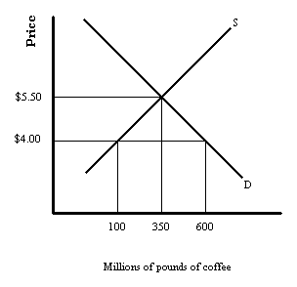

- Assume that the above figure represents the domestic supply and demand for
coffee.The domestic price with no trade is represented by $5.50. The price with free trade is represented by $4.00. Assume that the government places a $1 per pound tariff on imported coffee, which decreases the domestic quantity demanded of coffee by 100 million pounds and increases domestic production by 100 million pounds. Draw the rectangle that would represent the amount of tax revenue that the government would realize from this tax and calculate the dollar figure.
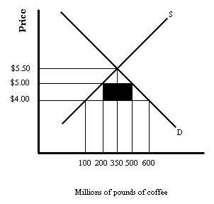

The amount of tax revenue would be represented by the black rectangle which is $300 million ($1 x 300 million pounds of imported coffee).

Difficulty: M Type: A

- Identify the two losses of efficiency associated with the imposition of a tariff.

First, consumers must pay a higher price for goods that could be produced at lower cost. Second, marginal producers are drawn into the industry away from other goods, resulting in inefficient domestic production.

Difficulty: E Type: C

- In general, what is the final result of trade barriers?

Trade barriers prevent a nation from reaping the full benefits of specialization, push to adopt relatively inefficient production techniques, and force consumers to pay higher prices for protected products than they would otherwise pay. It should be noted however, that domestic producers do win in the short run by providing an artificial comparative advantage.

Difficulty: E Type: C

- One popular case for protectionism is the "Protection Saves Jobs" argument. What is
the nature of this argument? What is its weakness?

The main argument is that foreign competition costs domestic jobs. If Americans purchase foreign-made goods then domestic-made goods go unsold. This costs American workers their jobs. The weakness of this argument is that it fails to recognize or admit that workers from displaced sectors may be absorbed in other expanding sectors of the economy.

Difficulty: E Type: C

- Explain the "Unfair Trade Practices" argument as a case against free trade.

The argument is that foreign firms may sometimes behave strategically against a domestic firm or industry by setting prices below cost in an effort to monopolize the domestic industry. Since this type of behavior would generally be considered a violation of the Sherman and Clayton acts we should give the government power to fight back when it comes to foreign firms whom are not playing by the rules.

Difficulty: E Type: C

- What is the basis of the "Cheap Foreign Labor" argument and what are its weaknesses?

The basis of the argument is the domestic producers cannot compete against foreign produces who are paying their workers low wages. There are two things wrong with this argument. First, wages reflect productivity. Workers in the U.S. earn higher wages because they are more productive. Second, trade flows not according to absolute advantage but according to comparative advantage. All countries benefit, even if one country is more efficient at producing everything.

Difficulty: E Type: C

- Discuss the national security argument as a case against free trade. What is the problem with this argument?

Certain industries argue that their business is vital to national security interest and ought to be protected. The trouble is that many industries make this claim and it is difficult to sort out the genuine claims from the bogus ones.

Difficulty: E Type: C

- Explain the infant industry argument case against free trade.

The argument is that a young industry that may need temporary protection from competition from the established industries of other countries to develop an acquired comparative advantage.

Difficulty: E Type: C

- Some people argue that protection discourages dependency. Explain this argument.

The argument is that small or developing countries may come to rely too heavily on one or more trading partner for many items. If it does it may make it difficult for the smaller nation to remain politically neutral. Some even argue that superpowers consciously engage in trade with smaller countries to create these dependencies.

Difficulty: M Type: C

