The Balance of Payments

- From a macroeconomic point of view what is the main difference between an international transaction and a domestic transaction?

The main difference concerns currency exchange. When people in different countries buy from and sell to each other, an exchange of currencies must also take place.

Difficulty: E Type: F

- Define the exchange rate.

The exchange rate is the price of one country's currency in terms of another country's currency; the ratio at which two currencies are traded for each other.

Difficulty: E Type: D

- Explain the basic terms of the Bretton Woods agreement.

It established a system of essentially fixed exchange rates under which each country agreed to intervene by buying and selling currencies in the foreign exchange market when necessary to maintain the agreed-upon value of its currency.

Difficulty: E Type: F

- Explain what happened to international system of exchange rates in 1971.

In 1971, most countries, including the United States, gave up trying to fix exchange rates formally and began allowing them to be determined essentially by supply and demand.

Difficulty: E Type: F

- Explain how the market for currencies is not that much different from the market for goods or services. Use U.S. dollars and British pounds to illustrate your answer.

The price of British pounds in dollars is determined by the interaction of those who want to exchange dollars for pounds (those who "demand" pounds) and those who want to exchange pounds for dollars (those who "supply" pounds).

Difficulty: E Type: C

- Give a basic definition of the balance of payments.

The balance of payments is the record of a nation's transactions in goods, services, and assets with the rest of the world; also the record of a country's sources (supply) of and uses (demand) for foreign exchange.

Difficulty: E Type: D

- What is a country's balance of trade?

A country's balance of trade is its exports of goods and services minus its imports of goods and services.

Difficulty: E Type: F

- How can a trade deficit occur?

A trade deficit occurs when a country's exports of goods and services are less than its imports of goods and services in a given period.

Difficulty: E Type: C

- Explain what the balance on current account means.

It is the balance of trade, plus net investment income, plus the category "net transfer payments and other."

Difficulty: E Type: D

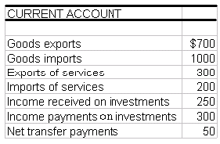

- Using the table above calculate the balance on current account.

(1) Net exports of goods $ 700
- 1000
- 300

(2) Net export of services $ 300
- 200
100

(3) Net investment income $ 250
300
- 50

(4) Net transfer payments $ 50

The balance on current account is the sum of 1,2,3, and 4. This yields -$200 billion.

Difficulty: E Type: A

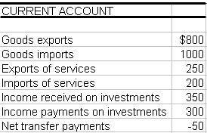

- Using the table above calculate the balance on current account.

(1) Net exports of goods $ 800
- 1000
- 200

(2) Net export of services 250
- 200
50

(3) Net investment income 350
300
50

(4) Net transfer payments - 50

The balance on current account is the sum of 1,2,3, and 4. This yields - $150 billion.

Difficulty: E Type: A
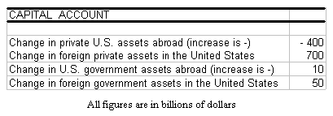

- Using the table above calculate the balance on capital account.

The balance on capital account is simply the sum of all the figures in the table which equals $360 billion.

Difficulty: E Type: A

- If there are no errors of measurement in the data collection, to what must the balance on capital account always be equal? Why is this true?

If there were no errors of measurement in the data collection, the balance on capital account would equal the negative of the balance on current account, because, for each transaction in the current account there is an offsetting transaction in the capital account.

Difficulty: E Type: C

- What is the balance on capital account a measure of in the United States?

In the United States, the sum of the following (measured in a given period): the change in private U.S. assets abroad, the change in foreign private assets in the United States, the change in U.S. government assets abroad, and the change in foreign government assets in the United States.

Difficulty: E Type: D

- Suppose that a Mexican company buys a building in New York City from an American company. Assume that this American company takes the proceeds from this sale and purchases and equal amount of stock in a Mexican based company. How will the effect of these two transactions impact the net wealth position of the U.S.?

If the U.S. took the pesos and bought securities in a Mexican company, this was simply a switch of one kind of U.S. asset abroad (pesos) for another (Mexican stock). It would have no impact on the net wealth position of the U.S. (This ignores the initial transaction. Nonetheless, there's still no net impact.) The bottom line is that Mexicans have bought as much American assets as Americans have bought Mexican assets.

Difficulty: E Type: C

- Define a nation's balance of payments. Explain the major accounts of a country's balance of payments and explain their relationship.

A nation's balance of payments is the record of a country's transactions in goods, services, and assets with the rest of the world; it is also the record of a country's sources and uses of foreign exchange. Simply, in the balance of payments any transaction that brings in foreign exchange is a credit and any transaction where a nation loses foreign exchange is a debit. The two major accounts in the balance of payments are the current account and the capital account. The current account is subdivided into merchandise imports and exports, exports and imports of services, and income received and paid on investments. The capital account is subdivided into change in private U.S. assets abroad, change in foreign private assets, change in U.S. government assets abroad, and change in foreign government assets in the United States.

Difficulty: E Type: D

- In the following series of questions explain how the situations affect the United States' balance of payments.

(a) A U.S. defense contractor sells its consulting services to a company in France.
(b) Your investment club decides to buy 100 shares of a promising Korean automobile manufacturer.
(c) A consortium of European investors decides to build a large manufacturing facility in Montana.
Answer:
(a) This would bring foreign exchange into the country, thus there would be a credit on the balance of payments. This would be a credit on the U.S. current account.
(b) This is a debit on the U.S. capital account. Here, U.S. dollars are leaving the country to buy a foreign stock. This would be a debit to the overall balance of payments.
(c) This transaction will be a credit on the U.S. current account, as this will bring in new investment (foreign exchange) from overseas investors.

Difficulty: M Type: A

- Identify whether each of the following would lead to an appreciation or depreciation of the dollar. In each case, explain why the currency either appreciates or depreciates.

(a) U.S. citizens switch from buying stock in British companies to buying stock in U.S. companies.
(b) The inflation rate in the United States increases relative to the inflation rate in England.
(c) The money supply is increased in the United States.
(d) Income in the United States increases.

(a) This causes the supply of dollars to decrease in the foreign exchange markets and the value of the dollar to appreciate.
(b) An increase in the inflation rate in the United States relative to England causes the demand for dollars in the foreign exchange markets to decrease and the supply of dollars in the foreign exchange markets to increase. This leads to a depreciation of the dollar.
(c) An increase in the money supply leads to lower interest rates, which reduces the demand for dollars in the foreign exchange markets and increases the supply of dollars in the foreign exchange markets. This leads to a depreciation of the dollar.
(d) When income in the United States increases, the supply of dollars increases in the foreign exchange markets. This leads to a depreciation of the dollar.

Diff: 2
Type:

Equilibrium Output (Income) in an Open Economy

- Define net exports.

Net exports represent the difference between a country's total exports and total imports of goods and services.

Difficulty: E Type: D

- Define marginal propensity to import.

The marginal propensity to import is the change in imports caused by a $1 change in income.

Difficulty: E Type: D

- Write out the equation for the open-economy multiplier.

$\text{multiplier}=\frac{1}{1−(\text{MPC}−\text{MPM})}$The open-economy

where MPC is the marginal propensity to consume and MPM is the marginal propensity to import.

Difficulty: E Type: A

- Calculate the open-economy multiplier where the MPC = .9 and the MPM = .1
$\text{multiplier}=\frac{1}{1−(\text{MPC}−\text{MPM})}$

Substituting yields 1/1 - (.9 - .1) = 1/.2 = 5.

Difficulty: E Type: A

- Why is it that a sustained increase in government spending (or investment) on income is smaller in an open economy than in a closed economy?

The reason is that when government spending (or investment) increases and income and consumption rise, some of the extra consumption spending that results is on foreign products and not on domestically produced goods and services.
Difficulty: E Type: C

- Explain the trade feedback effect.

It is the tendency for an increase in the economic activity of one country to lead to a worldwide increase in economic activity, which then feeds back to that country.

Difficulty: E Type: C

- How is it possible for an increase in U.S. imports to eventually benefit U.S. exporters? What is this effect called?

An increase in U.S. imports increases other countries' exports, which stimulates those countries' economies and increases their imports, which increases U.S. exports. This is the trade feedback effect.

Difficulty: E Type: C

- What are a country's export prices generally a function of and how does this affect exportable and nonexportable goods for that country?

A country's export prices tend to move fairly closely with the general price level in that country. If that country is experiencing a general increase in prices, it is likely this change will be reflected in price increases in all domestically produced goods, both exportable and nonexportable.

Difficulty: E Type: F

- Why is it true that when the prices of a country's imports increase, the prices of domestic goods may increase in response? Provide two explanations.

First, an increase in the prices of imported inputs will shift a country's aggregate supply curve to the left. This will cause an increase in the domestic price level. Second, if import prices rise relative to domestic prices, households will tend to substitute domestically produced goods and services for imports. This is equivalent to a rightward shift of the aggregate demand curve. If the economy is operating on the vertical part of the aggregate supply curve, the overall domestic price level will rise.

Difficulty: E Type: C

- If in 2003 the MPM = .15 and there was a $5,000 increase in income, would import spending change? By how much?

$5,000 × .15 = $750. Yes, import spending increases by $750.

Difficulty: E Type: F

- Answer the questions below using the following information about the economy of Tumania. Hint: Don't forget about taxes!

C = 100 + .8(Yd)

I = 100

G = 75
T = 60
EX = 50
IM = 40 + .15(Yd)

(a) Determine the equilibrium level of GDP.
(b) What is the government budget deficit?
(c) At this level of equilibrium is there a trade deficit or surplus? What is the amount of deficit or surplus?
(d) What is the open-economy multiplier in this economy?
(e) If government spending increases by 15, what happens to equilibrium GDP? Does the balance of trade situation change when government spending increases?
(f) The country of Tumania experiences a 5% appreciation of its currency. Assume that for every 1% increase in its currency's value, imports increase by 6 units and exports fall by 3 units. How does this currency appreciation affect GDP?

(a) Equilibrium GDP = $702.86.
(b) The government budget deficit is $15.
(c) There is a trade deficit of $86.43.
(d) The open-economy multiplier is 2.86.
(e) Equilibrium GDP changes by $42.9 if government spending changes by 15. The trade deficit will increase by $6.44.
(f) 5% × 6 = a 30 unit increase in imports. 5% × 3 = a 15 unit decrease in exports. Equilibrium GDP changes from $702.86 to $574.29, a change of $128.57 due to the appreciation of its currency.

Difficulty: D Type: A

- Define the price feedback effect. Graphically illustrate how the price feedback effect causes the domestic aggregate supply and demand curves to shift.

The price feedback effect is the process by which a domestic price increase in one country can "feed back" on itself through export and import prices. An increase in the price level in one country can drive up prices in other countries, which then increases the price level in the first country. When the price feedback effect occurs, there is an increase in the price of imported inputs which causes AS to shift to the left, and if import prices increase relative to domestic prices, households will substitute domestically produced goods for imports. With a leftward shift of AS and a rightward shift of AD, there is an increase in the overall price level.

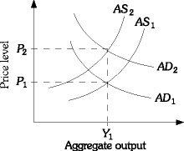

Difficulty: M Type: D

- Explain why there must be a surplus in a country's capital account if the country is running a deficit in its current account.

The overall balance of payments must be zero, so if there is a surplus in the capital account there must be a deficit in the current account.

Difficulty: E Type: C

- Explain why the size of the government spending multiplier is smaller in an open economy than in a closed economy.

The government spending multiplier is smaller in an open economy because part of the increase in income is spent on foreign products and not on domestically produced goods.

Difficulty: M Type: C

- You are given the following information about an economy: C = 200 + .75Yd; I = 50; G = 100; EX = 25; IM = .15Yd; and T = 60.

(a) What is the equilibrium level of income?
(b) At the equilibrium level of income is the economy running a trade deficit or trade surplus? What is the amount of the trade deficit or surplus?
(c) What is the open-economy multiplier?
(d) If government spending increases by 100, what will be the change in income? What is the new equilibrium level of income?
(e) At the new equilibrium level of income, what is the level of imports and exports?

(a) The equilibrium level of income is 847.5.
(b) At the equilibrium level of income there is a trade deficit of 93.125.
(c) The open-economy multiplier is 2.5.
(d) An increase in government spending of 100 increases output by $250. The new level of income is 1,097.5.
(e) Exports are still 25. Imports are 155.625.

Difficulty: D Type: A

- Explain the trade feedback effect.

As the economic activity of one country rises and its imports increase, other countries will be exporting more. As these countries export more, their income rises and their imports increase. This increases the country's exports, and the feedback process continues.

Difficulty: E Type: D

- Why is it in the best interest of the United States when its trading partners' levels of economic activity increase?

If there is an increase in the economic activity of the United States' trading partners, then according to the trade feedback effect, economic activity in the United States will also increase.

Difficulty: E Type: C

- Explain what effect a fiscal expansion would have in an open economy under flexible exchange rates.

A fiscal expansion will cause an increase in planned expenditures, a reduction in inventories, and an increase in output. As output rises, money demand will increase. As money demand rises, the domestic interest rate will increase. The increase in the domestic interest rate will make domestic bonds more attractive. So, the demand for the domestic currency will increase. This will cause the domestic currency to appreciate. This appreciation will make domestic goods relatively more expensive; therefore, exports will fall and imports will rise. This reduction in net exports will partially crowd out some of the fiscal expansion.

Difficulty: D Type: A

- What is the expression for planned aggregate expenditures for an open economy? Briefly explain why and how this is different from the expression of planned aggregate expenditures for a closed economy.

The expression for planned aggregate expenditures (of domestically produced goods and services) is: AE = C + I + G + (EX - IM). We must add exports (EX) in order to take into account the demand for domestically produced goods and services by individuals, firms, and governments outside the domestic economy. At the same time, some of the goods and services bought by U.S. households, firms, and governments might have been produced outside the United States. Therefore, we must subtract these imports from C, I and G. For the closed economy, AE = C + I + G. All of the goods produced domestically were sold to domestic residents (i.e., EX = 0). At the same time, all of the goods purchased by domestic residents, firms, and governments were produced domestically (i.e., IM = 0).

Difficulty: M Type: C

- Give five reasons why demand for a foreign currency may increase.

Firms, households or governments may want to buy goods from the foreign country. Citizens may need the foreign currency because they will be traveling to the country. Individuals may want to buy foreign stocks, bonds or other financial instruments. Countries may want to invest in the foreign country. Speculators may anticipate a decline in value of the country's currency relative to the foreign country's currency.

Difficulty: M Type: A

- Explain how the size of the multiplier in an open economy is different from the size of the multiplier in a closed economy.

In a closed economy, all of the additional planned spending that occurs when income, for example, rises is spent on domestically produced goods and services. In an open economy, some of the additional spending goes to foreign produced goods and services (i.e., imports). This reduces the extent to which inventories at domestic firms fall as spending rises. This will also reduce the extent to which output will rise as a result of a given change in planned expenditures. Therefore, the multiplier is smaller for an open economy.

Difficulty: M Type: D

- Suppose an economy is represented by the following equations.

1. Consumption function C = 200 + 0.6Yd
2. Planned investment I = 250
3. Government spending G = 600
4. Exports EX = 200
5. Imports IM = 0.1Yd
6. Disposable income Yd = Y - T
7. Taxes T = 500
8. Planned aggregate expenditure AE = C + I + G + (EX - IM)
9. Definition of equilibrium income Y = AE

(a) Calculate the equilibrium level of income for this economy.
(b) Based on your answer in Part (a), is the country experiencing a trade surplus or deficit? If so, what is the size of the deficit or surplus?
(c) Suppose government spending increases by 100. Calculate what happens to the size of the trade deficit or surplus. Briefly explain any changes in the size of any surplus or deficit.
(d) What is the government spending multiplier?
(e) What is the size of the deficit response index for this economy? Explain.

(a) Y = 2000
(b) EX = 200 and IM = 150; therefore, a trade surplus of 50 exists.
(c) Y = 2200. EX = 200 and IM = 170. The trade surplus is now 30. The surplus is now smaller. This occurs because as income rises, imports increase.
(d) The multiplier is 2.
(e) The deficit response index for this economy is zero!! Any change in Y has NO effect on the size of the budget deficit or surplus. This is so because G and T are completely independent of Y in this economy.

Difficulty: M Type: A

The Open Economy with Flexible Exchange Rates

- What are floating exchange rates?

Floating exchange rates are determined by unregulated forces of supply and demand.

Difficulty: E Type: D

U.S. citizens traveling to Mexico
Mexican citizens traveling to the U.S.
Holders of dollars who want to buy Mexican stocks
U.S. companies that want to invest in Mexico
Speculators who anticipate a rise in the value of the dollar relative to the peso

- The table above represents a list of private buyers and sellers in international exchange markets in the United States and Mexico. Identify each as either "demanding pesos" or "supplying pesos."

U.S. citizens traveling to Mexico | Demanding pesos
Mexican citizens traveling to the U.S. | Supplying pesos
Holders of dollars who want to buy Mexican stocks | Demanding pesos
U.S. companies that want to invest in Mexico | Demanding pesos
Speculators who anticipate a rise in the value of the dollar relative to the peso | Supplying pesos

Difficulty: E Type: C

- Draw a demand for pesos. Assume that the "price" of pesos is in dollars. Explain what happens as the price of the peso falls.
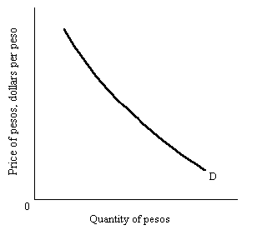

When the price of pesos falls, Mexican-made goods and services are less expensive to U.S. buyers. If prices in Mexico are constant, U.S. buyers will buy more Mexican goods and services, and the quantity of pesos demanded will rise.

Difficulty: E Type: A
- Draw the supply of Mexican pesos in the foreign exchange market. Assume that the "price" of pesos is in dollars. Explain what happens as the price of the peso rises.
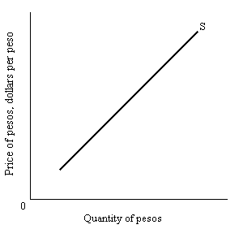

When the price of pesos rises, Mexican residents can obtain more dollars for each peso. This means that U.S.-made goods and services are less expensive to buyers in Mexico. Thus, the quantity of pesos supplied is likely to rise with the exchange rate.

Difficulty: E Type: A

- Define currency appreciation.

Currency appreciation is the rise in the value of one currency relative to another.

Difficulty: E Type: D

- Define currency depreciation.

Currency depreciation is the fall in value of one currency relative to another.

Difficulty: E Type: D

- Assume that there is trade only between the U.S. and Mexico. In addition, there is a floating exchange rate. Explain what would happen in the case of an excess demand for pesos. Explain what would happen in the case of an excess supply of pesos.

An excess demand for pesos will cause the peso to appreciate against the dollar. An excess supply of pesos will lead to a depreciating peso.

Difficulty: E Type: C

- Explain the "law of one price."

If the costs of transportation are small, the price of the same good in different countries should be roughly the same.

Difficulty: E Type: D

- Explain the purchasing-power-parity theory.

It is a theory of international exchange holding that exchange rates are set by market forces so that the price of similar goods in different countries is the same.

Difficulty: E Type: D

- What role would monetary policy play in a country with a fixed exchange rate? Explain.

The short answer is that it would play no role. If a country wants to keep its exchange rate fixed to let’s say the U.S. dollar then interest rates in that country cannot change vis-a-vis the U.S. If the monetary authority tried to lower its interest rate this would lead the country’s currency to depreciate. People would want to sell the country’s currency. In other words, if a country tries to change monetary policy to affect interest rates this will have an impact on the exchange rate. Of course this is counter productive if what you are also trying to achieve is a fixed exchange rate.

Difficulty: E Type: D

- Explain the economic pressures that will come to bear on the exchange rate if there is a high rate of inflation in one country relative to another.

A high rate of inflation in one country relative to another puts pressure on the exchange rate between the two countries, and there is a general tendency for the currencies of relative high-inflation countries to depreciate.

Difficulty: E Type: D

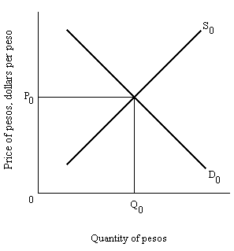

- Using the figure above show the effect on the demand and supply of pesos if there is an increase in the price level in the U.S. Assume a two nation world.

The higher price level in the United States makes imports relatively less expensive. U.S. citizens are likely to increase their spending on imports from Mexico, shifting the demand for pesos to the right. At the same time, residents of Mexico see U.S. goods getting more expensive and reduce their demand for exports from the United States. The supply of pesos shifts to the left. The result is an increase in the price of pesos. The peso appreciates and the dollar is worth less.

Difficulty: E Type: A

- Assume that interest rates for bonds in Canada are 9 percent and 6 percent in the United States. All other things being equal what will be the impact on the value of the dollar as investors seek to take advantage of this interest rate differential.

We would assume that investors in the U.S. would take advantage by buying up Canadian bonds. Canadian bonds can only be purchased with Canadian dollars. The increased demand for the Canadian dollar will increase its price and therefore decrease the price of the U.S. dollar.

Difficulty: E Type: C

An Interdependent World Economy

- What would you predict would happen to U.S. exports if the dollar were to depreciate?

When the value of the dollar is cheap, U.S. products are more competitive with products produced in the rest of the world. This leads to a rise in U.S. exports.

Difficulty: E Type: C

- Explain the J-curve effect.

Following currency depreciation, a country's balance of trade may get worse before it gets better. The graph showing this effect is shaped like the letter J, hence the name "J-curve effect."

Difficulty: E Type: C

- Draw the J-curve effect. Make sure to explain the initial effects and the subsequent effects after full adjustment has taken place.
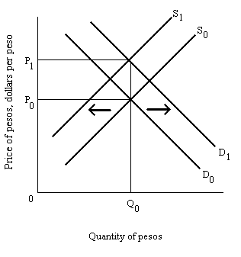
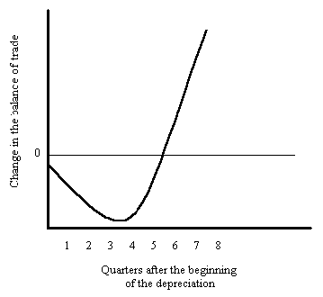
Initially, depreciation of a country's currency may worsen its balance of trade. The negative effect on the price of imports may initially dominate the positive effects of an increase in exports and a decrease in imports.

Difficulty: E Type: A

- Why is time a factor in making the trade balance worsen after a depreciation? What impact does the elasticity of exports and imports have on the eventual improvement in the balance of trade as more time passes?

The impact of depreciation on the price of imports is generally felt quickly, while it takes time for export and import quantities to respond to price changes. In the short run, the value of imports increases more than the value of exports, so the trade balance worsens. The more elastic the demand for exports and imports, the larger the eventual improvement in the balance of trade.

Difficulty: E Type: C

- Give two explanations for why depreciation of a country's currency tends to increase its price level.

The first reason is that when a country's currency is less expensive, its products are more competitive on world markets, so exports rise. This pushes aggregate demand rightward and could cause the price level to rise if the economy is at or near the vertical segment of the aggregate supply curve. The second reason is that depreciation makes imported inputs more expensive. If costs increase, the aggregate supply curve shifts to the left. If aggregate demand remains unchanged, the result is an increase in the price level.

Difficulty: E Type: C

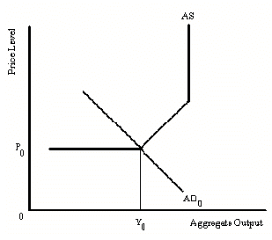

- Using the above figure draw the new aggregate demand curve and the new aggregate supply curve that are likely to be the result of a currency depreciation. What happens to the price level and aggregate output?
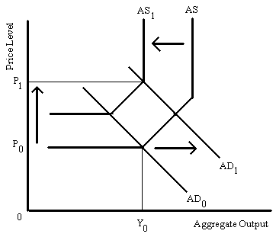

The depreciation causes the aggregate demand curve to shift to the right because of the rise in exports that is likely to result from U.S. exports become cheaper. Secondly, the aggregate supply curve will shift to the left, as imported inputs become more expensive. The effect is to raise the general price level. The effect on aggregate output is indeterminate.

Difficulty: E Type: C

- Explain the impact on the international value of the dollar of an expansionary monetary policy when the economy is below full employment.

First, the expansionary monetary policy will lower interest rates. This will lower the demand for U.S. securities by foreigners, so the demand for dollars drops. Second, U.S. investors will be more likely to buy foreign securities, so the supply of dollars rises. Both events push down the value of the dollar.

Difficulty: E Type: C

- Explain the impact on the international value of the dollar of a contractionary monetary policy when the economy is operating at full employment with price inflation.

First, the contractionary monetary policy will raise interest rates. This will raise the demand for U.S. securities by foreigners, so the demand for dollars rises. Second, U.S. investors will be less likely to buy foreign securities, so the supply of dollars falls. Both events push up the value of the dollar.

Difficulty: E Type: C

- How might a cheaper dollar be a good thing for monetary authorities when they are expanding the money supply?

A cheaper dollar is a good thing if the goal of the monetary expansion is to stimulate the domestic economy, because a cheaper dollar means more U.S. exports and fewer imports. If consumers substitute U.S.-made goods for imports, both the added exports and the decrease in imports mean more spending on domestic products, so the multiplier effect actually increases.

Difficulty: E Type: C

- Suppose that inflation is a problem and the Fed wants to slow it down by contracting the money supply. How can floating exchange rates help the Fed do its job?

Contractionary monetary policy raises interest rates. The higher interest rate lowers domestic investment spending and consumer spending, and lowers the price level. The higher interest rate also attracts foreign buyers into U.S. financial markets, driving up the value of the dollar, which reduces the price of imports. The reduction in the price of imports shifts the aggregate supply curve to the right which helps fight inflation.

Difficulty: E Type: C

- Without a fully accommodating Fed what are the three factors at work to reduce the multiplier effect when the government is engaging in expansionary fiscal policy?

First, a higher interest rate from the increase in money demand may crowd out private investment and consumption. Second, some of the increase in income from the expansion will be spent on imports. Third, a higher interest rate may cause the dollar to appreciate, discouraging exports and further encouraging imports.

Difficulty: E Type: C

- Why is it important for the success of an expansionary fiscal policy to be accommodated by the Fed?

An expansionary fiscal policy that is accommodated by the Fed will keep interest rates from rising by as much or at all than without the Fed's help. This will help blunt the negative side effects of expansionary fiscal policy both domestically and the impact of the open economy. It will reduce the amount of the crowding out effect on investment and will slow or stop the inflow of foreign capital that may otherwise cause the dollar to appreciate and reduce the competitiveness of U.S.-made goods and services.

Difficulty: E Type: C

- Explain the law of one price.

According to the law of one price, if the costs of transportation are small, the price of the same good in different countries should be roughly the same. If transportation costs are small and prices were not equal, profit opportunities would persist. It will pay someone to buy the product where it is cheap and sell it where it is expensive. This will continue to happen until the prices are roughly equal.

Difficulty:E Type: D

- Explain why the depreciation of a country's currency tends to increase its price level.

A depreciation of a country's currency tends to increase its price level because it increases the price of imported inputs. A currency depreciation stimulates exports, which increases aggregate demand, and also increases the price level.

Difficulty: E Type: C

- According to purchasing power parity theory, in the long run what would happen to the exchange rate if the price of a computer in the United States = $1,000, the price of a computer in Japan = 200,000 yen, and the current exchange rate was $1.00 = 100 Yen?

The purchasing power parity theory holds that in the long run the exchange value of the dollar would appreciate and the yen would depreciate until the price of computers is the same in both countries.

Difficulty: M Type: A

- Explain the effect of U.S. expansionary monetary policy on the U.S. economy if exchange rates are flexible. How would the effectiveness of an expansionary monetary policy change if exchange rates were fixed?

An expansionary monetary policy reduces the interest rate. The lower interest rate makes U.S. investments less attractive to foreigners and reduces the demand for dollars. This leads to a depreciation in the value of the dollar. The lower value of the dollar stimulates exports and reduces imports. This leads to a further expansion in aggregate demand and the multiplier actually increases. If the exchange rate is fixed, an increase in the money supply could not change the exchange rate and therefore there would be no added stimulus to the economy in the form of an increase in net exports.

Difficulty: M Type: A

- Explain what effect a monetary contraction would have in an open economy under flexible exchange rates.

A monetary contraction will cause an excess demand for money and an increase in the domestic interest rate. The increase in the domestic interest rate will make domestic bonds more attractive. So, the demand for the domestic currency will increase. This will cause the domestic currency to appreciate. This appreciation will make domestic goods relatively more expensive; therefore, exports will fall and imports will rise. The reduction in net exports will cause a reduction in planned expenditures and cause output to fall (in addition to the reduction in AE caused by the r-induced drop in investment).

Difficulty: M Type: D

