FIRMS AND HOUSEHOLDS

- Define what a firm is and its role in the market.

The firm is an organization that transforms resources (inputs) into products (output). Firms are the primary producing units in a market economy.

Difficulty: E Type: D

- Explain what an entrepreneur is and its function.

An entrepreneur is a person who organizes, manages, and assumes the risks of a firm, taking a new idea or a new product and turning it into a successful business.

Difficulty: E Type: D

- Even though household have wide-ranging preferences, discuss some of the things
that all households have in common including their constraints.

All households have limited income and all must pay in some way for the things they consume. They are also constrained by the availability of jobs, current wages, their own abilities, and their accumulated and inherited wealth.

Difficulty: E Type: C

INPUT MARKETS AND OUTPUT MARKETS: THE CIRCULAR FLOW

- List and describe three different input markets.

The labor market is where household members sell their labor services in exchange for wages. In capital markets, households supply funds for firms to purchase capital equipment. Land and other real property are exchanged in the land market.

Difficulty: E Type: F

- What types of things are sold in input or factor markets? Who are the buyers and
sellers in these markets?

Resources used to produce goods and services are sold in input markets. These include labor, capital, and land. In input markets, households are the sellers (suppliers) and firms are the buyers (demanders).

Difficulty: E Type: F

DEMAND IN PRODUCT/OUTPUT MARKETS

- What relationship is shown by a demand curve?

The demand curve shows the relationship between price and quantity demanded. Since price and quantity demanded are inversely related, the demand curve is downward sloping.

Difficulty: E Type: D

- Explain the difference between a change in demand and a change in quantity
demanded.

A change in demand is represented by a shift in the demand curve and can be caused by changes in non-price determinants of demand such as income, preferences, or prices of related goods. A change in quantity demanded is represented by a movement along the demand curve and is caused by a change in the price of the good in question.

Difficulty: M Type: D

- A video rental store rents old movies for $1.50 per day. On average, 300 movies are
rented each day. The store receives several copies of a new smash movie just released in video and decides to rent these movies at $3.50 per day. Now, 400 movies are rented each day. Thus, though the average rental price of a movie increased, the quantity rented increased. Does this mean that the law of demand does not hold for this market?

The two types of movies (old and new release) represent two different markets. Thus, there is a demand for old movies and a demand for new releases. Both of these demand curves would be downward sloping, meaning that the law of demand applies.

Difficulty: M Type: C

- Explain the law of demand. What does it imply about the shape of the demand curve?

The law of demand describes the inverse relationship between price and quantity demanded. All else equal, as the price of a good rises, the quantity demanded of the good will fall. As the price of a good falls, the quantity demanded rises. This implies that the demand curve will be downward sloping.

Difficulty: E Type: D

- What is the difference between a demand schedule and a demand curve?

Both show quantity demand at a given price. The only difference is the form of the information. A demand schedule lists the price and quantity information in a table. A demand curve shows the same information using a graph.

Difficulty: M Type: D

- List three things that can cause an increase in demand. Be specific.

Student responses will vary but may include:
(1.) An increase in income (normal good).
(2.) A decrease in income (inferior good).
(3.) An increase in the price of a substitute good.
(4.) A decrease in the price of a complementary good.
(5.) A change in preferences (the product is more desirable than before).

Difficulty: E Type: C

- Suppose the U.S. economy enters a recession and incomes fall. What will happen to
the equilibrium prices and quantities of normal goods? Would your answer be the same if you were discussing inferior goods? Why or why not?

If incomes fall, the demand for normal goods will fall as well. This means that the demand curve will shift to the left, lowering both the equilibrium price and equilibrium quantity. The answer would be opposite if we were discussing inferior goods. A decrease in income raises the demand for inferior goods, leading to a higher equilibrium price and quantity.

Difficulty: E Type: A

- List three characteristics of demand curves. Make sure to explain the shape of the
curve and the meaning of the vertical and horizontal intercepts.

First, they are downward sloping. Second, they intersect the vertical axis because there will be a price above which quantity demanded will be zero. Last, they intersect the horizontal axis. Even at a price of zero, quantity demanded will be limited for a given period of time.

Difficulty: E Type: C

- Explain the law of diminishing marginal utility. How does it relate to the shape of
the demand curve?

The law of diminishing marginal utility states that each additional unit of a good consumed provides less and less additional satisfaction. Therefore, the amount that a person will be willing to pay for a product will fall as more of the product is consumed. This is one reason why demand curves slope downward.

Difficulty: E Type: D

- When the price of good X rises, the demand for good Y falls. Explain what this
relationship implies about the two goods.

Goods X and Y must be complements. When the price of good X rises, the quantity of good X demanded will fall. If the demand for Y also falls, the two goods must be used together.

Difficulty: E Type: C

- In what ways can expectations change your demand for a product today?

Expectations about both future prices and future incomes may affect your demand for a product today. For example, if you expect the price of gasoline to rise tomorrow, you will want to fill up your car’s gas tank today. Also, expectations about future incomes may affect purchases today. An individual who believes that he may soon be laid off from his job (and therefore see a drop in his income) will be unlikely to purchase a new car today.

Difficulty: E Type: A

- John's income has just increased by $10,000 per year. If Ramen noodles is an
inferior good in John’s opinion, what will happen to his demand for Ramen noodles? Show your answer using a graph.

Since Ramen noodles is an inferior good for John, his demand for ramen noodles will decrease when his income rises. Therefore, his demand curve will shift to the left.
Price

D1

D2

Quantity of ramen noodles

Difficulty: E Type: F

- Compare and contrast the concepts of income and wealth. Are these measured as a
stock or a flow? Explain.

Wealth, or net worth, is the total value of what an entity owns minus what it owes. It is a stock measure because wealth is measured at a given point in time. Income is the sum of all wages, salaries, profits, interest and other forms of earnings for an entity over a given period of time. Because it is measured over a period of time, it is a flow measure.

Difficulty: M Type: D
- Show graphically (in two separate graphs) the effects of an increase in the price of
peanut butter on the demand for peanut butter and on the demand for jelly.

An increase in the price of peanut butter causes a decrease in the quantity of peanut butter demanded. This is shown by a movement along the demand curve for peanut butter from point A to point B. Since peanut butter and jelly are complements, an increase in the price of peanut butter will cause a decrease in the demand for jelly. This is shown by a shift in the demand curve for jelly to the left.
Price
Price

B

D1
A

Demand
D2

Quantity of jelly
Quantity of peanut butter

Difficulty: M Type: A

- When the price of compact disc players decreases, the demand for compact discs
rises while the demand for cassette tapes decreases. What does this imply about the relationship between compact disc players, compact discs, and cassette tapes?

Compact disc players and compact discs must be complements. Compact disc players and cassette tapes must be substitutes.

Difficulty: E Type: C

- Explain how the market demand curve can be derived. Does the law of demand
apply to the market demand curve?

The market demand curve for a good can be found by summing the quantities demanded by all of the households buying in the market for that good. Since all individuals’ demand curves are downward sloping (due to the law of demand), the market demand curve will also be downward sloping. Therefore, the law of demand does apply to the market demand curve as well.

Difficulty: E Type: C

- Below are the demand curves for CDs for two individuals: Bob and Tom.
Price
Price
Bob’s demand
Tom’s demand

$20.00
$20.00

$15.00
$15.00

12
9
3
5

Quantity of CDs
Quantity of CDs

Assume that Bob and Tom are the only two buyers in the market for CDs. Draw the market demand curve.

Market demand is the sum of the quantities of a good demanded by all of the households in the market for that good. Therefore, the market demand for CDs will look like the one in the figure below.
Price

$20.00
Market demand

$15.00

21
8
Quantity of CDs

Difficulty: E Type: A

- Suppose a long lost relative died and left you a trust fund worth $1 million that you
will receive ten years from now. What effect, if any, will this have on your demand for airline travel? (Assume that airline travel is a normal good.)

This will likely increase your demand for airline travel, shifting the curve to the right.

Difficulty: E Type: C

Supply in Product/Output Markets

- What relationship is shown by a supply curve?

A supply curve shows the relationship between price and quantity supplied. Because price and quantity supplied are directly related, the supply curve is upward sloping.

Difficulty: E Type: D

- Explain the law of supply. What does the law of supply imply about the shape of the
supply curve?

The law of supply describes the positive relationship between price and quantity supplied. All else equal, as the price of a good rises, the quantity supplied of the good rises as well. As the price of a good falls, the quantity supplied falls. This implies that the supply curve will be upward sloping.

Difficulty: E Type: D

- Explain the difference between a change in supply and a change in quantity supplied.

A change in supply is represented by a shift in a supply curve. It can be caused by changes in non-price determinants of supply such as the cost of producing the product or the prices of related products. A change in the quantity supplied is represented by a movement along a supply curve. It is caused by a change in the price of the good itself.

Difficulty: E Type: D

- Explain how an increase in the price of leather brought about by shift in tastes may
lead to an increase in the supply of beef.

An increase in the price of leather will lead to an increase in the quantity of leather supplied. Thus, as ranchers raise more cattle (to increase the quantity of leather supplied), they will also have more beef to supply to the market.

Difficulty: M Type: A

- Explain how price expectations can affect the supply of a product.

If sellers expect the price of the product to rise in the future, they will want to hold onto their product and sell it at that time. Therefore, their current supply will fall. Likewise, if sellers expect the price of their product to fall in the future, they will want to sell as much of their product as possible today, increasing the supply.

Difficulty: E Type: C

- Below are the supply curves for cucumbers for two firms: Firm X and Firm Y.
Price
Price
Firm X's supply
Firm Y's supply

$0.50
$0.50

$0.30
$0.30

20
10
60
30
Quantity of cucumbers
Quantity of cucumbers

Assume that Firm X and Firm Y are the only two sellers in the market for cucumbers. Draw the market supply curve.

Market supply is the sum of all the quantities of a good supplied by all of the suppliers in the market for that good. Therefore, the market supply for cucumbers will look like the one in the figure below.
Price

Market supply
$0.50

$0.30

80
40
Quantity of cucumbers

Difficulty: E Type: A

- Explain how the market supply curve can be derived. Does the law of supply apply
to the market supply curve?

The market supply curve for a good can be found by summing the quantities supplied by all of the firms selling in the market for that good. Since all firms’ supply curves are upward sloping (due to the law of supply), the market supply curve will also be upward sloping. Therefore, the law of supply does apply to the market supply curve as well.

Difficulty: E Type: C

- Show graphically the effect of an increase in the wage paid to autoworkers on the
supply of new cars.

An increase in wage paid to autoworkers would increase the cost of producing a new car. Therefore, the supply of new cars will decrease.
Price
S2
S1

Quantity of new cars

Difficulty: E Type: C

- Define the following: market equilibrium, surplus, and shortage.

When a market is in equilibrium, quantity supplied is equal to quantity demanded. If quantity supplied is greater than quantity demanded, there is a surplus. If quantity demanded is greater than quantity supplied, there is a shortage.

Difficulty: E Type: D

- Using graphs, explain the effect of an increase in the price of cheese on the supply of
cheese and the supply of pizza.

The increase in the price of cheese will cause an increase in the quantity of cheese supplied, which can be shown by a movement along the supply curve for cheese. Since an increase in the price of cheese will raise the cost of producing pizza, the supply of pizza will decrease. This is shown by a shift of the supply curve for pizza to the left.

S2
Price
Price
Supply

S1
B

A

Quantity of pizza
Quantity of cheese

Difficulty: M Type: A

Market Equilibrium

- The following are some changes that may take place in the market for textbooks. For
each of the following, indicate what will happen to either the demand for or the supply of textbooks by listing which curve is affected and then the terms: "shift right or "shift left".

(a.) An increase in student enrollment at universities across the country.
(b.) A decrease in the price of ink used to print textbooks.
(c.) A drop in income (textbooks are a normal good).
(d.) An improvement in the technology used to print textbooks..
(e.) An increase in college tuition.

(a.) The demand curve will shift right.
(b.) The supply curve will shift right.
(c.) The demand curve will shift left.
(d.) The supply curve will shift right.
- The demand curve will shift left.

Difficulty: M Type: A

- The market for restaurant pizza in Chicago is currently in equilibrium at a price of $8
and 2,000 pizzas are sold each day. Explain what will happen to the equilibrium price and quantity of pizzas sold and why (which curve has changed) for each of the following situations:

(a.) Delivery personnel form a labor union and secure a higher wage of $7.50 per hour (a large increase in their wage).
(b.) Fast-food hamburger restaurants (Burger King & McDonalds) cut their prices in half.

(a.) The increase in wage will lead to an increase in the cost of producing pizzas. Therefore, the supply of pizza will decrease, causing the equilibrium price to rise and the equilibrium quantity to fall.
- The drop in price of fast-food hamburgers will lower the demand for pizza because pizza and hamburgers are substitute goods. Therefore, both the equilibrium price and equilibrium quantity will fall.

Difficulty: M Type: A

SCENARIO 1: Consider the market for generic light beer, a product that only has “Light Beer” on its label. We know that demand for generic light beer falls when income increases, demand rises when the price of other beer increases, and that demand rises when the price of potato chips falls.

- Refer to Scenario 1. Graph and explain the effect on equilibrium price and
quantity on an increase in income. What type of good is “Light Beer”?

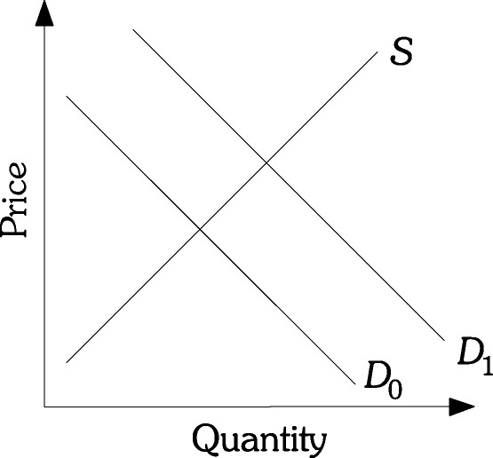

As income increases, demand for generic light beer falls and the equilibrium price and quantity both fall. Generic light beer is an inferior good.

Difficulty: M Type: A

- Refer to Scenario 1. Graph and explain the effect on equilibrium price and
quantity of an increase in the price of premium beer. How are the goods related?

As the price for premium beer increases, the demand for generic light beer rises, and the equilibrium price and quantity both rise. These goods are substitutes.

Difficulty: M Type: A

- Refer to Scenario 1. Graph and explain the effect on equilibrium price and
quantity of beer due to an increase in the price of potato chips. How are the goods related?

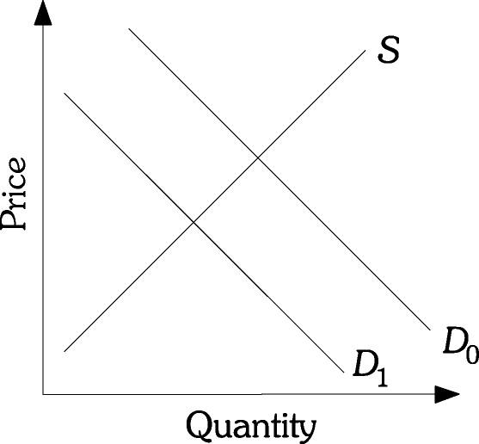

As the price of potato chips increases, the demand for generic light beer falls and the equilibrium price and quantity both fall. The goods are complements.

Difficulty: M Type: A

Refer to the information provided in Scenario 2 below to answer the questions that follow.

SCENARIO 2: Graphically illustrate each of the following effects on the market for home fitness equipment with supply and demand curves. State the effects on price and quantity. Consider each effect separately.

- Refer to Scenario 2. Assume that the price of dues in local health clubs
decreases.

Prices of home equipment will fall as will the equilibrium quantity.

Difficulty: M Type: A

- Refer to Scenario 2. “Infomercials” advertising home fitness equipment begin
to run at night on Cable TV stations.

Price of home fitness equipment will increase as will quantities.

Difficulty: M Type: A

- The cost of steel used in the production of many of the exercise products
increases.

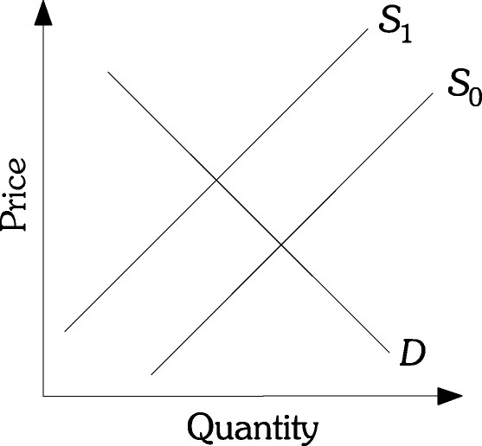

Prices of home fitness equipment will rise, but the equilibrium quantity will fall.

Difficulty: M Type: A

- Refer to Scenario 2. Health clubs begin to offer extras to make going to health
clubs easier, such as free parking and baby-sitting to encourage family memberships.

Prices of home fitness equipment will fall as will the equilibrium quantity.

Difficulty: M Type: A

- Refer to Scenario 2. The existence of a new health craze occurs
simultaneously as new home exercise products enter the market.

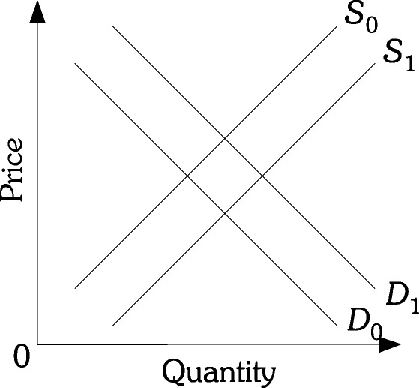

As both supply and demand increase the equilibrium quantity will increase. However, price changes are uncertain because it depends critically on the relative strengths of the demand and supply movements. If supply over powers the demand shock prices may fall. However, if demand moves at a faster clip than supply then prices could actually rise.

SCENARIO 3: Events prior to the 1995 baseball season, including a threatened “lockout” by owners if the players decided to end their strike, likely had a great effect on attendance at baseball games. Consider in this scenario market attendance as a measure of quantity and ticket prices as the measure of price.

- Refer to Scenario 3. Draw the supply and demand curves and explain why
they have the slope they do.

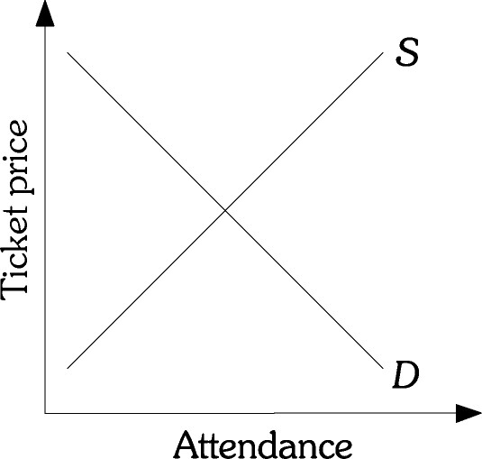

The demand curve slopes downward because as price falls, it is cheaper for individuals to attend games and attendance rises. The supply curve slopes upward because in order to allow for more attendance, there are greater costs on the owners.

Difficulty: M Type: A

- Refer to Scenario 3. Graphically illustrate the effect of dissatisfaction with the
team by fans. What effect does this have on the price and quantity of tickets sold?

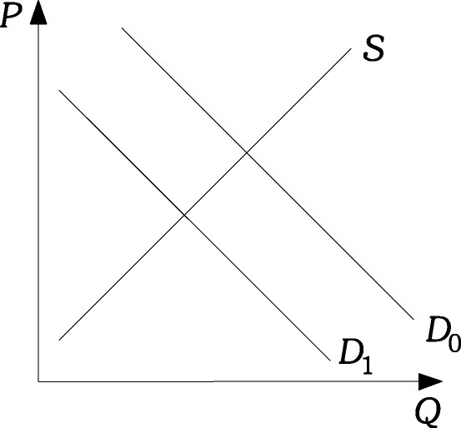

Price and quantity will fall as the demand shifts to the left.

Difficulty: M Type: A

- Refer to Scenario 3. Graphically illustrate the effect of a shortened season.
What effect will this have on the price and quantity of tickets sold?

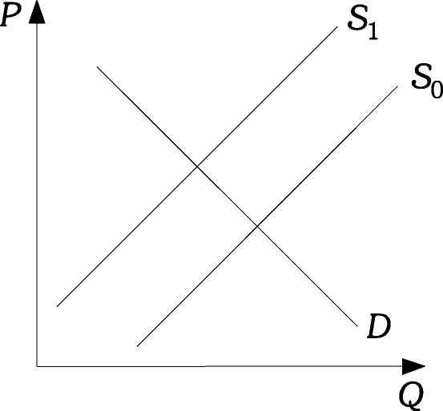

Since there will be fewer games this is the equivalent of a decrease in supply. Therefore, the price of tickets will increase, but the quantity of tickets will decrease.

Difficulty: M Type: A

- Refer to Scenario 3. Graphically illustrate the effect of both fan dissatisfaction
and shorter seasons. What effect will these changes have on price and quantity?

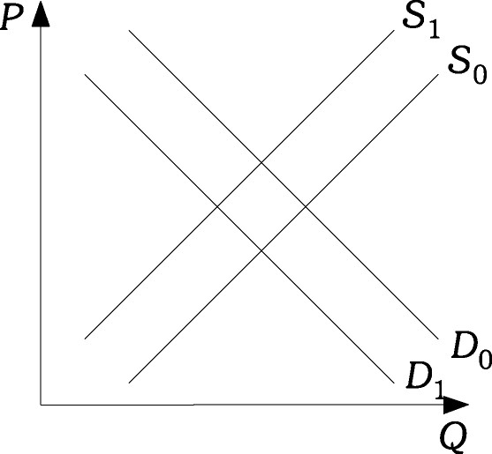

The quantity of tickets sold will decrease. However, the change in the price of tickets is uncertain. The reason is that the decrease in supply has the tendency to pull ticket prices upward but the decrease in demand has the opposite effect. The only way to be certain about the outcome is if the relative strength of the demand and supply shocks are known.

Difficulty: D Type: C

- Refer to Scenario 3. Explain the effect of consumer dissatisfaction on the
market for beer purchased at baseball games.

The lower demand for baseball games would have the effect of lowering the demand for beer purchases.

Difficulty: D Type: C

- The table below shows the supply and demand for T-shirts:

Price | Quantity Demanded | Quantity Supplied
$ 8.00 | 5,000 | 2,000
9.00 | 4,000 | 4,000
10.00 | 3,000 | 6,000
11.00 | 2,000 | 8,000
12.00 | 1,000 | 10,000

(a.) If the price in the market is currently $11.00, is the market in equilibrium? Explain.
(b.) If the price in the market is currently $8.00 and the supply and demand for T-shirts are stable, will the price remain $8.00? Why or why not?

(a.) No. At a price of $11.00, quantity supplied exceeds quantity demanded. Therefore, there is excess supply or a surplus of T-shirts.
(b.) No. At a price of $8.00, quantity demanded exceeds quantity supplied and there is a shortage of T-shirts. Thus, the price of T-shirts will rise until the market moves to a new equilibrium (at a price of $9.00).

Difficulty: E Type: A

- Suppose that the local hospital claims that the wages of nurses are too high. Yet, the
hospital has 10 nursing positions open and no applicants for the jobs. Is the hospital's claim legitimate? Why or why not?

No. Since the quantity of nurses demanded is greater than the quantity supplied, there is a shortage of nurses. Thus, the wage currently paid to nurses must be below the market equilibrium wage.

Difficulty: M Type: A

- Explain how price adjusts to eliminate excess demand.

When there is excess demand, quantity demanded is greater than quantity supplied. Therefore, the price will rise. As the price rises, quantity demanded falls and quantity supplied rises. Price will continue to rise until quantity demanded and quantity supplied are equal (at the market equilibrium).

Difficulty: M Type: C

- The table below shows the supply and demand for pencils:

Price | Quantity Demanded | Quantity Supplied
$ 0.60 | 10,000 | 15,000
0.50 | 12,000 | 12,000
0.40 | 14,000 | 9,000
0.30 | 16,000 | 6,000
0.20 | 18,000 | 3,000

(a.) What is the equilibrium price and quantity? How can you tell?
(b.) Suppose the current price is $0.20. What situation is present? Will the price remain at $0.20? Why or why not?

(a.) The equilibrium price is $0.50 and the equilibrium quantity is 12,000 pencils. Market equilibrium occurs where quantity demanded is equal to quantity supplied.
(b.) At a price of $0.20, quantity demanded (18,000) is greater than quantity supplied (3,000). Therefore, we have a shortage of 15,000 pencils. This will put upward pressure on the price (eventually pushing price to the market equilibrium of $0.50).

Difficulty: E Type: A

- Suppose you want to buy a popular brand of digital camera. Every store in town is out
of stock. You are willing and able to pay the current market price of $300 for a camera, but you cannot find any available. Is the market for the digital camera in equilibrium? If not, is the market equilibrium price of the camera above or below $300? Use supply and demand analysis to explain your answer.

No, the market for the digital camera is not currently in equilibrium because there is a shortage of the camera at the current price of $300. This implies that the market equilibrium price is greater than $300.

Difficulty: M Type: A

- The figure below shows the market for macaroni:

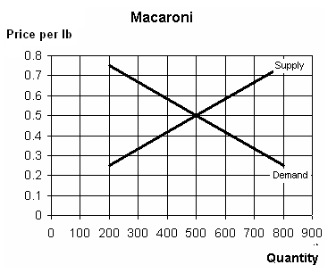
(a.) What is the equilibrium price and quantity?
(b.) At what price shown on the graph would there be an excess demand for macaroni? What would be the size of this excess demand?
(c.) At what price shown on the graph would there be an excess supply of macaroni? What would be the size of this excess supply?

(a.) The equilibrium price is $0.50 per pound and the equilibrium quantity is 500
pounds.
(b.) There would be excess demand at every price below 50 cents per pound.
(c.) There would be excess supply at very price above 50 cents per pound.

Difficulty: M Type: A

- Suppose that the market for oranges is currently in equilibrium at a price of $1 per
pound. An early frost in Florida destroys part of the orange crop. Use supply and demand analysis to predict the impact of the early freeze on the market equilibrium price and quantity of oranges.

The early frost will cause a decrease in the supply of oranges. This will cause the supply curve to shift to the left, raising the equilibrium price of oranges and lowering the equilibrium quantity sold.

Difficulty: M Type: A

- You attend a rock concert and notice that there are hundreds of empty seats. What
might you conclude about the market price of the concert ticket?

Since the quantity of tickets supplied is greater then the quantity of tickets demanded, there is a surplus of tickets. This means that the current price must be greater than the market equilibrium price.

Difficulty: M Type: A

- The figure below shows the market for cotton fabric:

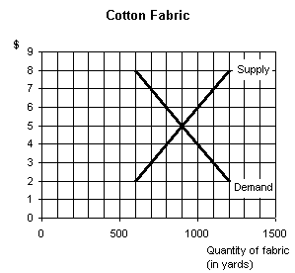

- If the price in the market is $8.00, would the market be at equilibrium? If not, is there a shortage or a surplus? How large is the shortage or surplus?
- If the price in the market is $5.00, would the market be at equilibrium? If not, is there a shortage or a surplus? How large is the shortage or surplus?
- If the price in the market is $2.00, would the market be at equilibrium? If not, is there a shortage or a surplus? How large is the shortage or surplus?

(a.) The market would not be at equilibrium. There would be a surplus of 600 yards of fabric.
(b.) The market would be at equilibrium.
(c.) The market would not be at equilibrium. There would be a shortage of 600 yards of fabric.

Difficulty: M Type: A

- Comment on the following statement: "A decrease in supply will lead to an increase in
the price which decreases demand, thus lowering price. Therefore, a decrease in supply has no effect on the price of a good."

The statement is incorrect because it confuses a decrease in quantity demanded with a decrease in demand. When supply decreases, the price increases and quantity demanded falls (shown by a movement along the demand curve). Demand does not change.

Difficulty: M Type: C

- A decrease in the demand for eggs results in a surplus of eggs at the original equilibrium
price. Explain how market forces will act to eliminate the surplus.

The price of eggs will fall. As it falls, the quantity of eggs supplied will fall and the quantity of eggs demanded will rise. Eventually, at the new market equilibrium price, quantity demanded will be equal to quantity supplied. The market will be in equilibrium.

Difficulty: M Type: C

- A decrease in the supply of steel results in a shortage of steel at the original equilibrium
price. Explain how market forces will act to eliminate the shortage.

The price of steel will rise. As it rises, the quantity of steel supplied will rise and the quantity of steel demanded will fall. Eventually, at the new market equilibrium price, quantity demanded will be equal to quantity supplied. The market will be in equilibrium.

Difficulty: M Type: C

- If incomes grow during the next year, what will happen in the market for RVs?
(Assume that RVs are normal goods.)

If RVs are normal, an increase in income will lead to an increase in demand. The demand curve will shift to the right. This will increase the equilibrium price of an RV and also increase the equilibrium quantity sold.

Difficulty: M Type: A

- Land in the South can often be used to grow either tobacco or cotton. Suppose the price
of tobacco increases. Explain how the market for cotton will be affected.

Because of the higher price of tobacco, farmers will reduce the amount of cotton grown and grow more tobacco. Thus, the supply of cotton will fall. This will raise the equilibrium price of cotton and reduce the equilibrium quantity sold.

Difficulty: M Type: A

- A new medical study reports that washing your hair everyday increases the probability
of baldness. Predict the effects of this report on the market for shampoo.

This will cause a decrease in the demand for shampoo. The demand curve will shift to the left, lowering both the equilibrium price and the equilibrium quantity of shampoo sold.

Difficulty: M Type: A

- Draw a graph showing the impact of students returning to campus in August on the
market for pizza in a college town.

When students return to a college town, the demand for pizza increases. This shifts the demand curve to the right, raising both the equilibrium price and the equilibrium quantity sold.

Price
Supply

D2

D1

Quantity of pizza

Difficulty: M Type: A

- Suppose that, last year, the price of peanuts fell and the quantity sold increased. Use
supply and demand analysis to explain how these changes could have occurred.

There are two possible causes of the drop in price: a decrease in demand or an increase in supply. If demand decreases, equilibrium quantity also falls. Thus, this could not be the cause of the changes in the peanut market. On the other hand, an increase in supply lowers equilibrium price while increasing the equilibrium quantity sold. Therefore, the supply of peanuts must have increased.

Difficulty: M Type: A

- In 1999, both the equilibrium price and equilibrium quantity of widgets increased. Use
supply and demand analysis to explain how these changes could have occurred.

There are two possible causes of the increase in price: an increase in demand or a decrease in supply. If demand increases, equilibrium quantity also rises. Thus, this could be the cause of the changes in the widget market. On the other hand, a decrease in supply raises equilibrium price but lowers the equilibrium quantity sold. This means that it could not be the cause of the change described. Therefore, the change described in the widget market must have been caused by an increase in the demand for widgets.

Difficulty: M Type: A

- The graph below reflects the market for tickets to a movie theater in a small
Midwestern town. Using the graph, show what happens if the price of a movie rental
at the local video rental store rises. What happens to the equilibrium price and quantity?

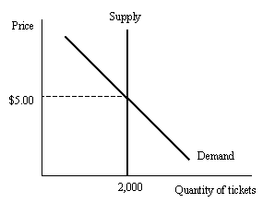

Since movie rentals and movie tickets are substitutes, the demand for movie tickets will increase. This will lead to a higher equilibrium price.

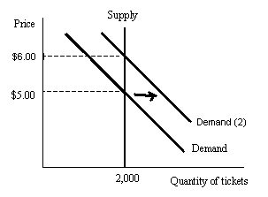
Difficulty: M Type: A

- Suppose that the demand for good Y and the supply of good Y both increase.
(a.) Is it possible to predict whether the equilibrium quantity of good Y will increase, decrease, or remain the same as a result of these changes? Why or why not?
- Is it possible to predict whether the equilibrium price of good Y increase, decrease, or remain the same as a result of these changes? Why or why not?

(a.) Yes. An increase in demand pushes the equilibrium quantity up and an increase in supply also pushes the equilibrium quantity up. Thus, equilibrium quantity will rise.
(b.) No. An increase in demand puts upward pressure on price, while an increase in supply puts downward pressure on price. Therefore, the effect on price is ambiguous.

Difficulty: D Type: A

- If the price of apples decreases, what is the likely effect on the market for peaches?

Since apples and peaches are substitutes, a decrease in the price of apples will lower the demand for peaches. This will shift the demand for peaches to the left, lowering the equilibrium price and quantity sold.

Difficulty: M Type: A

- The lumber market is currently in equilibrium at a price of $2 per foot. A new
technology is developed that reduces waste and increases efficiency in the production of lumber. Show graphically the effect of this new technology in the lumber market. What will happen to the equilibrium price and quantity sold?

The new technology will lower the cost of producing lumber. This results in an increase in supply and the supply curve shifts to the right. The equilibrium price will fall and the equilibrium quantity will rise.

Supply
Price

S2

$2.00

Demand

Quantity of lumber (ft.)

Difficulty: M Type: A

