Gross Domestic Product

- Define GDP in broad terms.

GDP stands for Gross Domestic Product. It represents the total market value of a country's output. It is the market value of all final goods and services produced within a given period of time by factors of production located within a country.

Difficulty: E Type: D

- Why aren't intermediate goods counted in GDP?

The reason is that if it weren't excluded the GDP figures would be double counting some production. That is to say that the market value of the final goods already reflects the value of the intermediate goods.

Difficulty: E Type: C

- Explain what is meant by the concept of "value added" and how it can be used to calculate GDP.

Value added simply refers to the difference between the value of goods as they leave a stage of production and the cost of the goods as they entered that stage. If you add up the "value added" at each stage of the production process, the final value is equal to GDP.

Difficulty: E Type: C

- Explain carefully the difference between GDP and GNP.

Gross Domestic Product is the market value of all final goods and services produced within the confines of a country regardless of the national origin of the inputs that were used to produce the goods. Gross National Product by contrast measures the market value of all final goods and services produced within a given period by factors of production owned by the country's citizens, regardless of where the output is produced.

Difficulty: M Type: C

- Suppose that your economics professor spent a week in Moscow delivering a series of lectures sponsored by the Russian government and a Russian professor spent a week in the U.S. delivering a series of lectures sponsored by your university. How would each of these events be reconciled in the U.S. and Russian GDP and GNP accounts?

The American economics professor's lecture would count as part of the U.S. GNP because it is output produced by an American input. It would also count as part of Russia's GDP since the lecture was delivered on Russian soil. Remember that GDP is prejudiced as to where the output is produced but is blind as to the national origin of the input. Just the reverse is true of the Russian professor's lecture in the U.S. His lecture would count as Russia's GNP and as U.S. GDP.

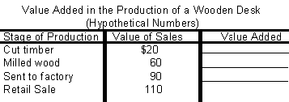
Difficulty: M Type: C

- Using the above table, calculate the value added at each stage of the production process.

The value added is $20, $40, $30 and $20 respectively.

Difficulty: E Type: A

- The Bahamas is a group of islands whose economy relies heavily on tourism. The majority of the hotels and resorts in the islands are owned by foreign countries. Which do you think is larger, Bahamas' GDP or GNP? Explain why.

Bahamas' GDP will exceed its GNP because GNP measures production by a nation's resources, regardless of location, whereas GDP measures output within the nation's boundaries. Much of the Bahamas' economic activities take place in the island. However, those activities are owned by foreign countries.

Difficulty: M Type: A

Calculating GDP

- Based on the expenditure approach, discuss and explain each of the components of GDP.

Personal consumption expenditures represent the purchase of final goods and services by the household sector. Gross Private Domestic investment represents spending by firms and households on new capital, changes in business inventories, and new residential structures. Government consumption and gross investment is the purchase of goods and services by the government at the federal, state, and local levels. And finally, net exports (exports - imports) represent the net sale of final goods and services to the rest of the world.

Difficulty:M Type:C

- Explain why we must take into account changes in business inventories when calculating GDP.

Changes in business inventories can be positive, negative, or zero. If they are positive, some goods produced in a given period were not purchased. Because GDP measures the value of the goods and services produced in a given period, we must take into account these goods that were produced but not sold. When the changes in business inventories is negative, some of the goods sold in a given period were produced in a previous period. For the same reason, we need to take this into account to obtain an accurate measure of economic activity for a GIVEN period.

Dificulty:E Type: C

- Explain the relationship among gross investment, net investment, and depreciation.

Gross investment is the total value of all newly produced capital goods produced in a given period. Depreciation represents the amount of the capital stock that wears out in a given period. Net investment, which is equal to gross investment minus depreciation, represents the extent to which the stock of capital changes in a given period.

Dificultyf: M Type: D

- Briefly explain under what condition, if any, net investment can be negative. If so, explain what this implies about the capital stock.

Net investment equals gross investment minus depreciation. If depreciation is greater than gross investment, net investment will be negative. In such a situation, there is insufficient gross investment to offset the effects of the depreciation of the capital stock. In this case, the capital stock would diminish in size during that period.

Dificultyf: M Type: C

- Suppose an individual wishes to determine the level of economic activity for a particular economy. To do so, assume that the individual calculates the level of consumption, investment, and government consumption and investment for a given period. Also assume that the individual ignores the level of net exports (NX) when calculating this measure of economic activity; call this alternative measure of output GDPalt. Under what condition(s), if any, will this alternative measure of output yield a calculation of the level of economic activity that is greater than the correct level of economic activity (i.e., as represented by the definition of Gross Domestic Product discussed in class)? Briefly explain.

This alternative measure of output equals C + I + G. This calculation omits two issues. First, goods produced in the country but sold to foreign individuals, firms, and governments are excluded; the value of these goods and services equals exports. Second, some of the goods and services purchased by domestic residents, firms, and governments are produced abroad; the value of these goods and services are imports. The correct measure of output (i.e., GDP) will add X to C + I + G. this number will clearly exceed the alternative measure. The correct measure will then subtract Q to take into account that portion of C, I, and G that represents foreign goods and services. This alternative measure of GDP will provide an estimate of economic activity that exceeds the actual (i.e., correct) measure of output if imports exceed exports (Q>X). When Q>X, the alternative measure of economic activity overestimates the actual level because it fails to take into account the fact that agents in this country are buying more foreign goods and services than they are selling to foreign agents. By neglecting X and Q, the alternative measure assumes that all goods consumed by domestic households, firms, and governments are produced domestically. Furthermore, it assumes that all goods produced domestically are sold domestically.

Difficulty:D Type: A

- Suppose an individual wishes to determine the level of economic activity for a particular economy. To do so, assume that the individual calculates the level of consumption, investment, and government consumption and investment for a given period. Also assume that the individual ignores the level of net exports (NX) when calculating this measure of economic activity; call this alternative measure of output GDPalt. Under what condition(s), if any, will this alternative measure of output yield a calculation of the level of economic activity that is less than the correct level of economic activity (i.e., as represented by the definition of Gross Domestic Product discussed in class)? Briefly explain.

This alternative measure of output equals C + I + G. This calculation omits two issues. First, goods produced in the country but sold to foreign individuals, firms, and governments are excluded; the value of these goods and services equals exports. Second, some of the goods and services purchased by domestic residents, firms, and governments are produced abroad; the value of these goods and services are imports. The correct measure of output (i.e., GDP) will add X to C + I + G. This number will clearly exceed the alternative measure. The correct measure will then subtract Q to take into account that portion of C, I, and G that represents foreign goods and services. This alternative measure of GDP will provide an estimate of economic activity that is less than the actual level of economic activity when there is a trade surplus (X > Q). On a net basis, this country is selling more goods and services to foreign individuals, etc., than it is buying foreign goods and services. By neglecting this net quantity of goods and services produced, this alternative measure of output will underestimate the level of economic activity in a given period.

Dificulty: D Type: A

- Explain what is meant by the expenditure approach to calculating GDP.

It is a method of computing GDP that measures the amount spent on all final goods and services during a given period.

Difficulty: E Type: D

- Explain what is meant by the income approach to calculating GDP.

It is a method of computing GDP that measures the income - wages, rents, interest and profits received by all factors of production in producing final goods and services.

Difficulty: E Type: D

- List and explain the four main spending groups in the economy.

Consumption - household spending on consumer goods, investment - spending by firms and households on new capital (i.e. plant, equipment, inventory and new residential construction), government consumption and gross investment and net exports. Net exports are the difference between spending by the rest of the world on domestically produced goods minus imports.

Difficulty: E Type: F

- What are the three types of personal consumption expenditures? Explain and give an example of each.

The three types of personal consumption expenditures are durable goods, nondurable goods and services. Durable goods are goods that last a relatively long time like automobiles and furniture. Nondurable goods are goods that are used up fairly quickly like food and clothing. Services are expenditures for things that do not involve physical production like legal services and universities.

Difficulty: E Type: C

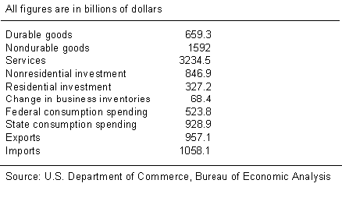
- Using the above figures, compute the subtotals for each of the four major spending categories and label them. Then compute the value of GDP.

Personal Consumption = $5485.8

Gross Private Domestic Investment = $1242.5

Government Spending = $1452.7

Net Exports = -$101

GDP = $8080

Difficulty: M Type: A

- Explain how the term investment in economics is different from the way it is used in everyday life.

In economics, investment refers to the purchase of new capital such as housing, plants, equipment and inventory. In everyday use the term often means the purchase of common stocks, bonds or mutual funds.

Difficulty: E Type: D

- Thinking about inventory as investment is sometimes confusing. What service does inventory provide that would cause economists to count it as investment?

There are several reasons why firms may wish to keep inventories. One is to meet unexpected increases in the demand for their products. Firms cannot always be sure precisely how much they will sell in a given quarter or a given year. In order to provide good service to their customers firms have to be able to respond to unforeseen increases in sales. Inventory allows firms to do this. Some firms use inventory as a direct service to customers like the case of retail stores. Retail firms don't produce anything at all. Their service is in providing a variety of items that their customers will want under one roof. In a nutshell they are providing convenience.

Difficulty: M Type: C

- Explain the relationship between final sales in the economy and GDP. In addition, explain why it would be inaccurate to say that final sales and GDP are the same thing.

GDP is simply equal to final sales plus changes in business inventories. It would be inaccurate to say that final sales and GDP are the same thing because final sales does not capture everything that is produced in an economy but rather everything that is sold.

Difficulty: E Type: C

- Define net investment and what it meant to measure.

Net investment is equal to gross investment minus depreciation. Net investment is a measure of how much the stock of capital changes during a period. If it is positive, the capital stock is growing. On the other hand, if it is negative the capital stock has decreased.

Difficulty: E Type: D

- Explain what net exports are and why they are included in the definition of GDP.

Net exports are the difference between exports (sales of U.S. - produced goods and services to foreigners) minus imports (purchase of foreign-made goods and services by the U.S.). The reason it is included in the definition of GDP is straightforward. Consumption, gross investment and government spending include spending on goods produced at home and abroad. That means that if we stop here we have an overstatement of GDP if we do not subtract imports. Similarly, those same expenditure components do not include goods that were produced here but not sold here. Therefore, we must add in exports so that the GDP figures do not understate production.

Difficulty: E Type: D

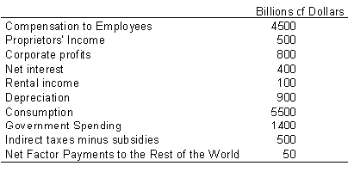
- Using the above data calculate GDP using the income approach and identify which two items on the list are superfluous in your calculation.

Using the income approach the GDP is $7750 billion. Consumption and government spending are not needed in the calculation, as they are expenditure components.

Difficulty: M Type: A

- Define national income and identify its five components.

National income is the total income earned by factors of production owned by a country's citizens. It includes compensation to employees, proprietor's income, corporate profits, net interest and rental income.

Difficulty: E Type: D

- Why do economists add depreciation to national income to calculate GDP when using the income approach but do not do so when using the expenditure approach?

Economists want to measure income from all sources including income that results from the replacement of existing plant and equipment. Since national income includes corporate profit after depreciation it must be added in to reconcile it in the GDP accounts with the expenditure approach. The expenditure approach does not leave depreciation out. It is included in gross investment.

Difficulty: D Type: C

- Give examples of indirect business taxes.

Indirect taxes are like sales taxes, customs duties, and license fees.

Difficulty: E Type: F

- What are subsidies? Give at least two examples.

Subsidies are payments made by the government for which it receives no goods and services in return. Examples might include payments to farmers or subsidized student loans.

Difficulty: E Type: F

- Explain what the phrase "net factor payment to the rest of the world" means and explain why this item is added when using the income approach to calculate GDP.

These are payments of factor income to the rest of the world minus the receipt of factor income from the rest of the world. This item is added because national income is defined as the income of factors of production owned by the country. GDP, however, is output produced by factors of production located within the country. National Income includes income that should not be counted in GDP like the income its citizens earn abroad. Therefore, this item must be subtracted. Also, national income doesn't include some income that should count in GDP such as the foreigners' income in the country whose GDP we are calculating. This figure must be added.

Difficulty: M Type: C

- When net factor payments to the rest of the world is a positive figure what does this mean?

It simply means that U.S. payments of factor income to the rest of the world exceeded U.S. receipts of factor income from the rest of the world.

Difficulty: M Type: F
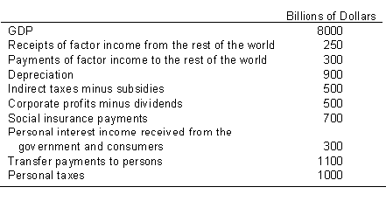

- Using the above table calculate GNP, NNP, National Income, Personal Income and Disposable income.

GNP = 8000 + 250 - 300 = 7950

NNP = 7950 - 900 = 7050

NI = 7050 - 500 = 6550

PI = 6550 - 500 - 700 + 300 + 1100 = 6750

DI = 6750 - 1000 = 5750

Difficulty: M Type: A

- Explain and define what NNP is.

Net National Product is equal to Gross National Product minus depreciation. It represents a nation's total product minus what is required to maintain the value of its capital stock.

Difficulty: E Type: D

- Explain in broad terms what personal income is.

Personal income is the income received by households before paying personal income taxes but after paying social insurance contributions. In a nutshell it is an adjustment to national income. It adds back in all income that is received but not earned and (but for personal taxes) subtracts out all income earned but not received.

Difficulty: E Type: D

- Define disposable personal income.

This is personal income minus personal income taxes. The amount that households have to spend or save.

Difficulty: E Type: D

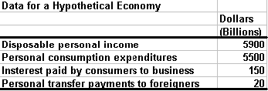

- Identify which of the following item(s) would be included in U.S. GDP.(a) The salary of an American consultant hired by a British firm to go and analyze their European operations (b) The output of a U.S.-owned family farm in Kansas (c) Food stamp payments (d) Welfare checks (e) The wages of a field worker in Louisiana

The output of a U.S.-owned family farm in Kansas (b) and the wages of a field worker in Louisiana (e) would be included in U.S. GDP. Wages are counted because they represent a payment for the use of a productive resource. Transfers (e.g., food stamps and welfare checks) are not included because they do not represent the value of a productive resource. The consultant's services are excluded because they would be provided outside the United States.

Difficulty: M Type: F

Refer to the information provided in Table 6.4 below to answer the questions that follow.

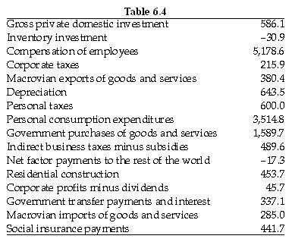

- Answer Parts (a) through (g) using the information in Table 6.4 describing the Macrovian economy. Quantities are given in millions of Macrovian dollars (M$).

(a) Calculate gross private investment.
(b) Calculate Macrovian GDP.
(c) Calculate gross national product (GNP).
(d) Calculate net national product (NNP).
(e) Calculate national income.
(f) Calculate personal income.
(g) Calculate disposable personal income.

(a) Gross private investment = Business investment in plant and equipment + Residential construction + Inventory investment = 586.1 + 453.7 + -30.9 = 1008.9.
(b) GDP = C + I + G + (EX - IM) = 3514.8 + (586.1 + 453.7 - 30.9) + 1589.7 + (380.4 - 285.0) = 6208.8 (millions of Macrovian dollars).
(c) GNP = GDP - Net factor payments to the rest of the world = 6,208.8 - (-)17.3 = 6,226.1.
(d) NNP = GNP - Depreciation = 6,226.1 - 643.5 = 5,582.6.
(e) National income = GNP - (Depreciation + Indirect business taxes minus subsidies) = 6,226.1 - (643.5 + 489.6) = 5,093.0.
(f) Personal income = National income + Government transfer payments and interest - (Payroll taxes + Corporate taxes + Corporate profit - Dividends) = 5,093.0 + 337.1 - (441.7 + 215.9 + 45.7) = 4,726.8.
(g) Disposable personal income = Personal income - Personal taxes = 4,726.8 - 600.0 = 4,126.8.

Difficulty: M Type: A

Refer to the information provided in Table 6.5 below to answer the questions that follow.

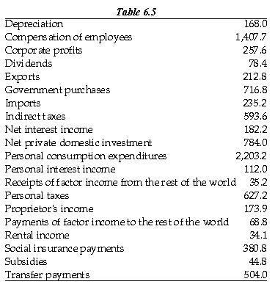
- Table 6.5 contains the national income and product accounts data on the Freedonia economy. Quantities following are given in millions of Freedonian dollars (F$). Use this information to answer Parts (a) through (g) below.

(a) Calculate Freedonian gross private investment.
(b) Calculate Freedonian GDP.
(c) Calculate Freedonian GNP.
(d) Calculate net national product (NNP).
(e) Calculate national income.
(f) Calculate personal income.
(g) Calculate disposable personal income.

(a) Gross private investment = Net private investment + Depreciation = 784.0 + 168.0 = 952.0.
(b) GDP = Personal consumption expenditures + Gross private investment + Government purchases + Net exports = 2,203.2 + 952.0 + 716.8 + (212.8 - 235.2) = 3,849.6.
(c) GNP = GDP + (Receipts of factor income from the rest of the world - Payments of factor income to the rest of the world) = 3,849.6 + (35.2 - 68.8) = 3,816.0.
(d) NNP = GNP - Depreciation = 3,816.0 - 168.0 = 3,648.0.
(e) National income = NNP - (Indirect taxes - Subsidies) = 3,648.0 - (593.6 - 44.8) = 3,099.2.
(f) Personal income = National income - (Corporate profits - Dividends) - Social insurance payments + Personal interest income + Transfer payments = 3,099.2 - (257.6 - 78.4) - 380.8 + 112.0 + 504.0 = 3,155.2.
(g) Disposable personal income = Personal income - Personal taxes = 3,155.2 - 627.2 = 2,528.0.

Difficulty: M Type: A

- Explain why each of the following items is excluded from GDP: (a) profits from the stock and bond market (b) transfer payments (c) sale of used goods (d) goods and services produced in the home.Explain why the following items are included in GDP: (a) depreciation (b) change in business inventories( c) indirect taxes

Profits from the sale of stocks and bonds have nothing to do with current production, so they are not included in GDP. Transfer payments are not included because they do not represent payments for current production. Used goods were counted in GDP in the year they were produced. They are not counted again when they are resold. Goods and services produced at home are not included in the GDP because they do not entail monetary transactions. For example, you don't pay yourself for mowing your own yard. Depreciation is included in GDP because GDP is a measure of all income, including the income that results from the replacement of existing plant and equipment. Change in business inventories is included because GDP is a measure of production, not sales. The change in inventories is necessary so that all current production is included, even if it is not sold, and production from previous years that is finally sold is not included. Indirect taxes are included because they represent income to the government.

Difficulty: M Type: A

- Explain the two approaches that can be used to compute GDP. Why do these two approaches lead to the same value for GDP?

The two approaches are the income approach and the expenditure approach. The income approach adds all sources of income, and the expenditure approach adds all expenditures for goods and services. The two approaches yield the same result because every expenditure leads to an income flow for someone.

Difficulty: E Type: C

- Explain the four main categories of expenditures used in calculating GDP.

The four main expenditure categories are consumption, investment, government spending, and net exports.

Difficulty: E Type: D

- Define GNP and GDP. Explain the difference between GNP and GDP. Why is the difference between GNP and GDP small for most countries?

GDP is the total market value of all final goods and services produced within a given period by factors of production located within a country. GNP is the total market value of all final goods and services produced within a given period by factors of production owned by a country's citizens, regardless of where the output is produced. For most countries the difference between GNP and GDP is small because the payments of factor income to the rest of the world is approximately the same value as the receipt of factor income from the rest of the world.

Difficulty: E Type: D

- Explain the difference between GNP and NNP. Explain why NNP is sometimes a better measure of how the economy is doing than GNP is.

The difference between GNP and NNP is that NNP is GNP minus depreciation. NNP is a measure of total product minus what is required to maintain the value of the capital stock. NNP is sometimes a better measure of how the economy is doing because it accounts for the capital stock that is left over after depreciation has been accounted for.

Difficulty: E Type: A

Nominal versus Real GDP

- Using the above table calculate personal saving as a percentage of disposable personal income. Make sure to show all your work.

We must first calculate personal saving which is 5900 - 5500 - 150 - 20 = 230. Then divide this number by the amount of disposable personal income = 230/5900 = 3.9%

Difficulty: M Type: A

- Compare and contrast the terms nominal GDP and real GDP.

Nominal GDP measures gross domestic product in current dollars. Real GDP measures gross domestic product by adjusting Nominal GDP for price changes.

Difficulty: E Type: C
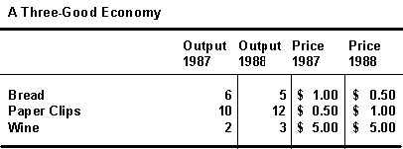

Table 6. 1

- Using the above table calculate the nominal GDP for 1987.

Bread = 6 x $1 = $6

Paper Clips = 10 x $.50 = $5

Wine = 2 x $5 = $10

Nominal GDP is thus the sum of the above figures - $21.

Difficulty: E Type: A

- Using Table 6.1 calculate real GDP for 1988 using 1987 as the base year.

Real GDP in 1988 is calculated using 1987's prices. Therefore the value of production of bread, paper clips and wine is $5.00, $6.00 and $15.00 respectively totaling to $26.00.

Difficulty: M Type: A

- Using Table 6.1 calculate the percentage increase in Real GDP from 1987 to 1988 using 1987 as the base year.

The increase in real GDP from 1987 to 1988 is equal to ($26-$21)/$21 * 100% = 23.8%

Difficulty: E Type: A

- Using Table 6.1 calculate Real GDP in 1987 using 1988 as the base year.

Bread will be valued at $3, paper clips at $10 and wine at $10 for a total of $23.

Difficulty: M Type: A

- Using Table 6.1 calculate the percentage increase in Real GDP from 1987 to 1988 using 1988 as the base year.

The percentage increase in Real GDP is equal to ($26 - $23)/$23 x 100% = 13.0%.

Difficulty: E Type: A

- Explain in broad terms what the Bureau Economic Analysis did to correct for the sensitivity of the choice of base years when calculating the percentage increase in Real GDP across time.

The new procedure makes two important changes. The first is to split the difference between the two percentage changes using two base years by taking a geometric average. That is to say, if you are calculating the percent change in real GDP from year 1 to year 2 you would average the percentage increase that you would get by using year 1 as the base year with the results you would have obtained by using year 2 as the base year. Second, when you move into the third year then you would use year 2 and year 3 as the base years when computing changes between year 2 and year 3.

Difficulty: D Type: C

- Explain what is meant by a fixed-weight procedure.

It is a procedure that uses weights from a given base year in order to keep all figures in all years measured in the same prices that prevailed in the base year.

Difficulty: E Type: D

- Discuss some of the problems associated with using fixed weights to compute real GDP.

The first problem is that many structural changes have taken place in the U.S. economy in the last 30 to 40 years that make using modern prices as unlikely good weights for the 1950s. Secondly, fixed price weights do not account for the responses in the economy to supply shifts like bad weather which may lower production for agricultural goods. The bottom line is that the fixed-weight procedure ignores the substitution away from goods whose prices are increasing and toward goods whose prices are decreasing or increasing less rapidly. The procedure tends to overestimate the increase in the overall price level.

Difficulty: M Type: C

- Explain how using GDP may not be a very good measure of overall social welfare.

The reason that GDP is an imperfect measure of social welfare is that it does not measure many goods and services that have real economic value. The most obvious case is leisure. Leisure is a normal good. We do not work just for the sake of work but to earn money so that we may buy goods and enjoy leisure. It also does not measure a great deal of non-market activity like housework, child care, lawn cutting, painting and other activities that the household may choose to perform for itself. It also does not back out of the statistics a number of social ills like the effects of pollution or crime. In fact it is interesting to note that not only are these items not subtracted from GDP, whenever we spend money to fix them like expenditures on pollution remediation or burglar bars these expenditures are added in.

Difficulty: M Type: C

- Why should we care about the underground economy?

To the extent that GDP reflects only a part of economic activity then that means it is a misleading figure of what we believed was a complete measure of what the economy produced. Similarly, unemployment rates may be lower than what is officially measured by the Bureau of Labor Statistics if people work in the underground economy but do not report this in government surveys. Lastly, it can make comparisons across countries troublesome if the degree of underground activity varies greatly from country to country.

Difficulty: E Type: C

- Label the following as either being a final or intermediate good.

Recycled steel purchased by a steel manufacturer
An automobile purchased by a package delivery company
Bubble gum
A computer purchased by
a professor for use in the classroom
An architect builds a scale model of a house he has designed
A minivan purchased by a family

Recycled steel purchased by a steel manufacturer | intermediate good
An automobile purchased by a package delivery company | final good
Bubble gum | final good
A computer purchased by  a professor for use in the classroom | final good
An architect builds a scale model of a house he has designed | intermediate good
A minivan purchased by a family | final good

Difficulty: E Type: F

- How can double counting be avoided?

Double counting can be avoided by counting only the value added to a product by each firm in the production process or by counting only the value of final goods.

Difficulty: E Type: F

- Next to each of the following items indicate in the table which items belongs to GDP and which to GNP.

Rent paid to an American who owns land in Mexico
Salary paid to foreigners working in the U.S. for a U.S. - owned company
Interest paid on a bond in a foreign-owned company to a U.S. citizen
Profits earned in the U.S. by a foreign-owned company

Rent paid to an American who owns land in Mexico | GNP
Salary paid to foreigners working in the U.S. for a U.S. - owned company | GDP
Interest paid on a bond in a foreign-owned company to a U.S. citizen | GNP
Profits earned in the U.S. by a foreign-owned company | GDP

Difficulty: M Type: F

- An automobile dealer purchases additional vehicles at the end of 1999 in anticipation of increased sales in January of 2000. How are these vehicles reconciled in the GDP accounts?

The vehicles will be counted as part of 1999's GDP and will come under the heading of gross private domestic investment. They will not count in the GDP for the year 2000 because they were not produced in 2000.

Difficulty: E Type: C

- Assume that in a given year there is negative inventory investment. What is the relationship between final sales and GDP? Comment on how this could be possible.

Final sales must have exceeded GDP. This could be accomplished by having drawn down on inventories produced in a previous year.

Difficulty: E Type: F

- What is the capital stock at the end of the year the sum of?

The capital stock at the end of the year is simply the sum of the capital stock at the beginning of the year plus net investment.

Difficulty: E Type: D

- How can net investment be a negative figure?

Net investment can be a negative figure if the amount of depreciation during the course of the year is greater than the amount of gross private domestic investment.

Difficulty: E Type: C

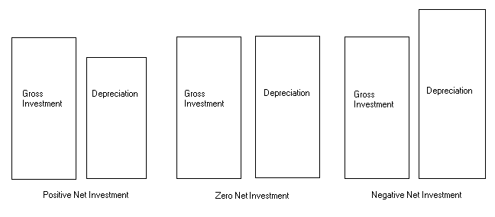
- Assume the following pairs of rectangles represents gross investment and depreciation. According to the value of net investment indicated under each, label each pair of rectangles as either gross investment or depreciation.
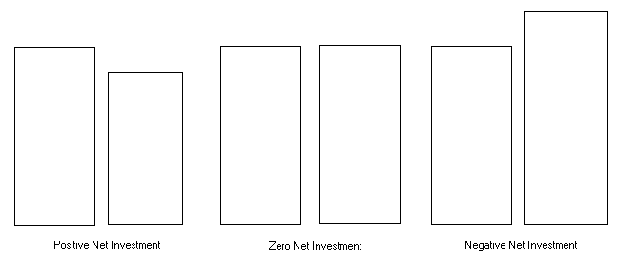
Difficulty: E Type: C

- Write out the formula for calculating GDP using the income approach.

GDP = National Income + Depreciation + (Indirect Taxes - Subsidies) + Net Factor Payments to the Rest of the World.

Difficulty: M Type: F

- How are interest payments by households and government reconciled in the GDP accounts? Explain your reasoning.

Interest paid by households and by the government is not counted in GDP because neither are assumed to flow from the production of goods and services.

Difficulty: M Type: C

- Assume that GDP is $9 Trillion, receipts of factor income from the rest of the world are $2 Trillion, and payments of factor income to the rest of the world are $1 Trillion. Calculate GNP from this information.

GNP = GDP +factor payments from the rest of the world - factor payments to the rest of the world.

Therefore GNP = $9 trillion + $2 Trillion - $1 Trillion = $10 trillion.

Difficulty: M Type: C

- Assume that you are given GDP and depreciation data for 1998. Explain why this is not enough information to calculate Net National Product.

In order to calculate Net National Product you must first have Gross National Product figures. Since the net factor payments to the rest of the world are not given it is impossible to calculate with the available information alone.

Difficulty: M Type: C

- If NNP is $7 trillion, net investment is $500 billion and gross investment is $1 trillion determine the level of GNP.

GNP = NNP + depreciation; depreciation = gross investment - net investment ($1 trillion - $500 billion) Therefore GNP = $7 trillion + $500 billion = $7.5 trillion.

Difficulty: E Type: A

- Write out the equation for calculating national income as derived from NNP.

National Income = NNP + Subsidies - indirect taxes.

Difficulty: E Type: C

- Write out the equation for calculating personal income as it relates to national income, retained corporate earnings, social insurance payments, personal interest income and transfer payments.

Personal Income = National Income - Retained Corporate Earnings - Corporate Profits Tax - Social Insurance Payments + Personal Interest Income Received + Transfer Payments.

Difficulty: M Type: C

- How are transfer payments reconciled in the national income and personal income accounts? Explain your reasoning.

Transfer payments are not included in national income but are included in personal income. The reason is that National Income represents all income that is earned but not necessarily received. Personal Income however, includes all income received regardless of whether it is earned. Since transfer payments represents unearned income they do not count in the National Income.

Difficulty: M Type: C

- If real GDP and nominal GDP both rise by 10% and 15% respectively from one year to the next what can we say is true about production and inflation between these two years and why?

Real GDP is nominal GDP adjusted for changes in the price level. Since real GDP rose we can be confident that production rose as well. Since nominal GDP grew faster than real GDP we can also assume that the price level rose. That is there must have been some inflation. The residual, or 5% amount, gives us the approximate inflation rate.

Difficulty: E Type: C

- If nominal GDP is $8 trillion and real GDP is $5 trillion, calculate the value of the GDP deflator.

Real GDP = Nominal GDP
-----------------

GDP Deflator / 100

Therefore the GDP Deflator = Nominal GDP / Real GDP x 100 = $8 trillion / $5 trillion x 100 = 160.

Difficulty: E Type: A

- What is the underground economy and what is its relationship if any to the value of GDP?

The underground economy is the part of the economy in which transactions take place and income is generated that is unreported and therefore not counted in GDP. Examples include such illegal activity as gambling, prostitution, extortion and the narcotics trade and legal production done "off the books" to avoid income taxes.

Difficulty: M Type: C

- List some limitations of GDP as a measurement of social welfare.

GDP is not necessarily a good measure of social welfare because it doesn't adjust production for negative externalities, home production is not included, all activity produced in the underground economy is excluded, and it tells us nothing about how the output is distributed.

Difficulty: E Type: C

- How would you adjust GDP to make it a better measure of social welfare?

Answers here can vary. Students may discuss adjusting GDP for pollution, increases in crime, including an estimate of services produced in the home, and including an estimate of output produced in the underground economy.

Difficulty: E Type: A

- Give an example of how real GDP could be increased even though no more output is produced.

Real GDP could be increased even though there is no more output produced if output that is currently produced in the home or in the underground economy is included. If activities that are currently illegal are declared legal, real GDP could increase.

Difficulty:M Type: A

