Whitman College
Econ 328
Exam 1
February 26, 2003

Write all answers in your bluebook. Show all of your work. The exam ends at 2:25.

1. (6pts) A formal definition of a game consists of six elements. List these six elements.

2. State whether each of the following could be a game tree. If not, explain why not.

(a) (5pts)
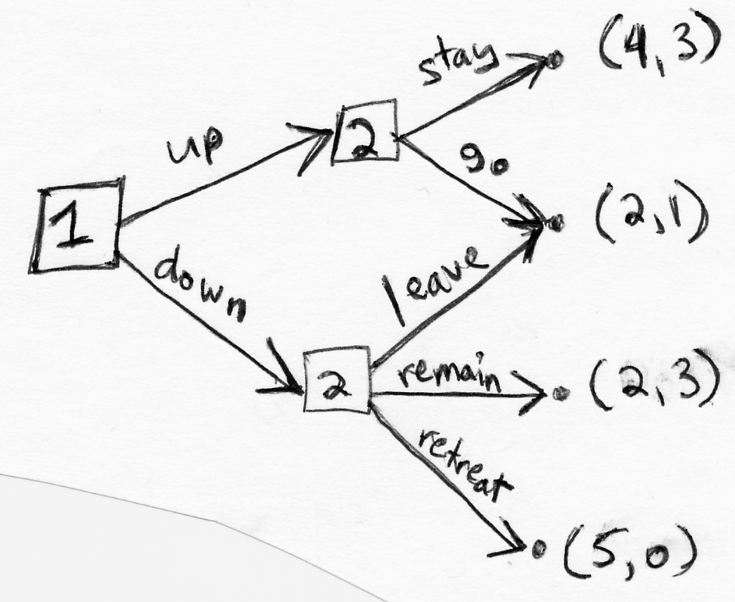

(b) (5pts)
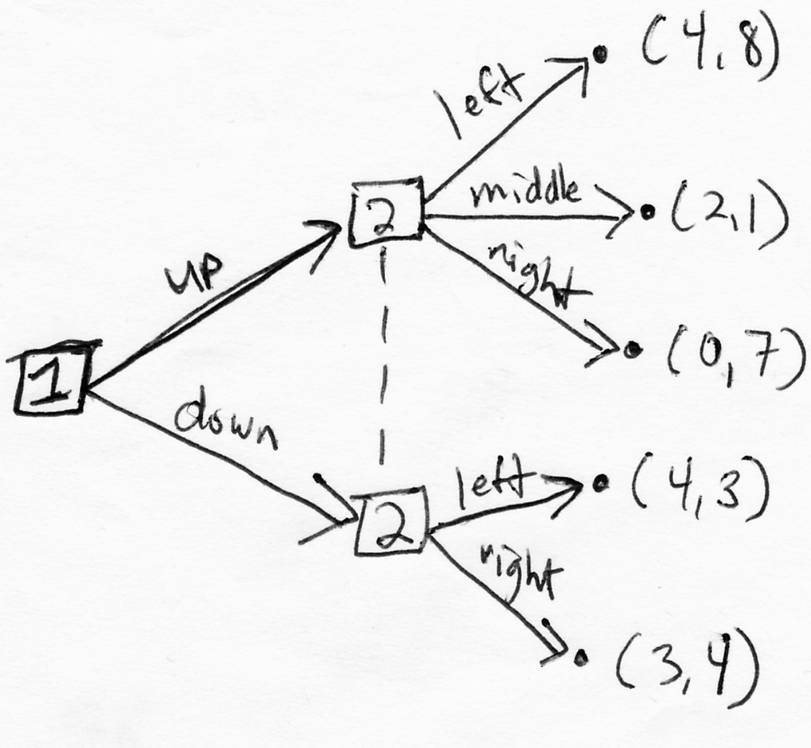
3. Consider the following sequential move game. Jim and Pete are adding a colleague to the economics department. Jim goes first, choosing whether the new hire will have a specialty in microeconomics or macroeconomics. After observing Jim's choice, Pete moves. Pete chooses between a subspecialty of labor economics or industrial organization. Jim gets a payoff of 5 from a micro-labor combination, 3 from a micro-industrial organization combination, 6 from a macro-labor combination, and 2 from a macro-industrial organization combination. Pete gets a payoff of 0 from a micro-labor combination, 5 from a micro-industrial organization combination, 8 from a macro-labor combination, and 4 from a macro-industrial organization combination.

(8pts) Draw the game tree. Be sure to label who plays at each decision node, what action each branch represents, and the payoffs at each terminal node.

(2pts) Is this a game of imperfect information? Explain.

4. Consider the following game.

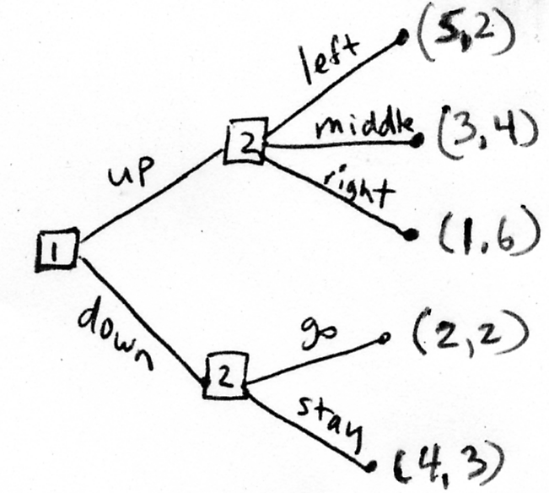

(a) (5pts) List the strategies in S₁, the strategy set for player 1.
(b) (5pts) List the strategies in S₂, the strategy set for player 2.
(b) (5pts) Write the normal form of this game.

5. Consider the game below.
Player 2
 |  | H | D
 | h | 0, 0 | 3, 1
Player 1 | d | 1, 3 | 2, 2

(a) (5pts) What is u₁(σ₁,σ₂), for σ₁=(1/2,1/2) and σ₂=(1/4,3/4)?
(b) (5pts) What is u₂(σ₁,σ₂), for σ₁=(1/2,1/2) and σ₂=(1/4,3/4)?
(c) (5pts) What is BR₁(μ₂), for μ₂ = (2/3, 1/3)?

6. For each of the five simultaneous-move one-shot games below, answer questions (a)-(e).

(a) (1pt) Is there a dominated strategy for either player? If so, list all dominated strategies.
(b) (1pt) Is there a dominant strategy equilibrium? If so, what is it?
(c) (1pt) Is there an iterated dominant strategy equilibrium? If so, what is it?
(d) (1pt) What are the rationalizable strategies for each player?
(e) (1pt) What are the pure strategy Nash equilibria of the game?

Game 1
Player 2
 |  | L | M | R
 | T | 12, 10 | 2, 5 | 25, 9
Player 1 | I | 10, 9 | 25, 4 | 20, 6
 | B | 14, 3 | 50, 2 | 30, 1

Game 2
Player 2
 |  | E | F | G | H
 | A | 20, 10 | 5, 11 | 8, 8 | 14, 6
Player 1 | B | 10, 11 | 10, 12 | 9, 22 | 15, 20
 | C | 15, 12 | 4, 13 | 10, 14 | 20, 21
 | D | 18, 13 | 5, 14 | 12, 20 | 18, 32

Game 3
Player 2
 |  | F | C | R
 | U | 20, 7 | 30, 5 | 40, 0
Player 1 | M | 17, 15 | 35, 17 | 45, 20
 | D | 15, 25 | 30, 30 | 50, 25

Game 4
Player 2
 |  | G | A | D
 | F | 10, 11 | 2, 12 | 14, 10
Player 1 | C | 12, 16 | 2, 20 | 15, 18
 | B | 14, 1 | 3, 4 | 20, 3

Game 5
Player 2
 |  | l | m | r
 | t | 2, 5 | 5, 6 | 3, 1
Player 1 | i | 1, 4 | 8, 5 | 7, 2
 | b | 2, 4 | 8, 4 | 10, 3

7. (a) (5pts) Define the Prisoner’s Dilemma class of games.

(b) (3pts) Consider Games 1-5 in Question #6 above. Which, if any, are in the Prisoner’s Dilemma class of games?

8. (a) (3pts) Define a Nash equilibrium.

(b) (2pts) Define a bad Nash equilibrium.

(c) (3pts) Consider Games 1-5 in Question #6 above. Which, if any, are examples of a game with a bad Nash equilibrium?

9. (3pts) True or false? A Nash equilibrium strategy is always a rationalizable strategy. Explain.

